**Production steps of the CLP Model**

**Step I:**

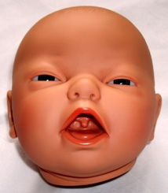 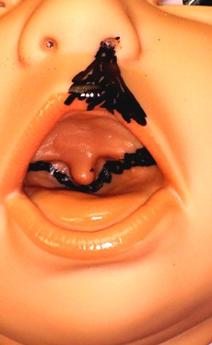 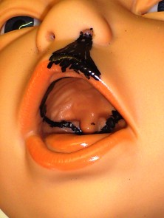

Ia Ib Ic

Defining the dimensions of the planned cleft lip palate in the original baby doll’s face (Figure Ia) by marking areas of the lip/nose (Figure Ib) and the palate (Figure Ic) with a black colored pen

**Step II:**

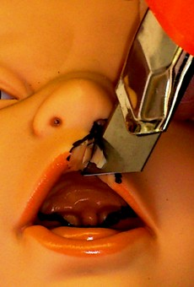 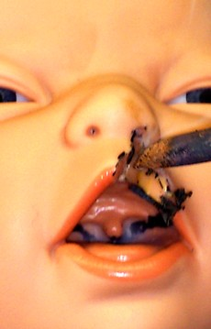 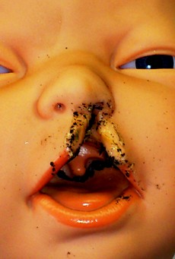   
IIa IIb IIc

Excision of the marked colored areas, starting with the extraoral parts. This procedure can be either carried out by using a knife (Figure IIa) or a soldering iron (Figure IIb). The letter is helpful to round off the edges (Figure IIc). Because the model is made out of polyvinyl chloride based plastics the material burns up. Residues of burned material can be easily stripped off by a milling machine.

**Step III:**

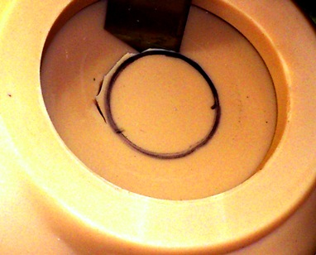 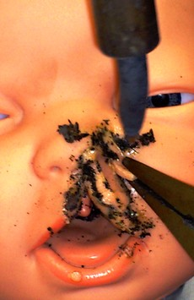

Cutting out a rounded area of the inner side of the doll’s thigh in the size of a 2x2cm (Figure IIIa). This plastic slice is used to shape a typical cleft nose wing and welded on the defect in the model’s face (Figure IIIb).

IIIa IIIb

**Step IV:**

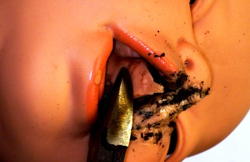 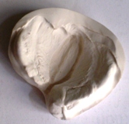 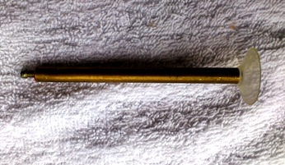

IVa IVb IVc

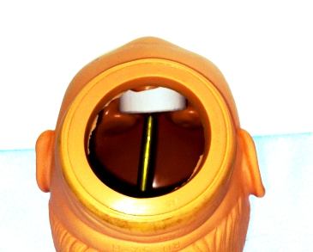

Excision of the doll’s palate with a side cutter (Figure IVa). A plaster cast of a cleft palate patient (Figure IVb) is utilized to construct the cleft palate of the doll. Once the size of the cast is adjusted to fit into the mouth, the cast is fixated firmly in the inner side of the doll’s head (Fugure IVd) by using a threaded rod (Figure IVc) and hot-glue.

IVd

**Step V:**

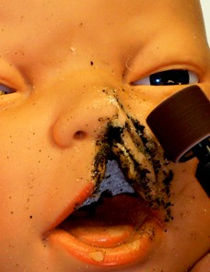 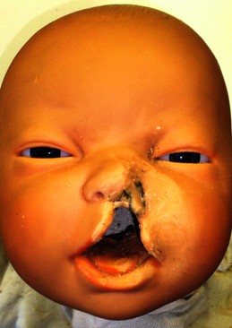 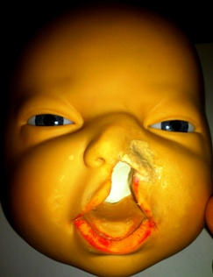

Va Vb Vc

Removal of residues by usage of a milling machine with different collets (Figure Va). Precise shaping of the characteristic flattening ala of the nose (Figure Vb). Use of skin-colored lacquer and cosmetic products to adapt the skin color. Figure Vc shows the completed CLP model.

All used Instruments/Materials for Production the Model

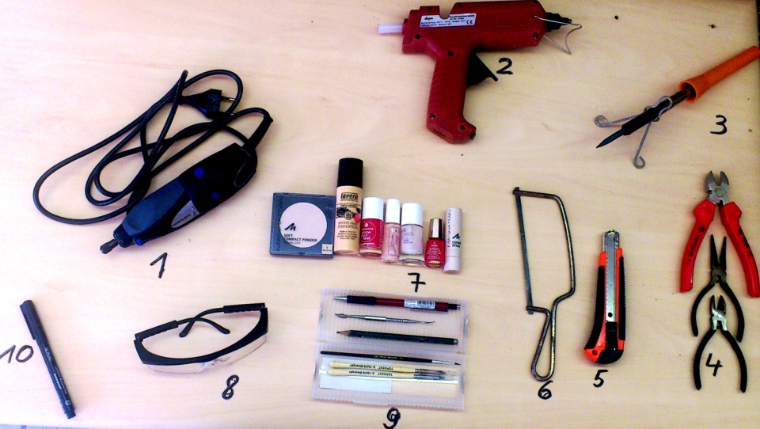

1: Milling Machine (Dremel ® 300 Series by Dremel Europe; Voltage Rating: 230-240 V, 50-60 Hz; Amperage Rating: 0,5A; No Load Speed: 33,000/min; Collet Capacity: 0.8mm, 1.6mm, 2.4mm, 3.2mm)

2: Hot-Glue Gun: HK500 Dema(2011); serial number BH1; Voltage Rating: 230V, 50 Hz; Watt Output: 500W;

3: Soldering Iron: Watt Output 60W

4. From up to down: Side Cutter Big; Long Nose Pliers; Side Cutter Small

5. Cutter knife; blades of 100mm

6. Chopsaw

7. Manhattan Soft Compact Powder (Natural Look); Manhattan Cover Stick Naturelle; Mavala Paris Nail Color

Cream 5ml; Douglas nylon base coat 9ml; Essence 37061; Lavera Natural Liquid Foundation, P2 Apricot

201

8. Safety Glasses

9. Fine Paintbrushs; Pencils; Modelling Instrument (Legrand)

10. Marker Pen waterproof black (Herlitz)