Supplemental Digital Content
The simulation laboratory provided a fertile testing ground to develop solutions to the potential ventilator shortage during the COVID-19 pandemic. This supplemental digital content aims to provide additional information regarding development and testing of ventilation modalities described in the main text in order to provide guidance for others who would like to test similar innovations using a simulation laboratory setup.
All modalities utilized Human Patient Simulator mannequins (CAE Healthcare, Sarasota FL) using METI HPS 6 (CAE Healthcare, Sarasota FL) to control mannequin physiologic parameters.
Full details regarding split ventilation simulation and in-vivo testing, including circuit design, has been previously published.¹ In brief, a split ventilation circuit was initially prototyped with brass plumbing gate valves at the inspiratory limb of an anesthesia machine (Datex-Ohmeda S/5, GE Healthcare, Waukesha WI) connected to two high-fidelity mannequins. Each mannequin was initially set to have identical physiologic parameters including lung compliance. The anesthesia machine was set to a pressure control ventilation mode and delivered identical tidal volumes to each mannequin. Measurements of tidal volumes and airway pressures for each mannequin were measured with stepwise closing of the valve going to one mannequin, followed by the same testing with the opposite mannequin. This was then repeated for each mannequin using maximum and minimum lung compliance settings for each. Using this data as a proof of concept, a 3D printed needle valve (Stryker Corporation, Kalamazoo MI) was rapidly prototyped and further tested in a similar manner as described above. See figure 1 for an image of the 3D printed needle valve. Finally, following institutional approval and legal consent, these valves were tested using a standardized protocol on 2 pairs of patients using an ICU ventilator (Puritan Bennet 840, Medtronic, Minneapolis MN). Each patient was able to maintain stable differential ventilation despite vastly different ideal body weights and lung compliances.
A detailed protocol for repurposing non-invasive BIPAP machines into invasive ventilators was developed by the Departments of Sleep Medicine and Anesthesiology, Perioperative & Pain Medicine.² Initial testing of the BIPAP machines utilized test lungs and then further testing using high-fidelity mannequins took place. Measured tidal volumes and airway pressures were recorded for a variety of BIPAP settings. The modified BIPAP machines were then successfully utilized to ventilate patients following legal consent. See figure 2 for an image of an example BIPAP ventilator setup.
Finally, a standardized testing protocol for evaluating newly developed ventilators was developed. Each ventilator was connected to a high-fidelity simulation mannequin via an endotracheal tube. Normal baseline physiologic parameters were used. Initial ventilator parameters were tidal volume of 400 ml, respiratory rate of 20 breaths per minute, and positive end-expiratory pressure of 5 cm H2O. Measured tidal volume and airway pressures were recorded. Stepwise increases and decreases in lung compliance of the mannequin were completed and all parameters measured. Furthermore, changes in ventilator settings such as tidal volume, respiratory rate, and positive end-expiratory pressure were completed in a standardized fashion and tidal volume and airway pressures were recorded. All data was analyzed for unexpected differences in programed and observed parameters and provided to the manufacturers of each ventilator. Throughout the testing, feedback on usability or machine error were recorded to improve future iterations of each ventilator.

Figure 1: 3D printed needle valves for split ventilation. The open outlet is inserted into the inspiratory limb of the ventilator during use. The knobs on the side of each valve can be closed to decrease tidal volumes for the corresponding patient.
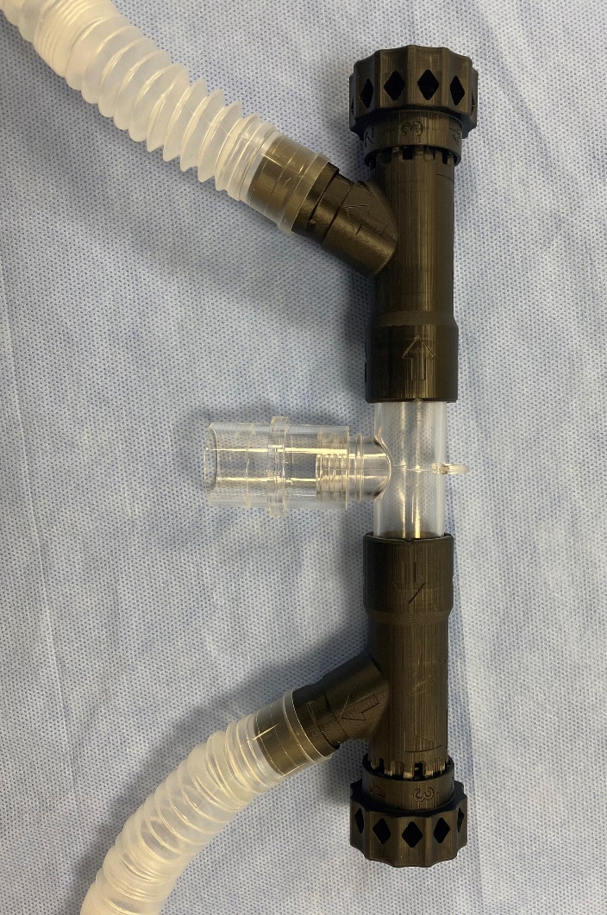
Figure 2: BIPAP machine converted to invasive ventilator. Viral filters have been placed at the machine outlet as well as at the expiratory outlet and just proximal to the endotracheal tube. Yellow spirometry tubing with gas analysis has been inserted to monitor tidal volumes and end tidal CO2.
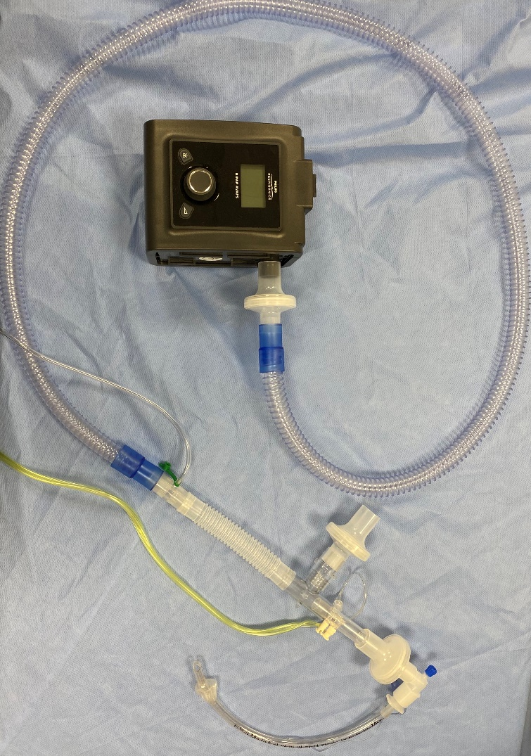

References:
1. Levin MA, Shah A, Shah R, et al. Differential Ventilation Using Flow Control Valves as a Potential Bridge to Full Ventilatory Support during the COVID-19 Crisis: From Bench to Bedside. Anesthesiology 2020; 133: 892–904
2. Copeland D, Wang J, Poor H, et al. Repurposing bi-level ventilators for use with intubated patients while minimizing risk to health care workers during insufficient supply of conventional ventilation for patients with COVID-19. Web site. Available from: http://researchroadmap.mssm.edu/wp-content/uploads/2020/04/Home-Bi-level-to-Vent-Modification-Protocol-v2.1.pdf Accessed September 8 2020.

