Supplementary file 6 Impact of patient and treatment related factors on PFR

Figure SF6. Impact of patient and treatment related factors on PFR.
95% confidence intervals are shown. The dashed line represents the border for clinically relevant improvements.
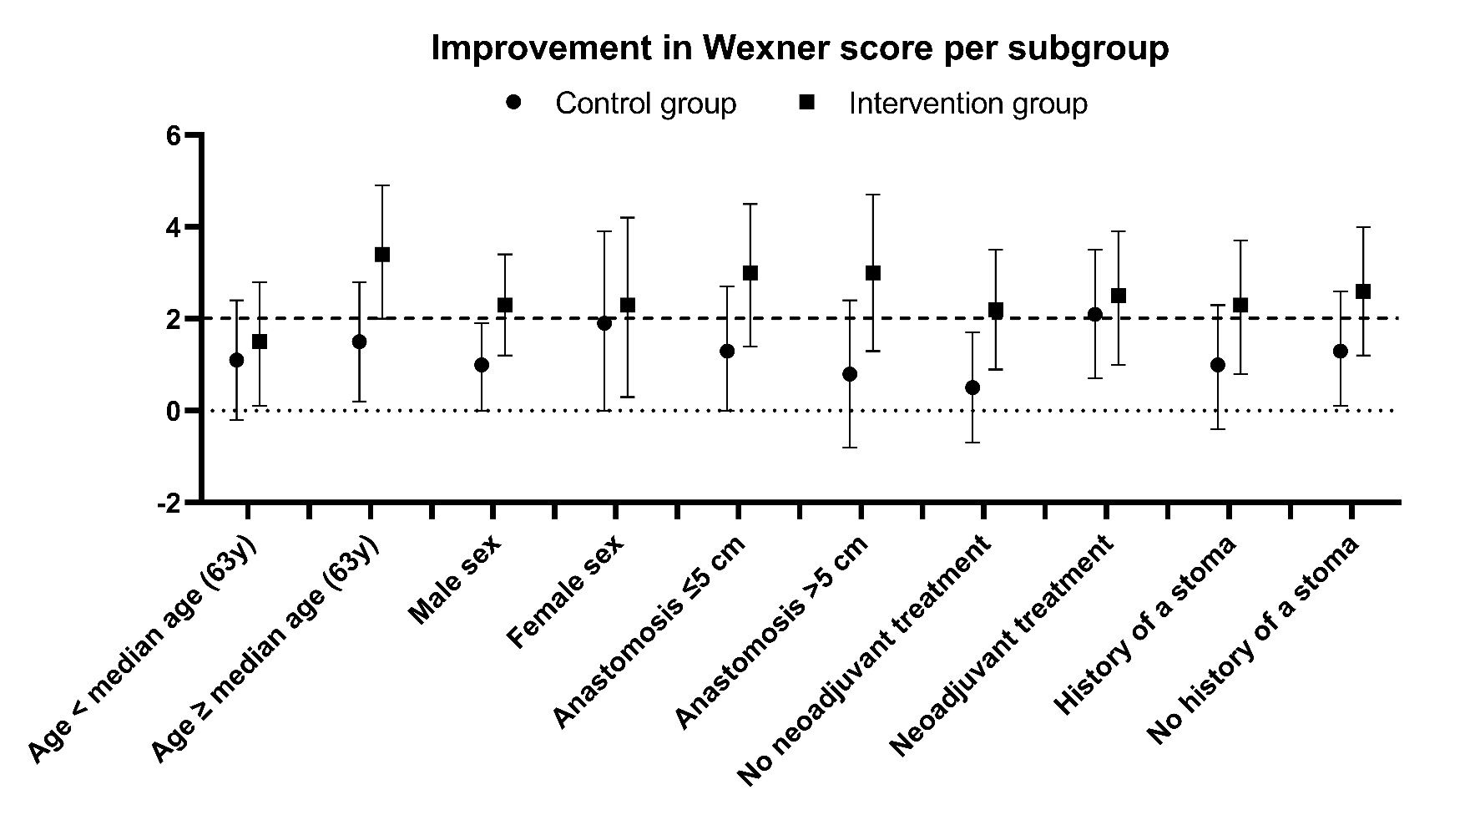

Table SF6. Impact of patient and treatment related factors on PFR.
Outcome measure | Subgroup | Intention to treat
 |  | Control group | PFR group | p value
Selection on age
Adjusted mean difference (M3-M2) * | Age<63 year | -1·1  95% CI -2·4 to 0·2  n=27 | -1·5  95% CI -2·8 to -0·1  n=25 | 0·66
 | Age≥63 year | -1·5  95% CI -2·8 to -0·2  n=24 | -3·4  95% CI -4·9 to -2·0  n=19 | 0·060
Selection on sex
Adjusted mean difference (M3-M2) * | Men | -1·0  95% CI -1·9 to 0·0  n=33 | -2·3  95% CI -3·4 to -1·2  n=26 | 0·07
 | Women | -1·9  95% CI -3·9 to 0·0  n=18 | -2·3  95% CI -4·2 to -0·3  n=18 | 0·81
Selection on administration of neoadjuvant treatment
Adjusted mean difference (M3-M2) * | No neoadjuvant treatment | -0·5  95% CI -1·7 to 0·7  n=27 | -2·2  95% CI -3·5 to -0·9  n=22 | 0·07
 | Received neoadjuvant treatment | -2·1  95% CI -3·5 to -0·7  n=24 | -2·5  95% CI -3·9 to -1·0  n=22 | 0·74
Selection on height of the anastomosis
Adjusted mean difference (M3-M2) * | Anastomosis height not reported # | -1·0  95% CI -2·5 to 0·6  n=12 | -1·4  95% CI -3·1 to 0·2  n=11 | 0·70
 | Anastomosis ≤5 cm from anal verge | -1·3  95% CI -2·7 to 0·0  n=20 | -3·0  95% CI -4·5 to -1·4  n=16 | 0·13
 | Anastomosis >5 cm from anal verge | -0·8  95% CI -2·4 to 0·8  n=19 | -3·0  95% CI -4·7 to -1·3  n=17 | 0·08
Selection on history of a deviating stoma
Adjusted mean difference (M3-M2) * | No history of a stoma | -1·3  95% CI -2·6 to -0·1  n=28 | -2·6  95% CI -4·0 to -1·2  n=23 | 0·20
 | History of a stoma | -1·0  95% CI -2·3 to 0·4  n=23 | -2·3  95% CI -3·7 to -0·8  n=21 | 0·21

* ANCOVA with mean change in Wexner incontinence score (M3-M2) adjusted for age, preoperatively assessed tumor height, neoadjuvant treatment and Wexner baseline score.
# Mean preoperative tumor height of these groups was 10·3 (SD 3·1) for the control group and 7·4 (SD 3·2) for the PFR group (measured by MRI, if not available by scopy, n=1).

