Online Supplements
This document contains the following figures, tables and miscellaneous supplemental materials:
- Supplemental Figure 1. Risk of bias assessment for randomized studies (RoB2, top) and non-randomized comparative studies (ROBINS-I, bottom)
- Supplemental Figure 2. Funnel plots
- Supplemental Figure 3. Surgical site infection after retro-rectus mesh repair versus onlay mesh repair
- Supplemental Figure 4. Seroma after retro-rectus mesh repair versus onlay mesh repair
- Supplemental Figure 5. Surgical site infection after retro-rectus mesh repair versus intraperitoneal onlay mesh repair
- Supplemental Figure 6. Seroma after retro-rectus mesh repair versus intraperitoneal onlay mesh repair
- Supplemental Figure 7. Recurrence after minimally invasive versus open surgery
- Supplemental Figure 8. Recurrence after lightweight versus heavyweight mesh
- Supplemental Figure 9. Surgical site infection after lightweight versus heavyweight mesh
- Supplemental Figure 10. Seroma after lightweight versus heavyweight mesh
- Supplemental Figure 11. Recurrence after synthetic versus biological mesh
- Supplemental Figure 12. Surgical site infection after sutured versus self-adhering mesh
- Supplemental Figure 13. Seroma after sutured versus self-adhering mesh
- Supplemental Figure 14. Overall recurrence after retro-rectus repair, only including studies that included recurrent incisional hernia patients
- Supplemental Figure 15. Overall surgical site infection after retro-rectus repair, only including studies that included recurrent incisional hernia patients
- Supplemental Figure 16. Overall seroma after retro-rectus repair, only including studies that included recurrent incisional hernia patients
- Supplemental Figure 17. Overall outcomes after retro-rectus mesh repair, randomized controlled trials and prospective cohort studies only
- Supplemental Figure 18. Overall outcomes after retro-rectus mesh repair, randomized controlled trials only
- Supplemental Figure 19. Overall recurrence after a minimum follow-up of 12 months after retro-rectus repair, all study types
- Supplemental Figure 20. Overall recurrence after a minimum follow-up of 24 months after retro-rectus repair, all study types
- Supplemental Figure 21. Overall serious complications after retro-rectus repair, all study types
- Supplemental Figure 22. Overall surgical site infection after retro-rectus repair, all study types
- Supplemental Figure 23. Overall seroma after retro-rectus repair, all study types
- Supplemental Figure 24. Overall mortality after retro-rectus repair, all study types
- Supplemental Figure 25. Overall recurrence after a minimum follow-up of 12 months after minimally invasive retro-rectus repair, all study types
- Supplemental Figure 26. Overall serious complications after minimally invasive retro-rectus repair, all study types
- Supplemental Figure 27. Overall surgical site infection after minimally invasive retro-rectus repair, all study types
- Supplemental Figure 28. Overall recurrence after a minimum follow-up of 12 months after retro-rectus repair, prospective cohorts and randomized controlled trials only
- Supplemental Figure 28. Overall seroma after minimally invasive retro-rectus repair, all study types
- Supplemental Figure 29. Overall recurrence after a minimum follow-up of 12 months after retro-rectus repair, prospective cohorts and randomized controlled trials only
- Supplemental Figure 30. Overall serious complications after retro-rectus repair, prospective cohorts and randomized controlled trials only
- Supplemental Figure 31. Overall mortality after retro-rectus repair, prospective cohorts and randomized controlled trials only
- Supplemental Figure 32. Overall seroma after retro-rectus repair, prospective cohorts and randomized controlled trials only
- Supplemental Figure 33. Overall surgical site infection after retro-rectus repair, prospective cohorts and randomized controlled trials only
- Supplemental Figure 34. Overall recurrence after a minimum of 12 months follow-up after retro-rectus repair, randomized controlled trials only
- Supplemental Figure 35. Overall serious complications after retro-rectus repair, randomized controlled trials only
- Supplemental Figure 36. Overall seroma after retro-rectus repair, randomized controlled trials only
- Supplemental Figure 37. Overall surgical site infection after retro-rectus repair, randomized controlled trials only
- Search syntax
- Table 1. Baseline characteristics for all included comparative studies
- Table 2. Baseline characteristics for all included non-comparative studies

Supplemental Figure 1. Risk of bias assessment for randomized studies (RoB2, top) and non-randomized comparative studies (ROBINS-I, bottom)
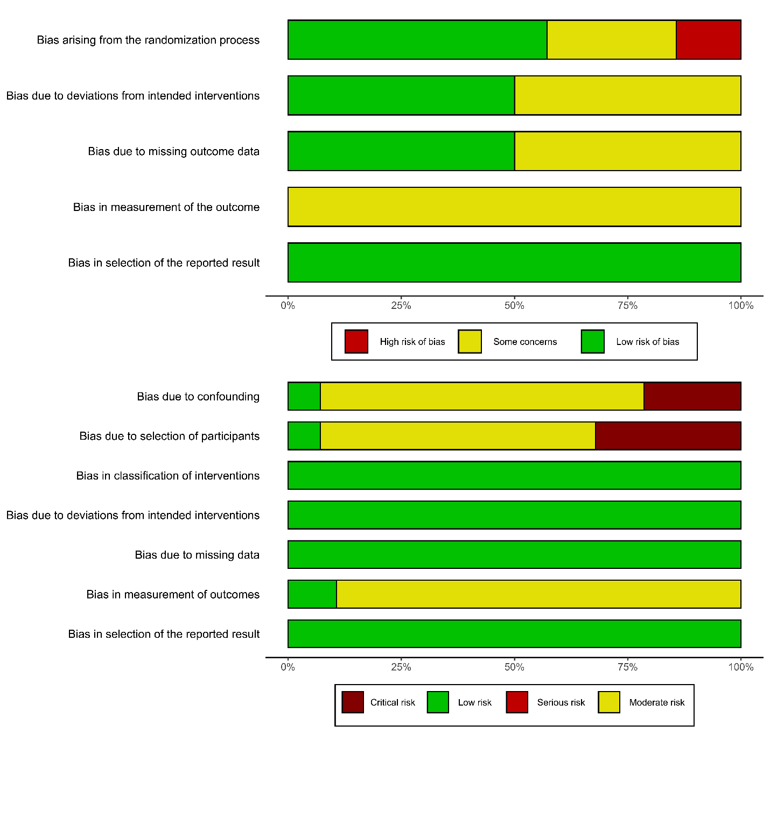

Supplemental Figure 2. Funnel plots
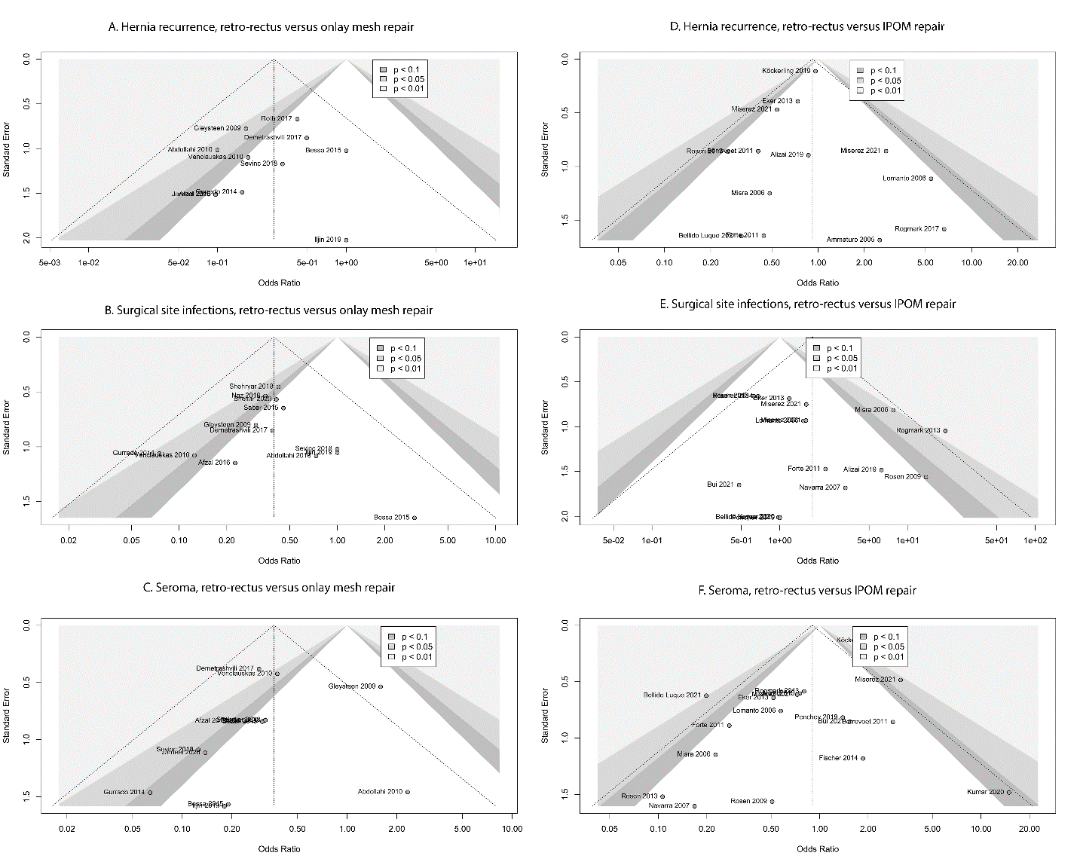
IPOM: intraperitoneal onlay mesh
Supplemental Figure 3. Surgical site infection after retro-rectus mesh repair versus onlay mesh repair
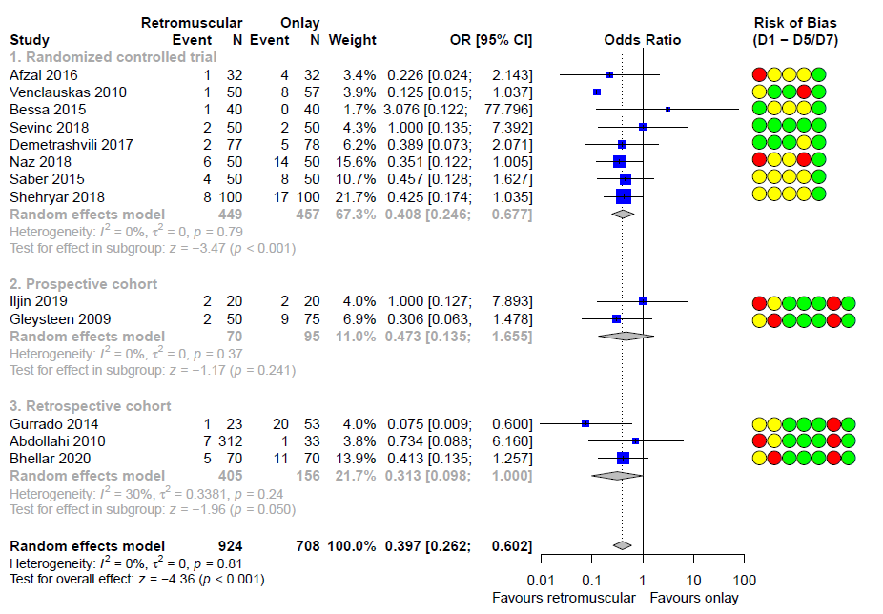
OR: odds ratio. D1 – D5/D7: risk of bias domains
Supplemental Figure 4. Seroma after retro-rectus mesh repair versus onlay mesh repair
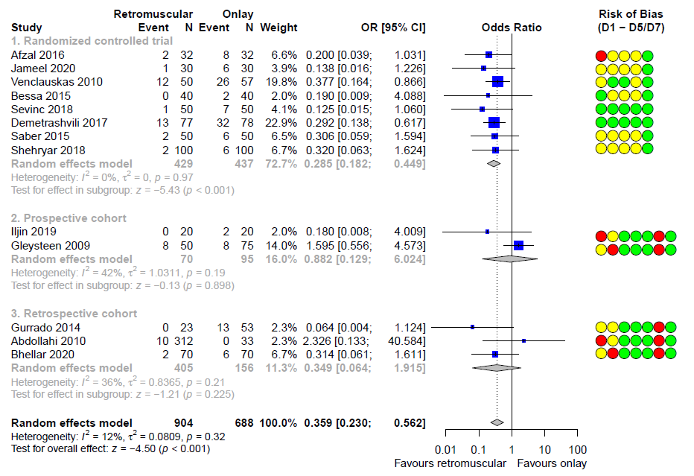
OR: odds ratio. D1 – D5/D7: risk of bias domains
Supplemental Figure 5. Surgical site infection after retro-rectus mesh repair versus intraperitoneal onlay mesh repair
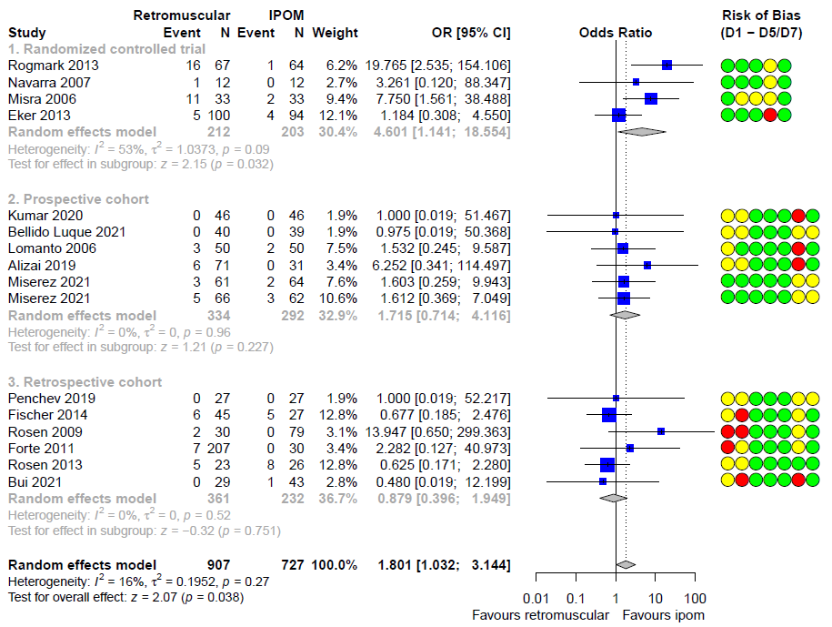
IPOM: intraperitoneal onlay mesh. OR: odds ratio. D1 – D5/D7: risk of bias domains
Supplemental Figure 6. Seroma after retro-rectus mesh repair versus intraperitoneal onlay mesh repair
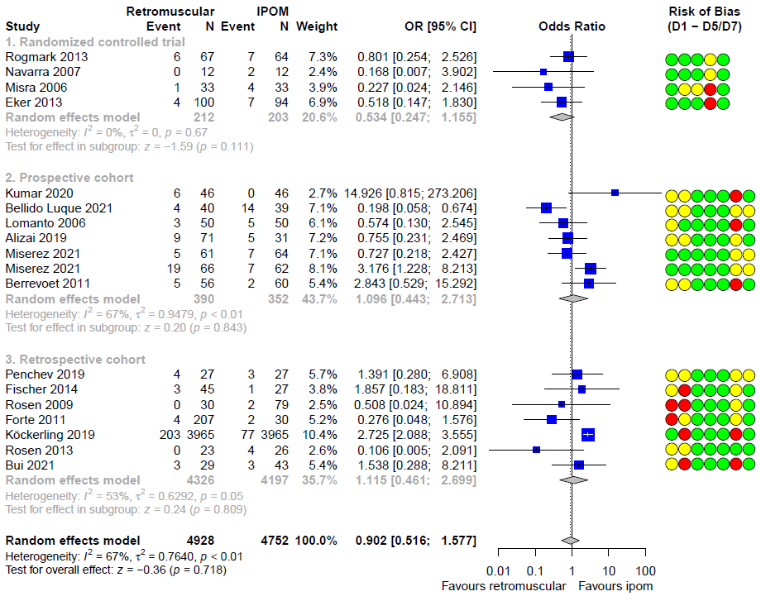
IPOM: intraperitoneal onlay mesh. OR: odds ratio. D1 – D5/D7: risk of bias domains

Supplemental Figure 7. Recurrence after minimally invasive versus open surgery
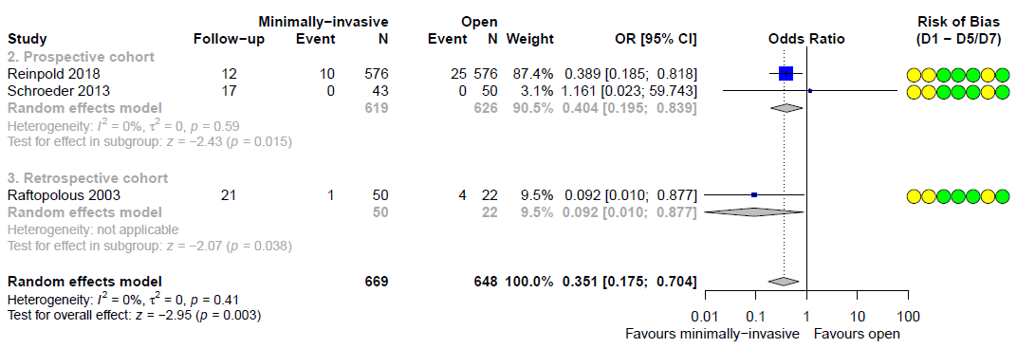
OR: odds ratio. D1 – D5/D7: risk of bias domains

Supplemental Figure 8. Recurrence after lightweight versus heavyweight mesh
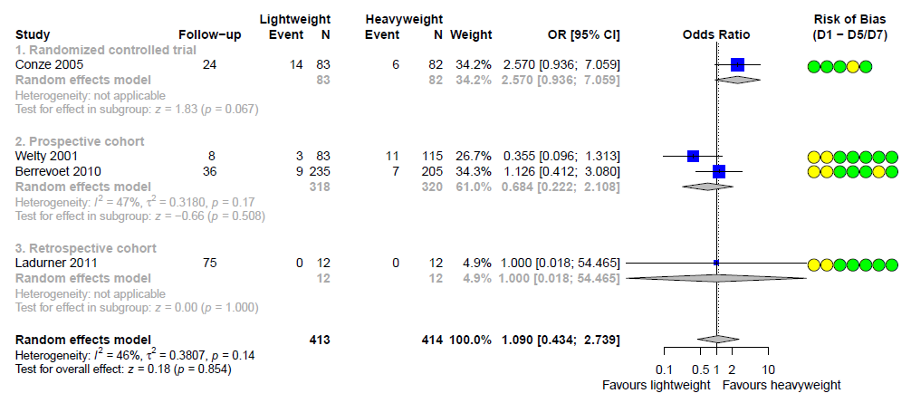
OR: odds ratio. D1 – D5/D7: risk of bias domains

Supplemental Figure 9. Surgical site infection after lightweight versus heavyweight mesh
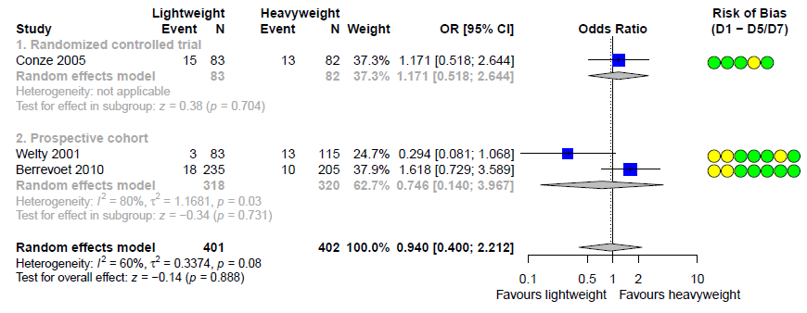
OR: odds ratio. D1 – D5/D7: risk of bias domains

Supplemental Figure 10. Seroma after lightweight versus heavyweight mesh
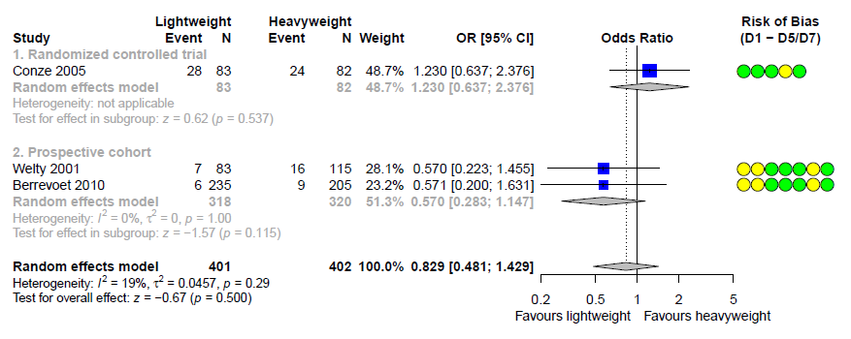
OR: odds ratio. D1 – D5/D7: risk of bias domains

Supplemental Figure 11. Recurrence after synthetic versus biological mesh
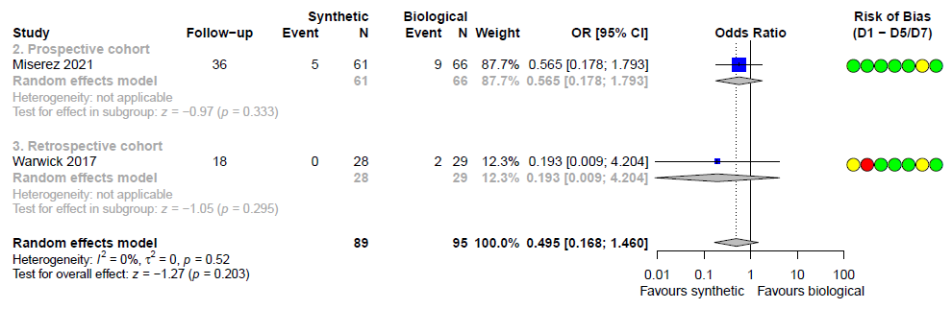
OR: odds ratio. D1 – D5/D7: risk of bias domains

Supplemental Figure 12. Surgical site infection after sutured versus self-adhering mesh
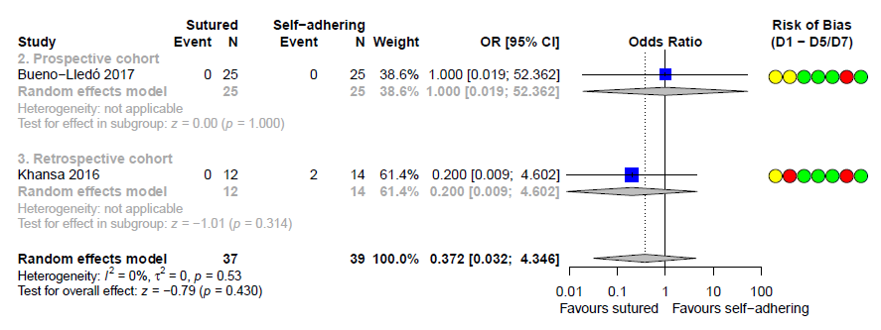
OR: odds ratio. D1 – D5/D7: risk of bias domains

Supplemental Figure 13. Seroma after sutured versus self-adhering mesh
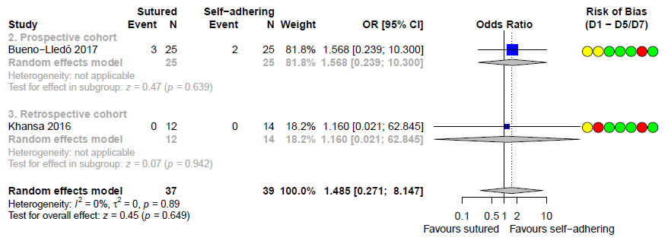
OR: odds ratio. D1 – D5/D7: risk of bias domains

Supplemental Figure 14. Overall recurrence after retro-rectus repair, only including studies that included recurrent incisional hernia patients
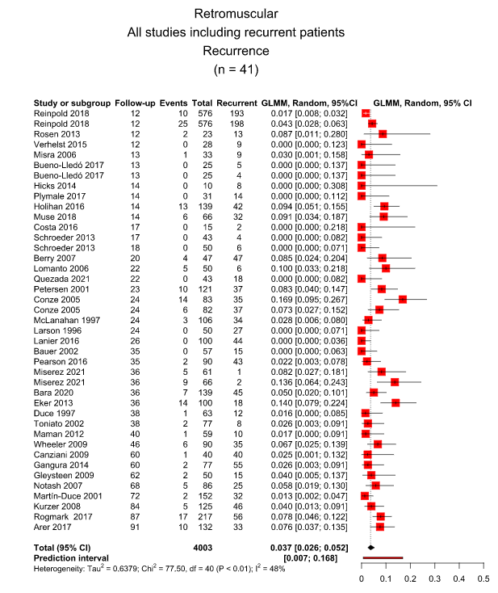

Supplemental Figure 15. Overall surgical site infection after retro-rectus repair, only including studies that included recurrent incisional hernia patients
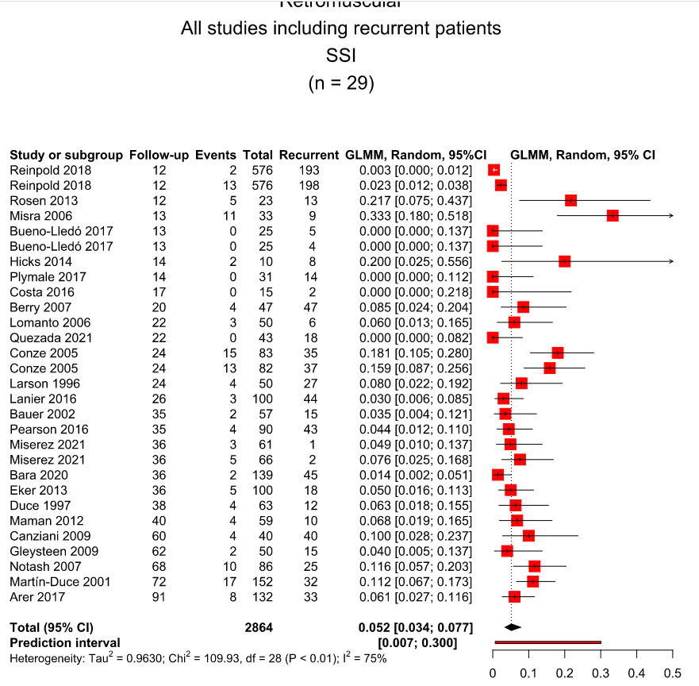

Supplemental Figure 16. Overall seroma after retro-rectus repair, only including studies that included recurrent incisional hernia patients
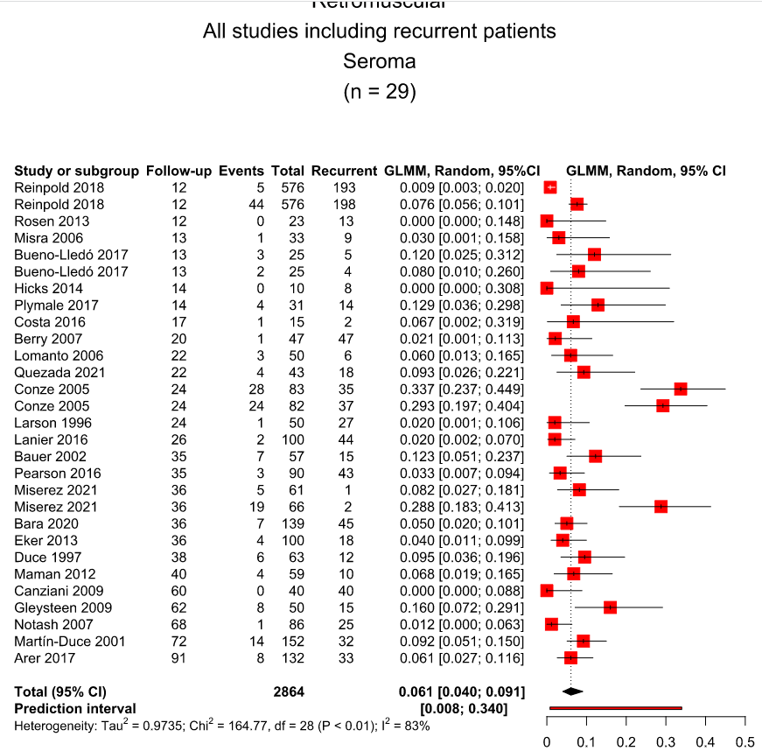

Supplemental Figure 17. Overall outcomes after retro-rectus mesh repair, randomized controlled trials and prospective cohort studies only
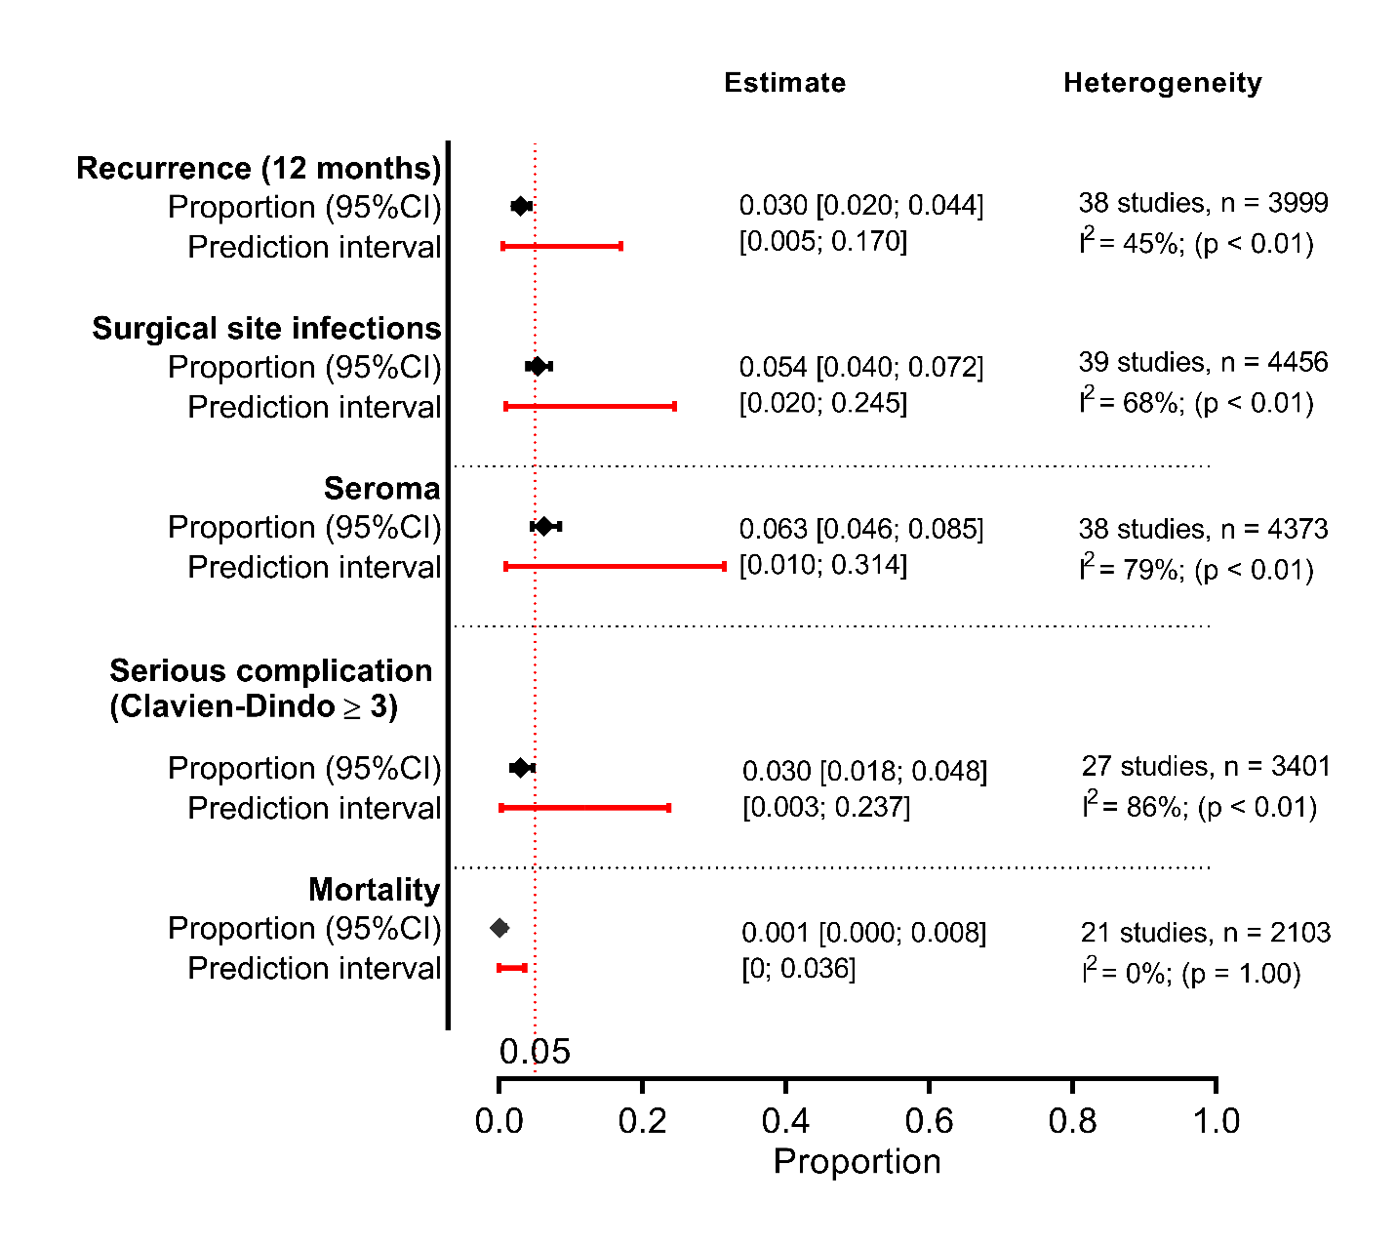
Studies used per outcome:
Recurrence (12 months): (19-21, 23, 25-30, 32-39, 41-46, 48, 50-55, 57, 58, 60-62, 64, 68, 70-78, 80, 82-95, 98-101, 103, 105, 107, 109, 110); Surgical site infection: (21, 22, 25-28, 30, 33, 34, 36, 39, 42-45, 49, 52, 54, 64, 65, 67, 69, 73, 74, 76-78, 84, 89, 95-98, 102, 104-107, 110); Seroma: (21, 22, 25-28, 30, 33, 34, 36, 39, 42, 44, 45, 47, 49, 52, 54, 64, 67, 69, 73, 74, 76-78, 84, 89, 90, 95, 96, 98, 102, 104-107, 110); Serious complication (Clavien-Dindo > 3): (21, 24, 25, 27, 30, 34, 36, 39, 42, 45, 47, 49, 52, 54, 58, 64, 65, 67, 69, 70, 74, 78, 95, 96, 102, 108, 110); Mortality: (21, 24-26, 28, 33, 34, 36, 42, 44, 49, 65, 67, 70, 74, 75, 77, 95, 99, 102, 108)

Complete forest plots for each individual outcome are available in the Online Supplements.
Supplemental Figure 18. Overall outcomes after retro-rectus mesh repair, randomized controlled trials only
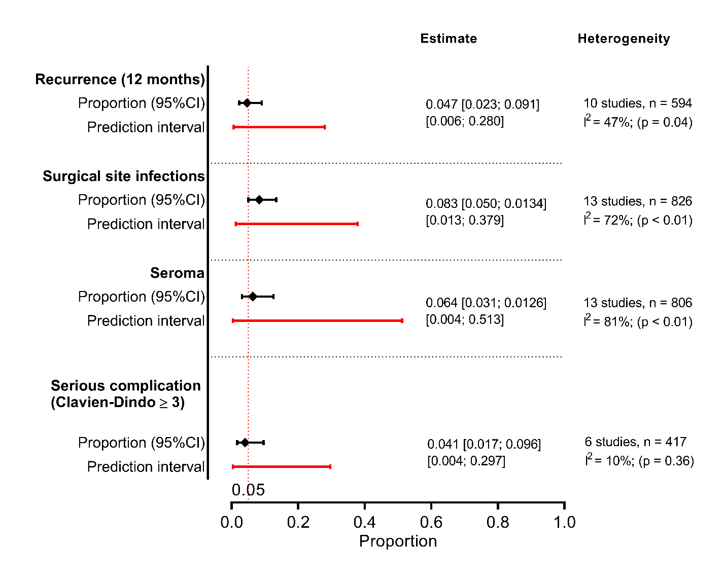
Studies used per outcome:
Recurrence (12 months): (27, 45, 73, 78, 84, 90, 102, 104, 105, 107); Surgical site infection: (27, 30, 45, 73, 78, 84, 96, 97, 102, 104-107); Seroma: (27, 30, 45, 73, 78, 84, 90, 96, 102, 104-107); Serious complication (Clavien-Dindo > 3): (27, 30, 45, 78, 96, 102)

Complete forest plots for each individual outcome are available in the Online Supplements.

Supplemental Figure 19. Overall recurrence after a minimum follow-up of 12 months after retro-rectus repair, all study types
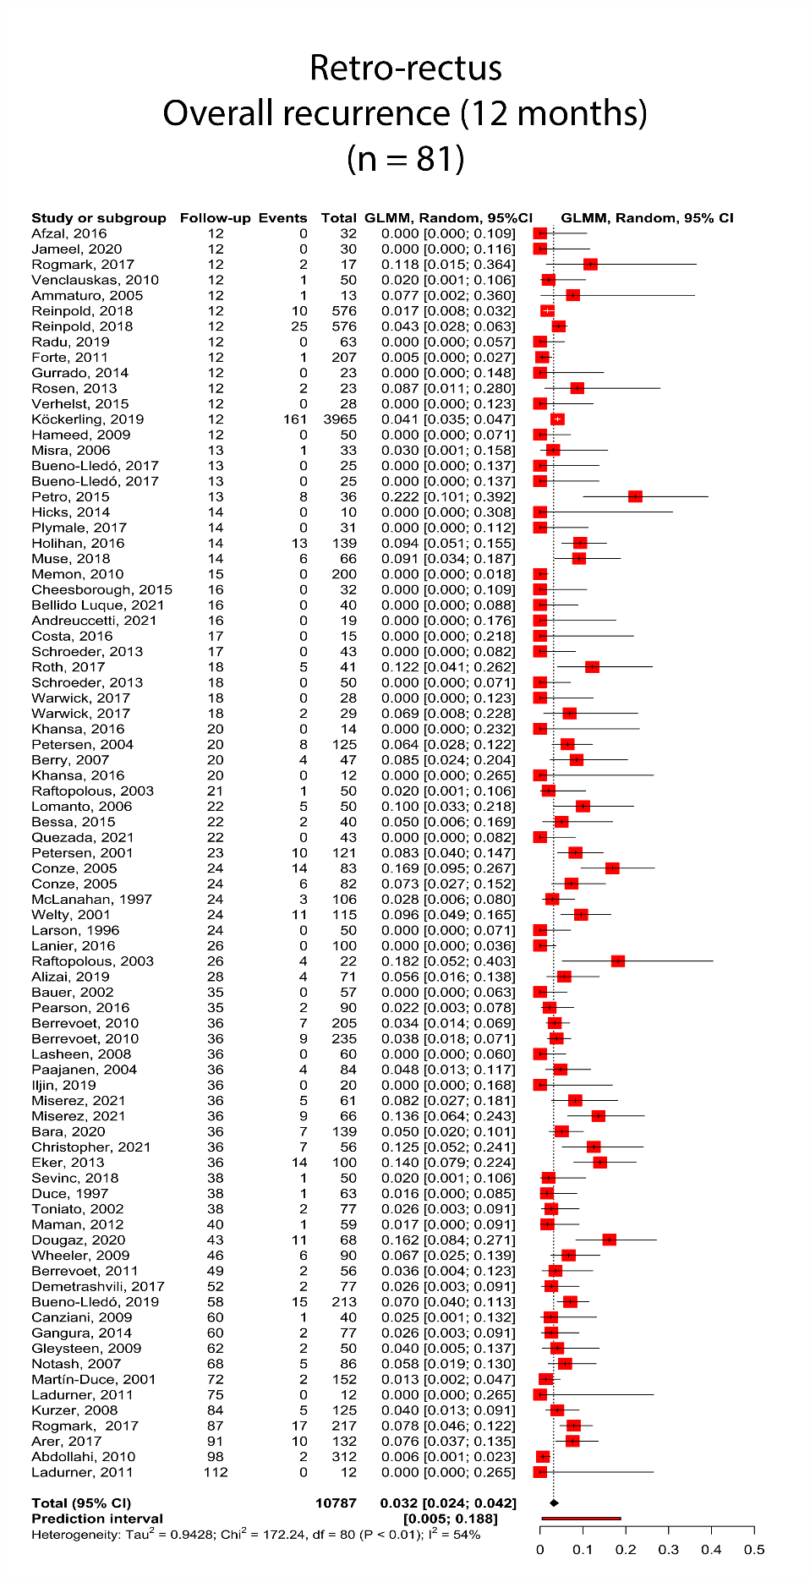
Supplemental Figure 20. Overall recurrence after a minimum follow-up of 24 months after retro-rectus repair, all study types
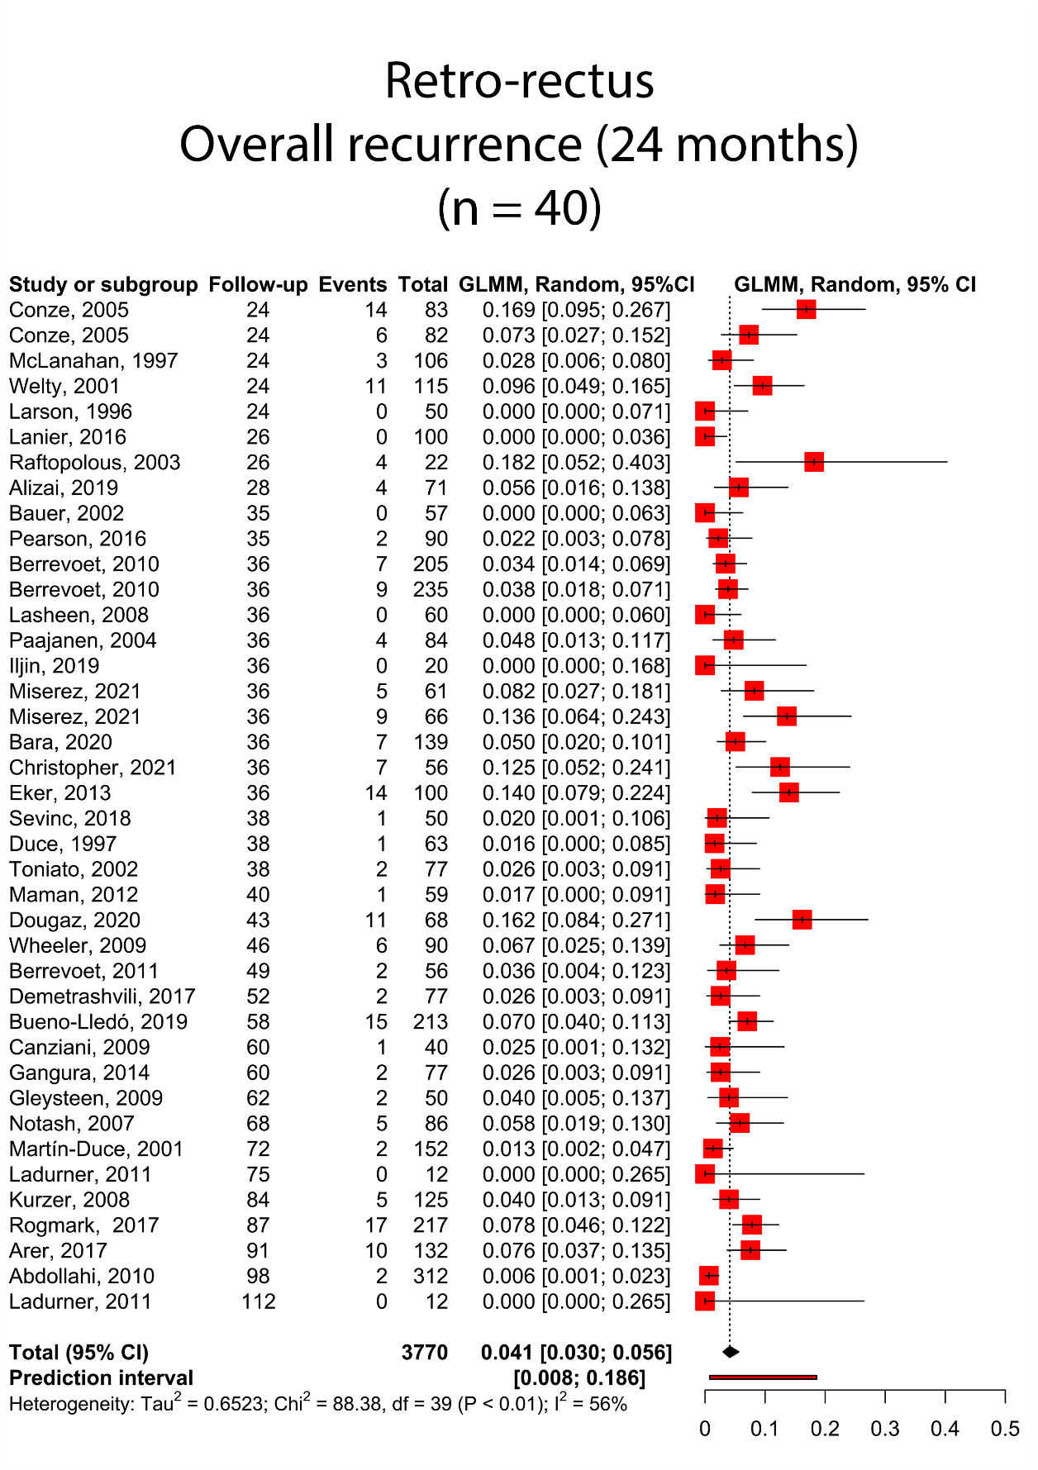

Supplemental Figure 21. Overall serious complications after retro-rectus repair, all study types
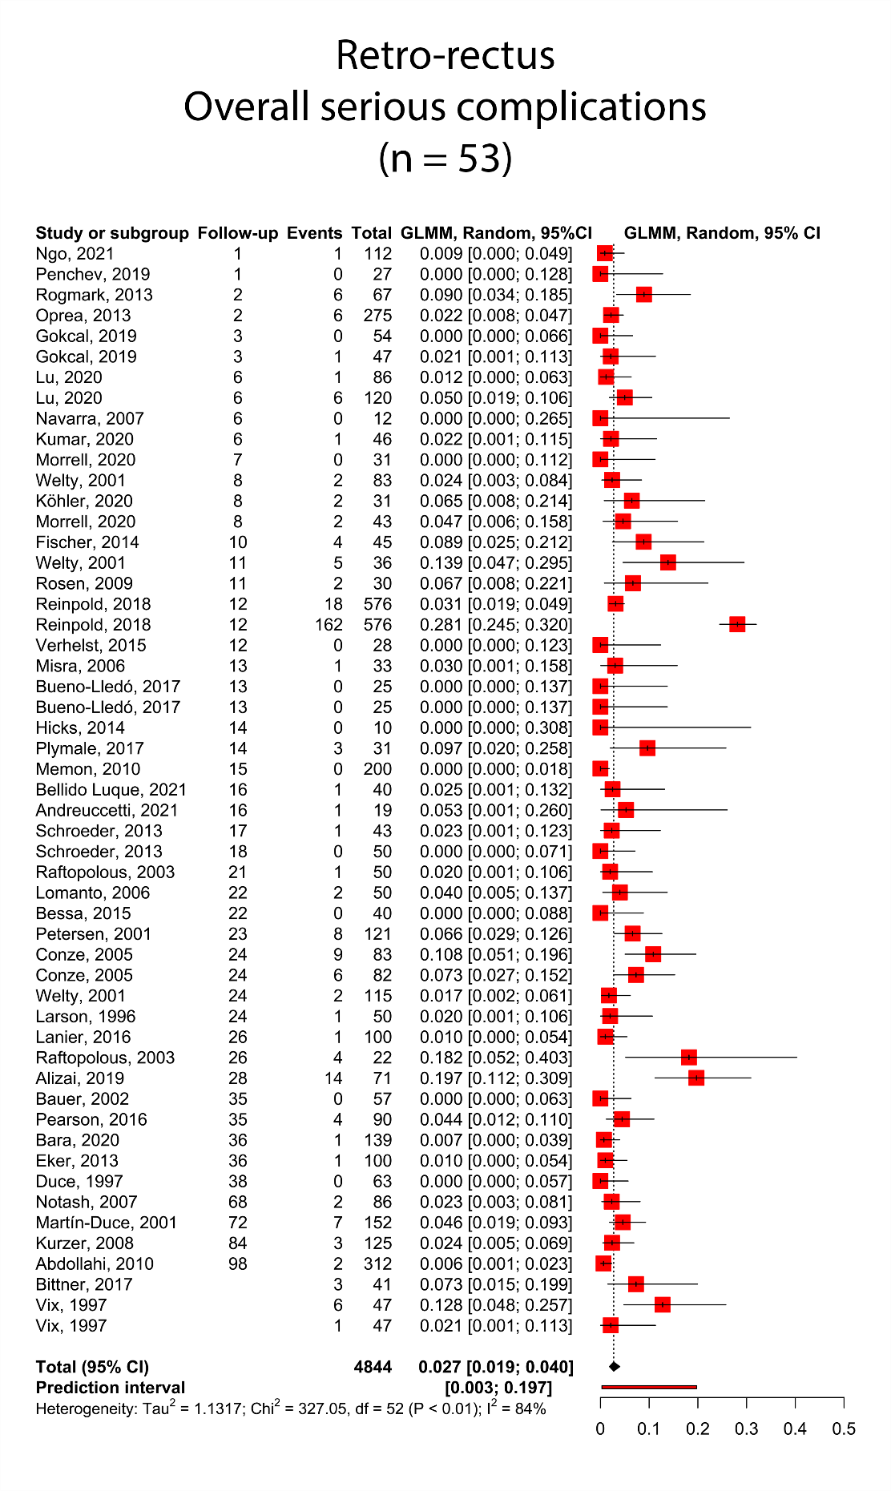
Supplemental Figure 22. Overall surgical site infection after retro-rectus repair, all study types
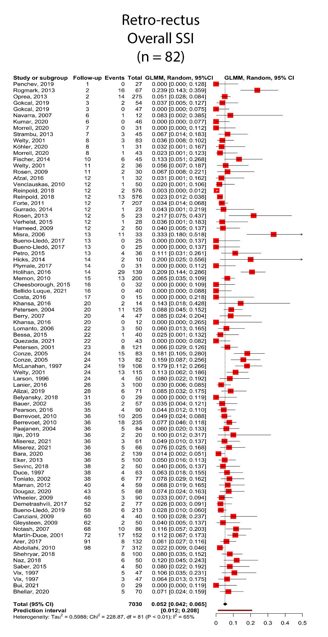
Supplemental Figure 23. Overall seroma after retro-rectus repair, all study types
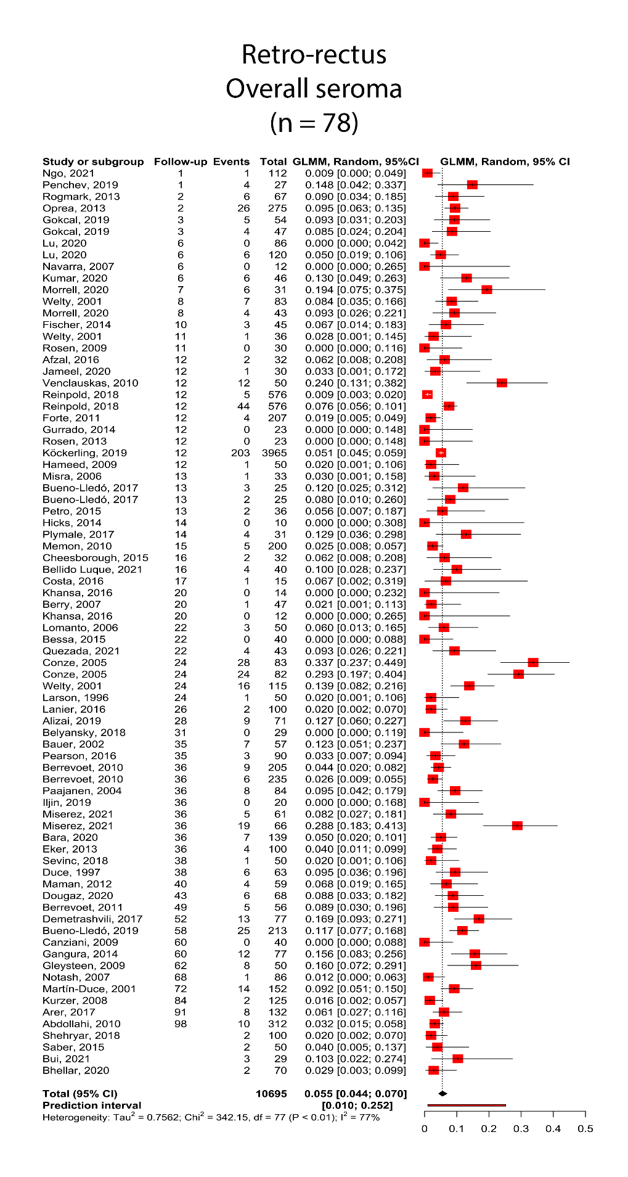
Supplemental Figure 24. Overall mortality after retro-rectus repair, all study types
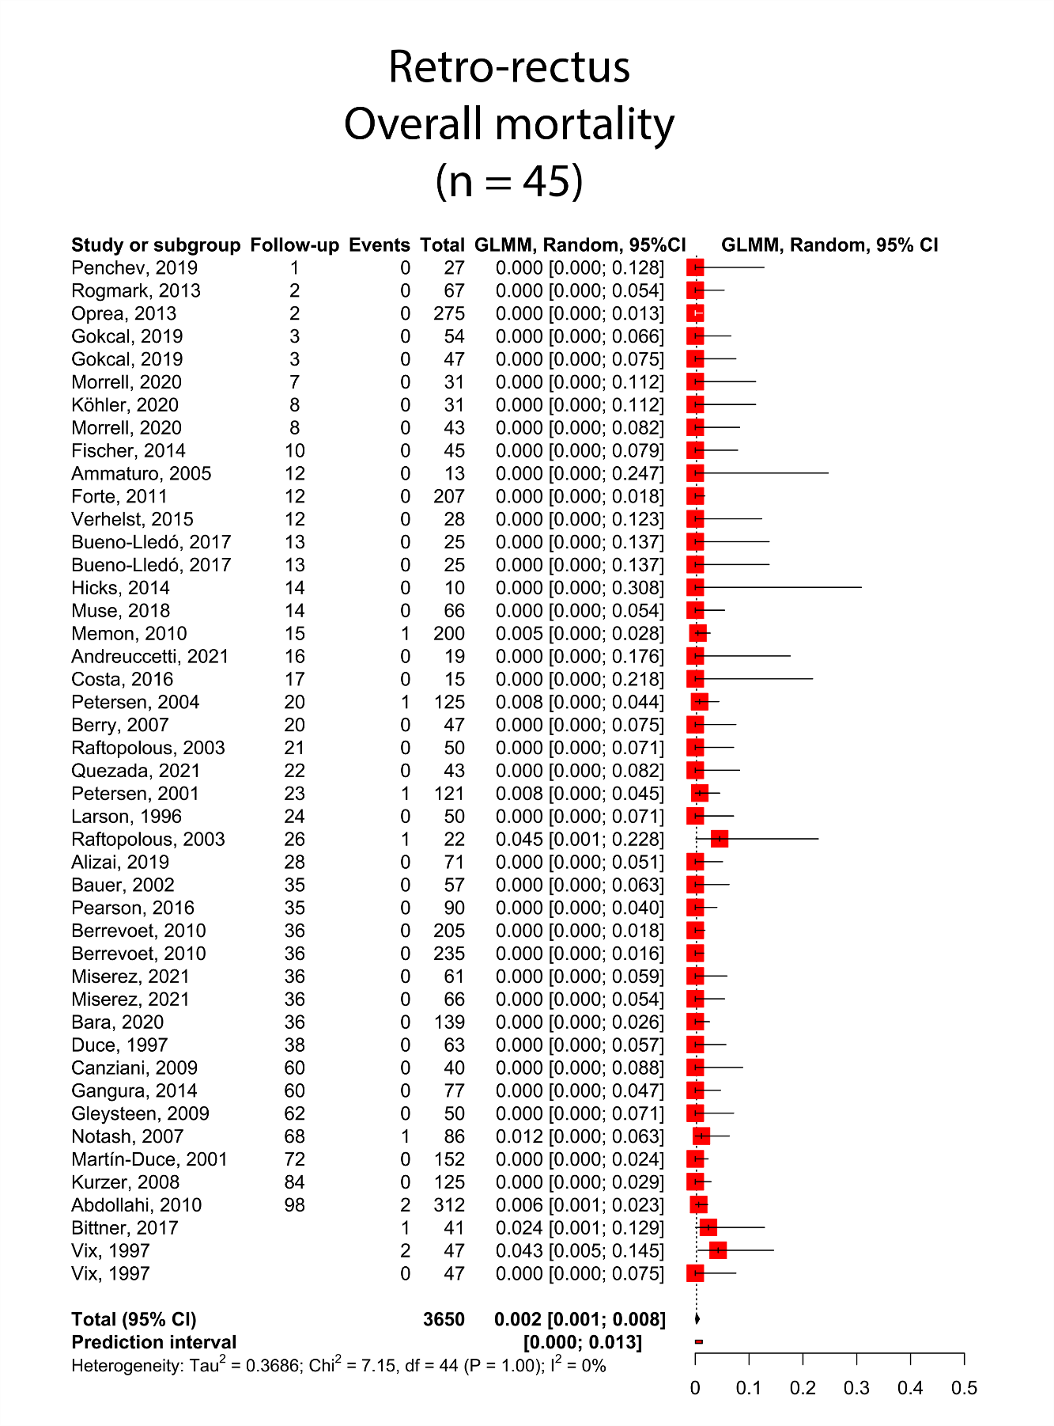

Supplemental Figure 25. Overall recurrence after a minimum follow-up of 12 months after minimally invasive retro-rectus repair, all study types
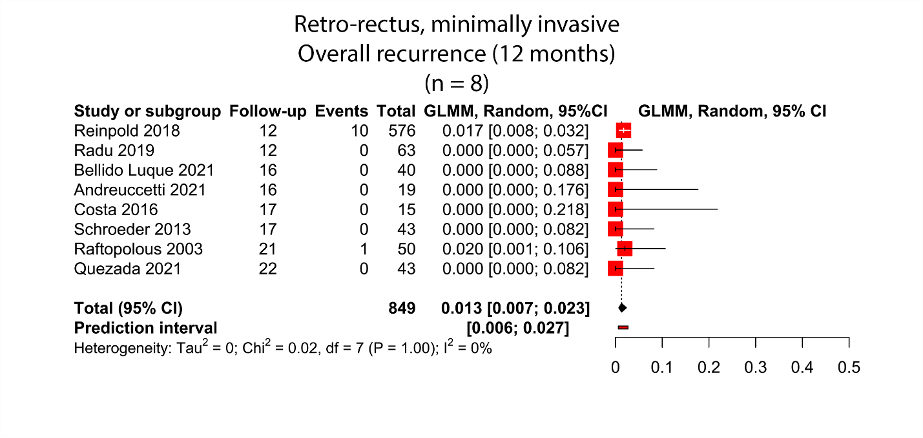
Supplemental Figure 26. Overall serious complications after minimally invasive retro-rectus repair, all study types
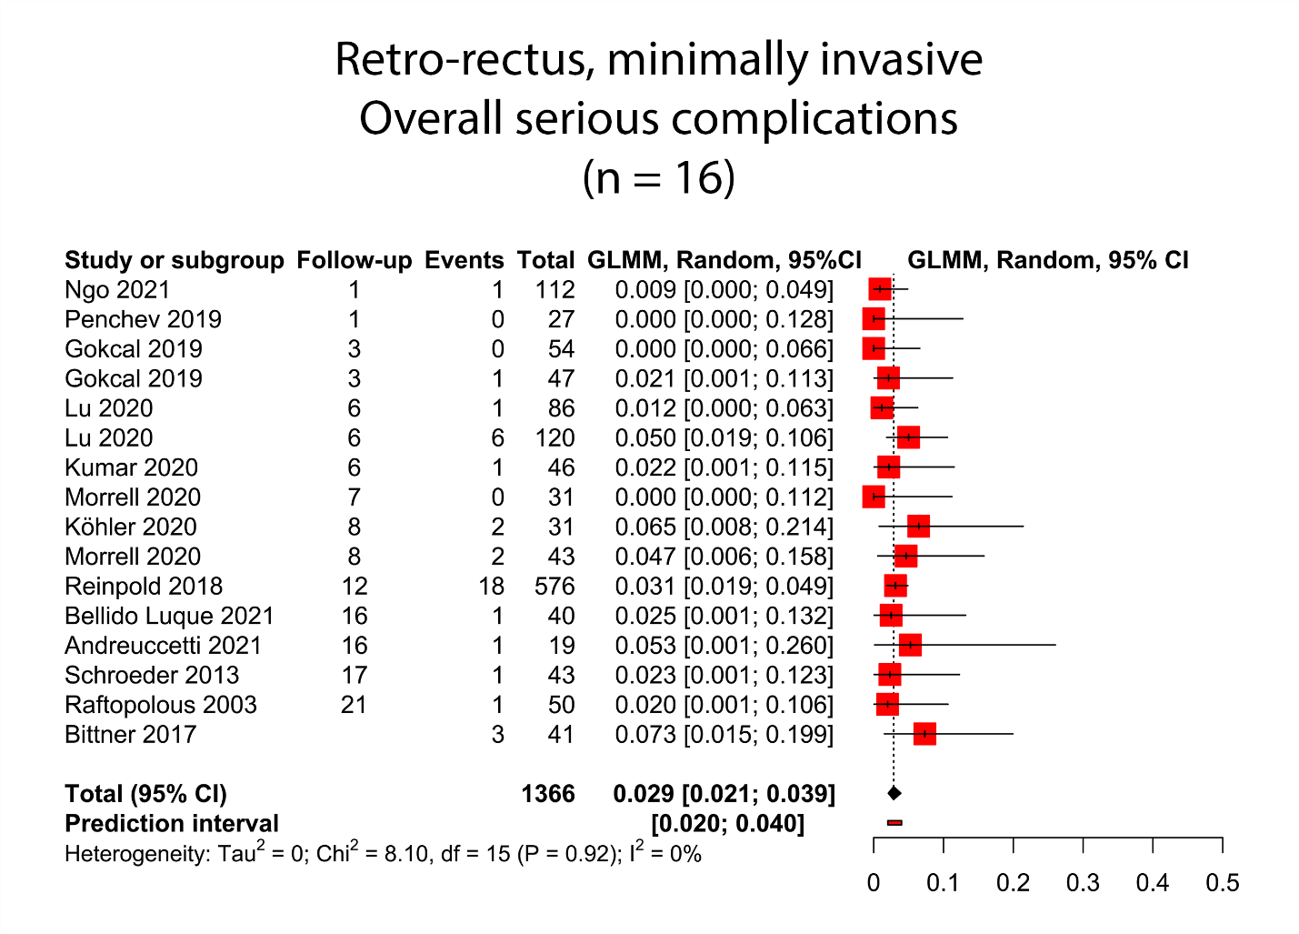

Supplemental Figure 27. Overall surgical site infection after minimally invasive retro-rectus repair, all study types
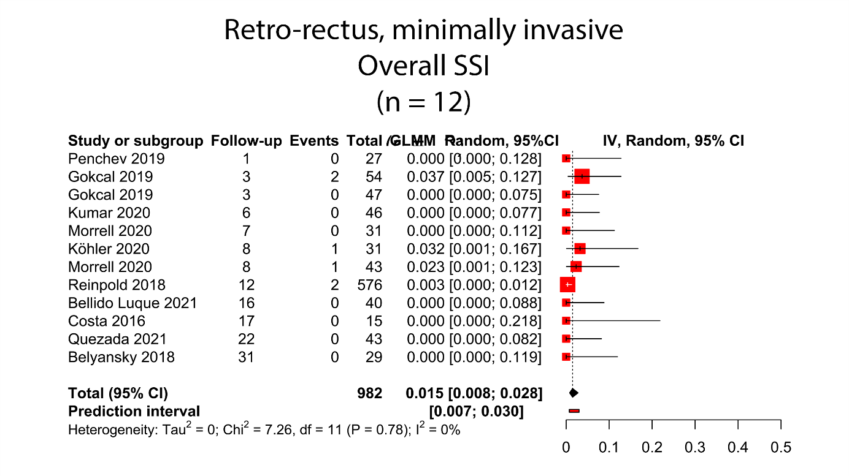
Supplemental Figure 28. Overall seroma after minimally invasive retro-rectus repair, all study types
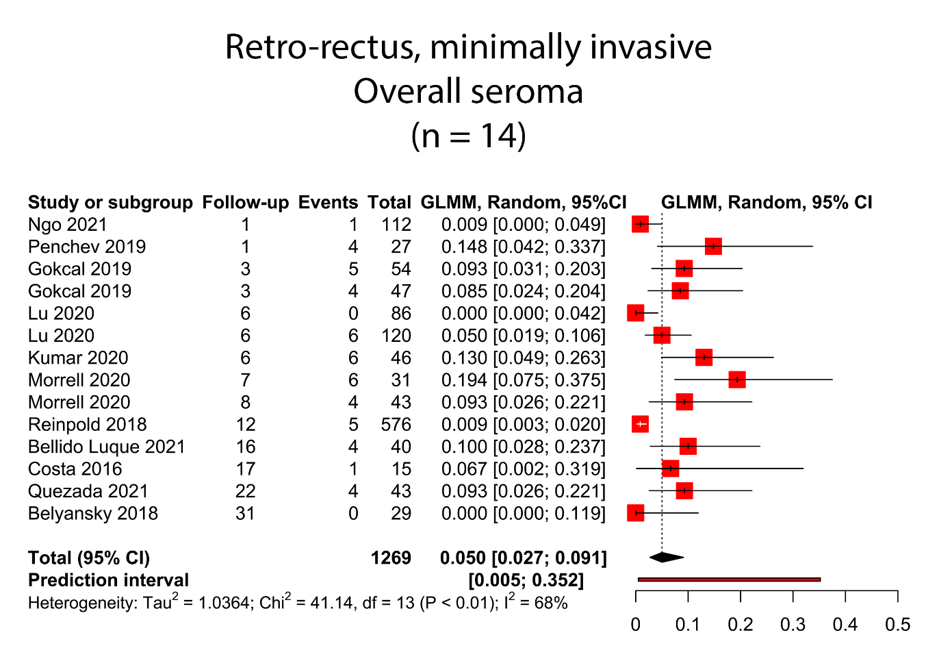
Supplemental Figure 29. Overall recurrence after a minimum follow-up of 12 months after retro-rectus repair, prospective cohorts and randomized controlled trials only
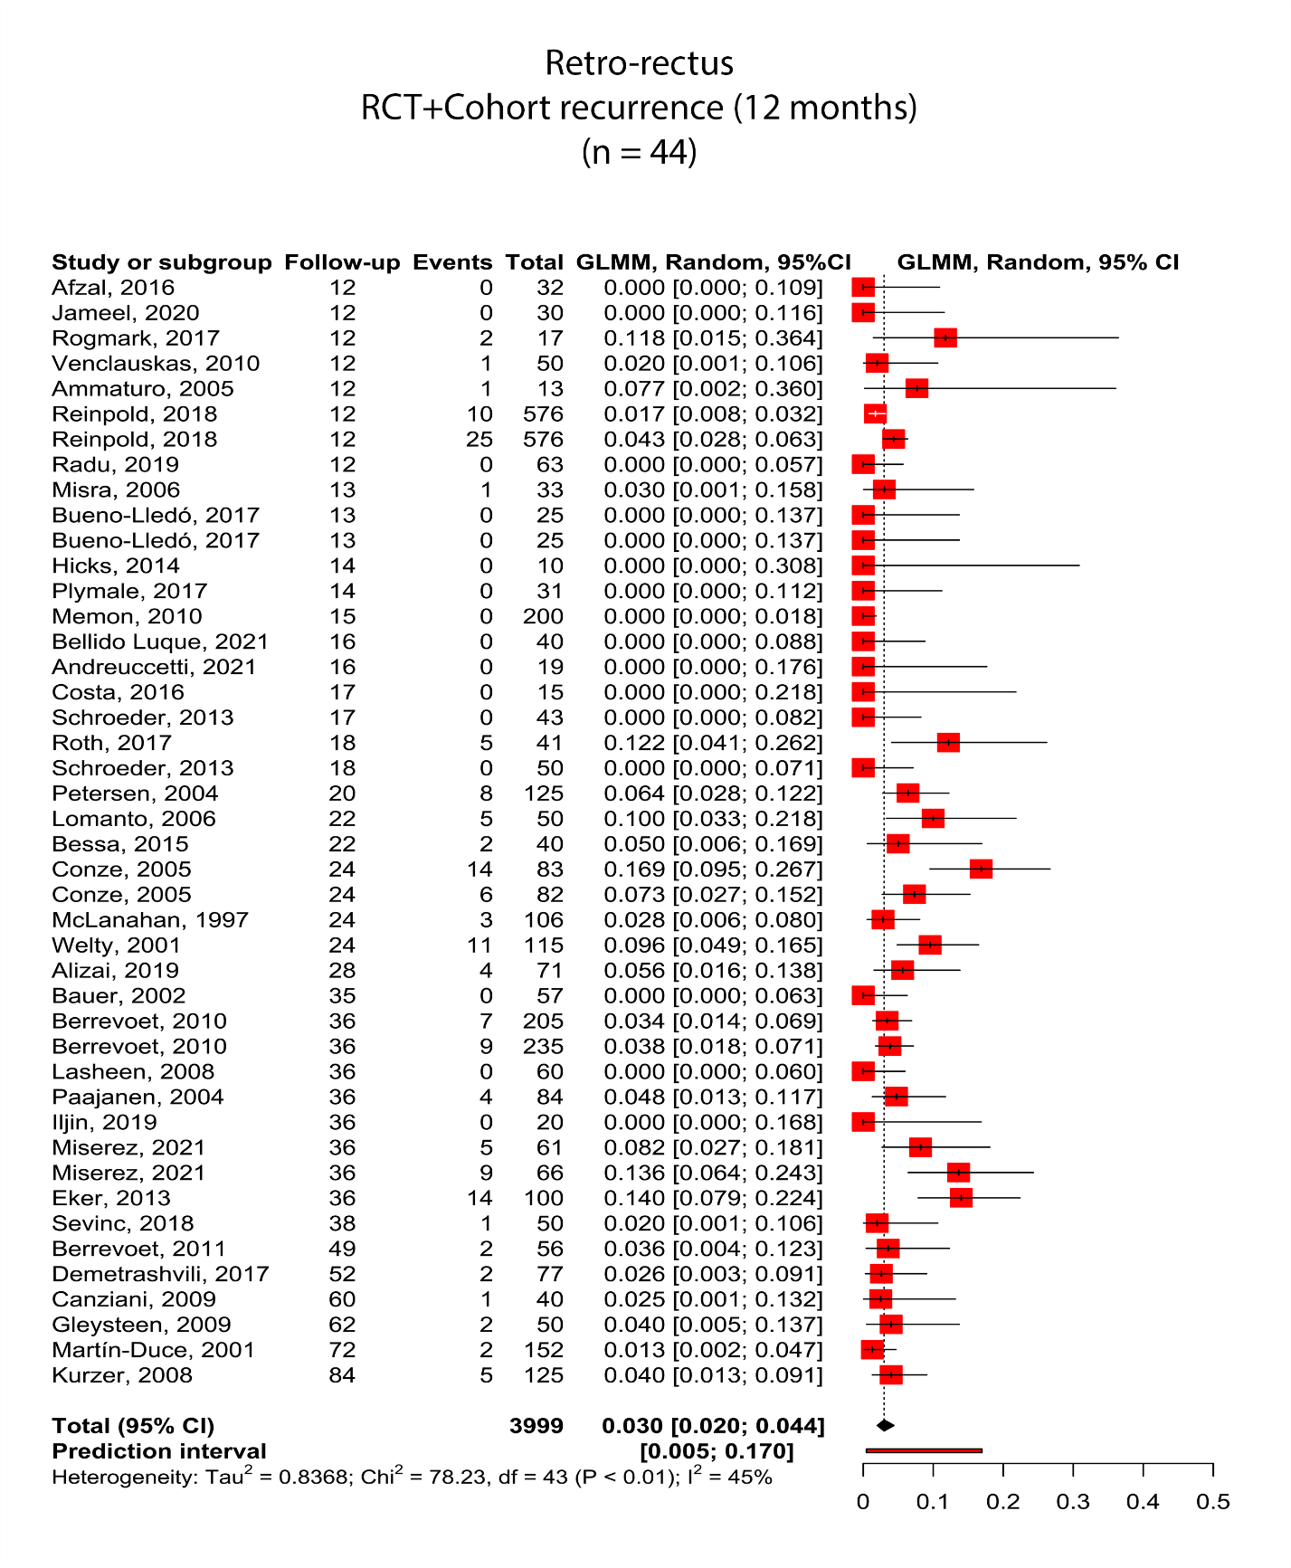

Supplemental Figure 30. Overall serious complications after retro-rectus repair, prospective cohorts and randomized controlled trials only
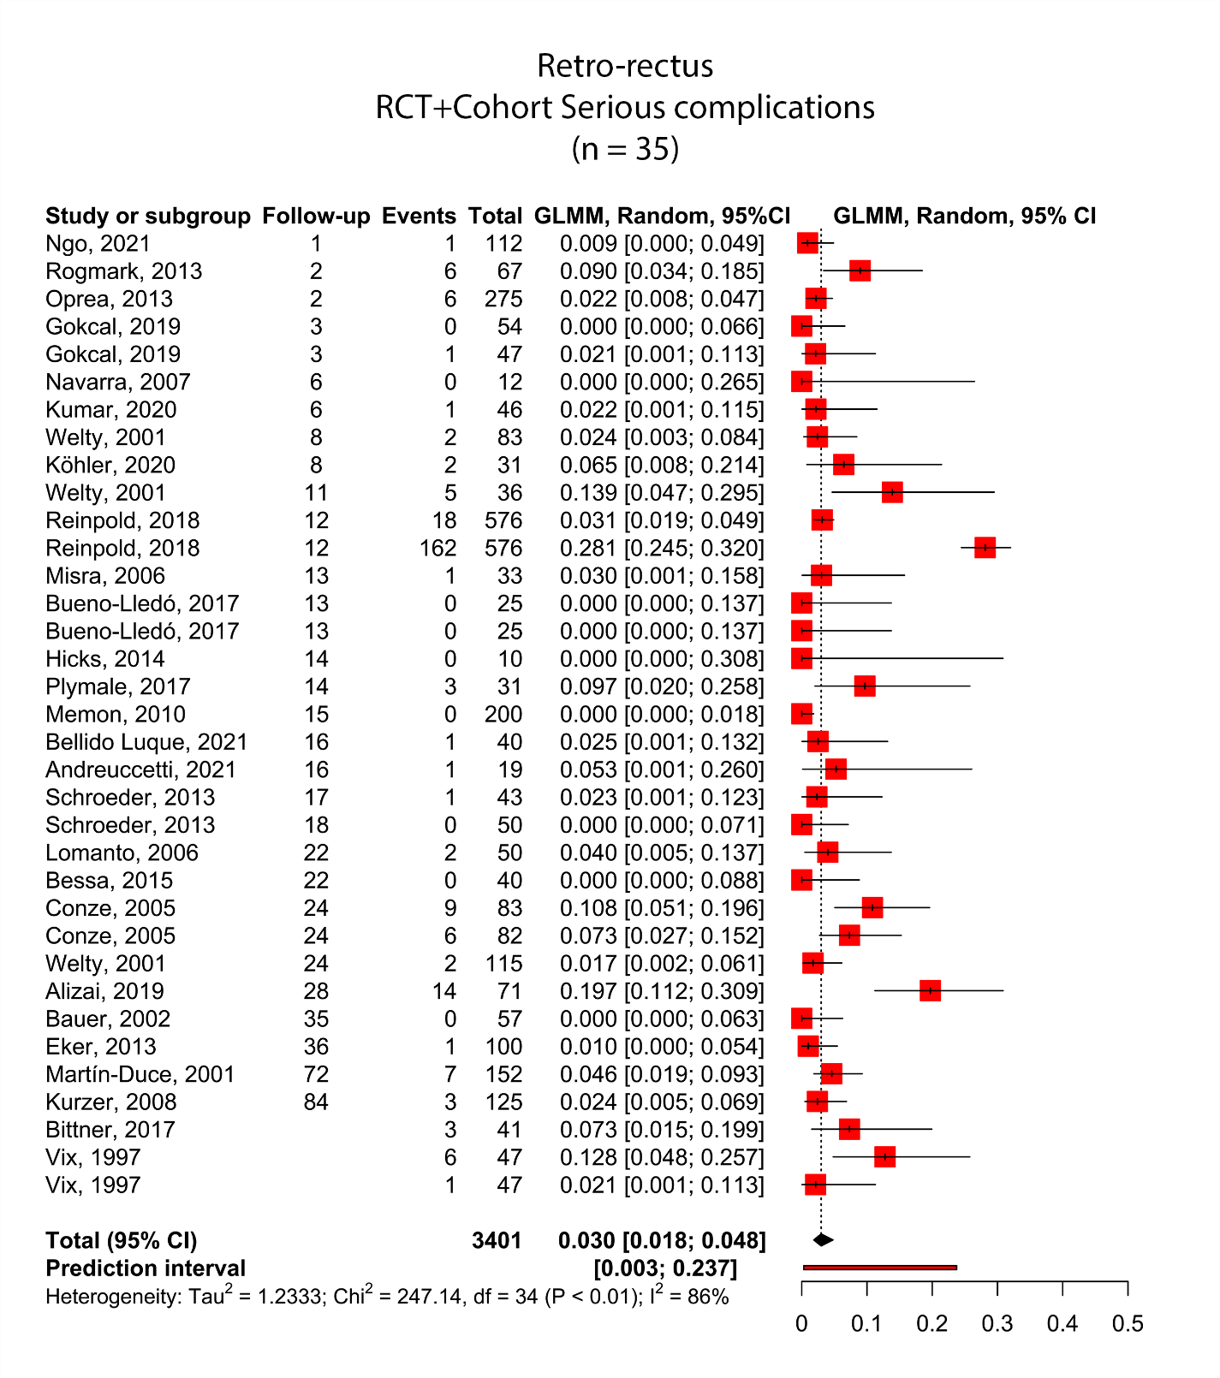

Supplemental Figure 31. Overall mortality after retro-rectus repair, prospective cohorts and randomized controlled trials only
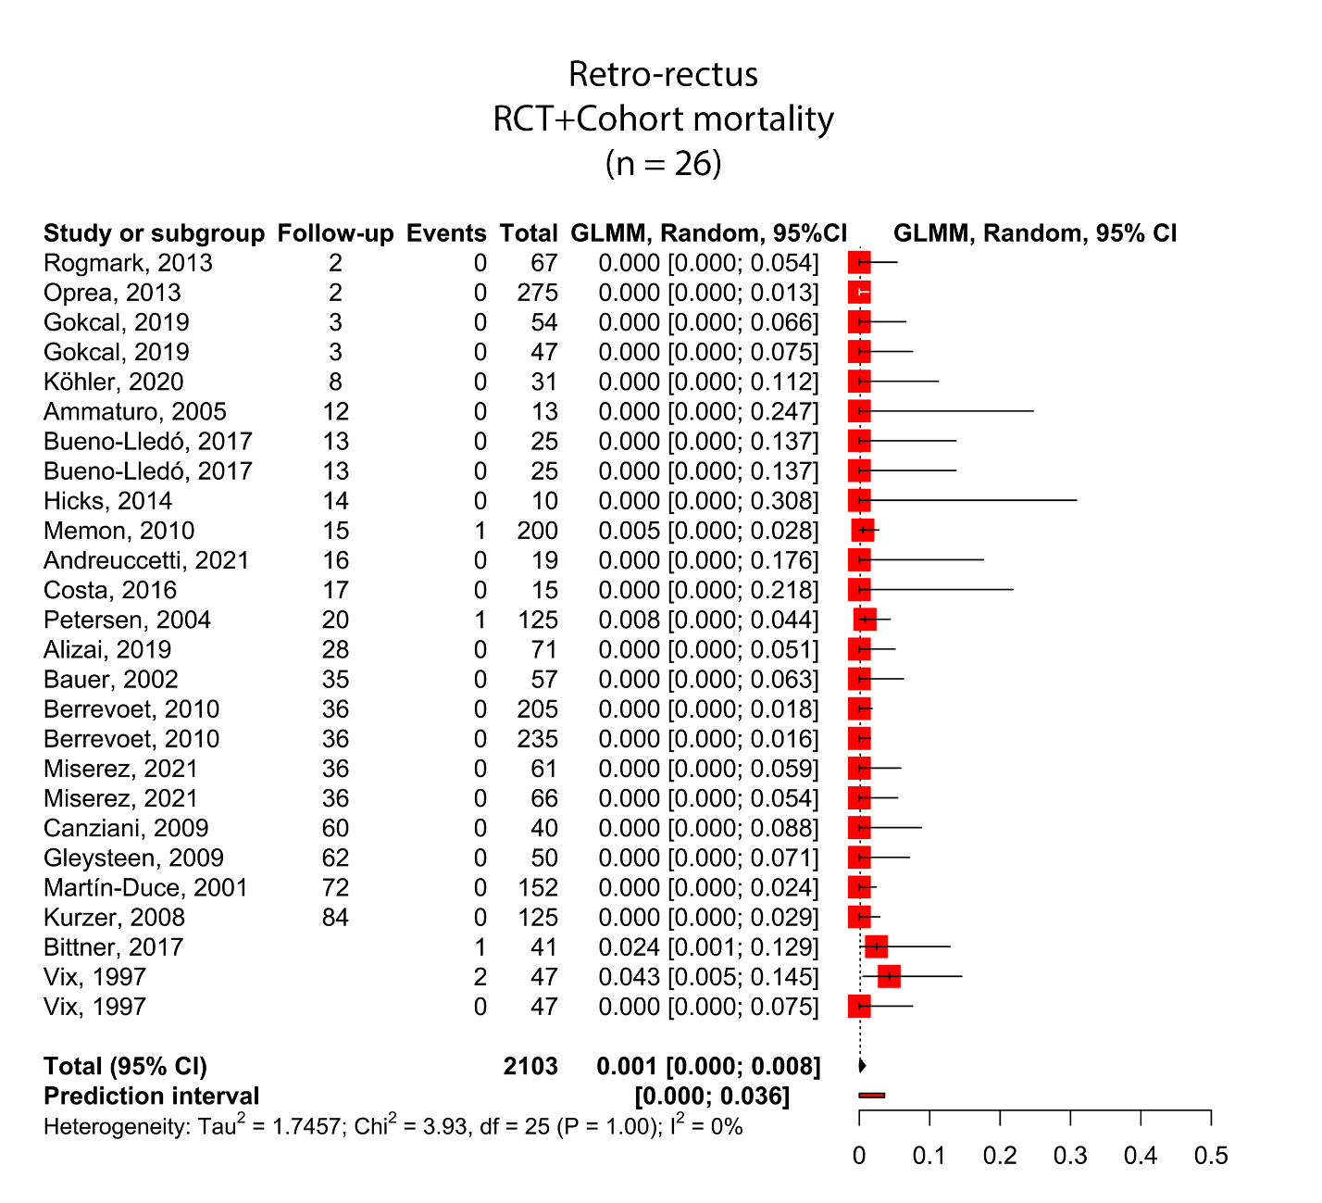

Supplemental Figure 32. Overall seroma after retro-rectus repair, prospective cohorts and randomized controlled trials only
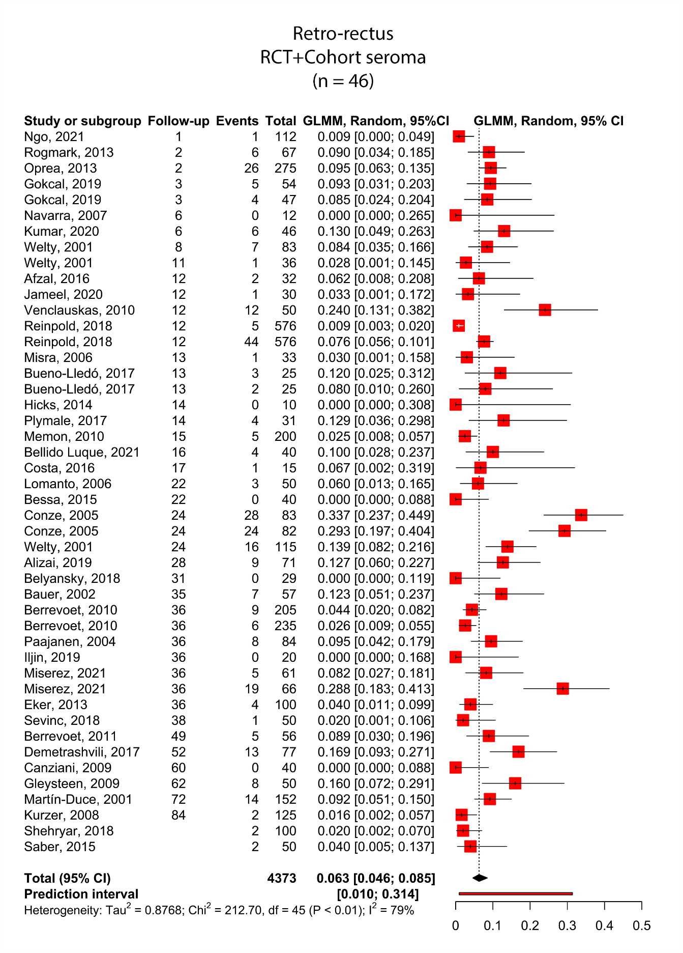
Supplemental Figure 33. Overall surgical site infection after retro-rectus repair, prospective cohorts and randomized controlled trials only
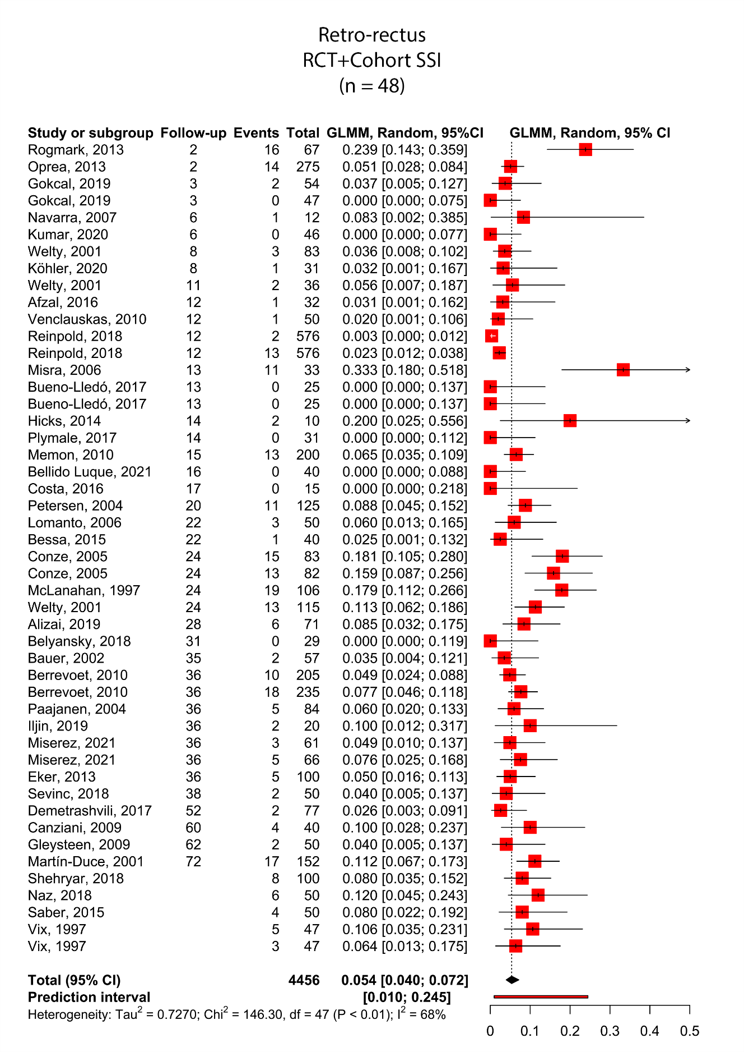
Supplemental Figure 34. Overall recurrence after a minimum of 12 months follow-up after retro-rectus repair, randomized controlled trials only
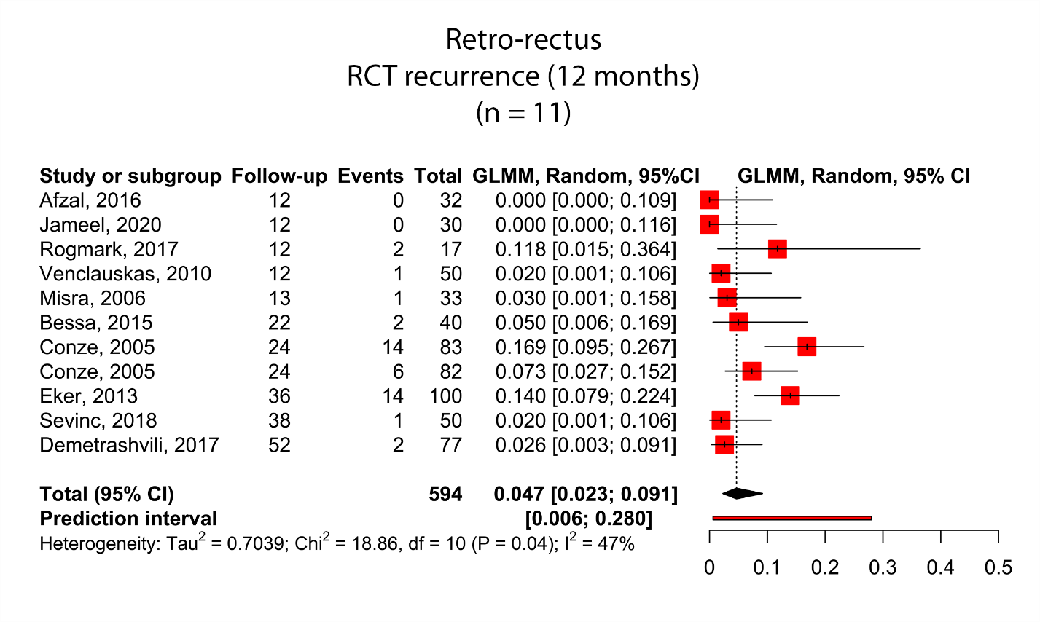
Supplemental Figure 35. Overall serious complications after retro-rectus repair, randomized controlled trials only
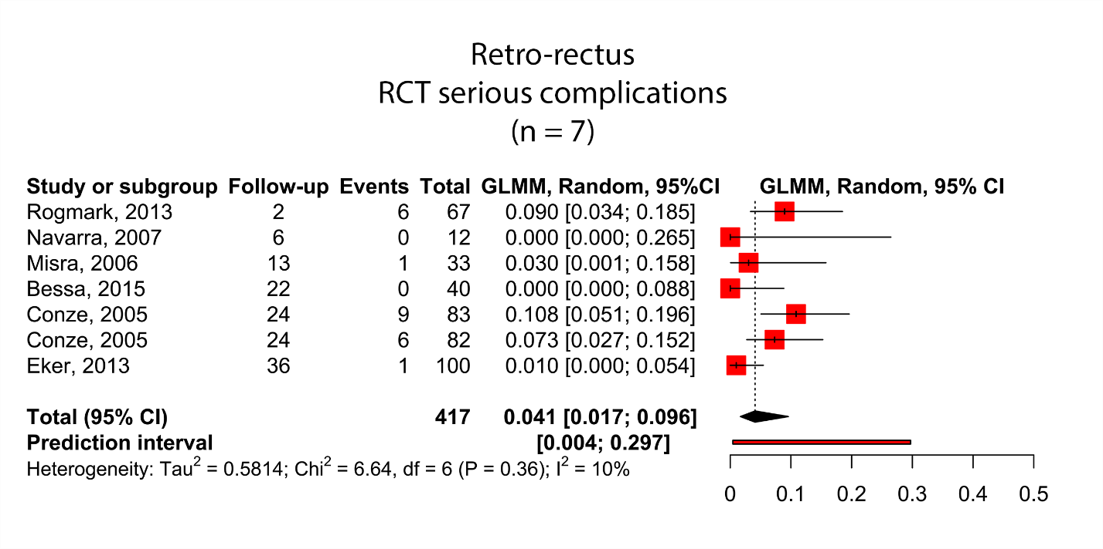

Supplemental Figure 36. Overall seroma after retro-rectus repair, randomized controlled trials only
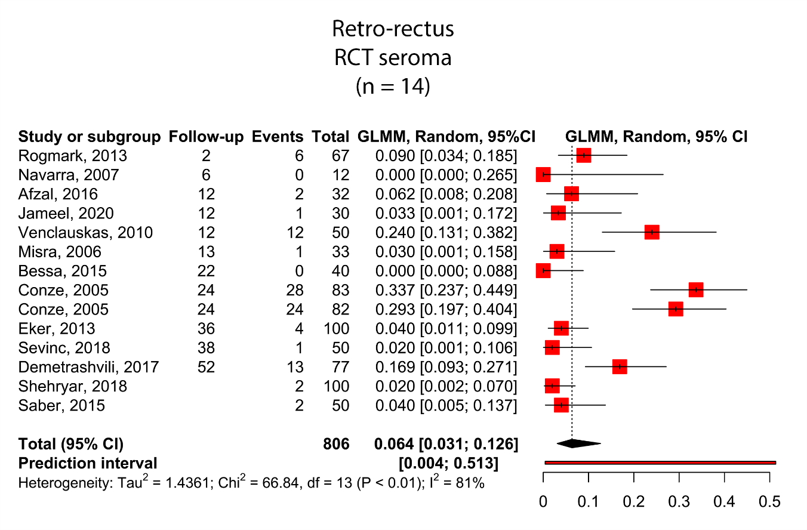
Supplemental Figure 37. Overall surgical site infection after retro-rectus repair, randomized controlled trials only
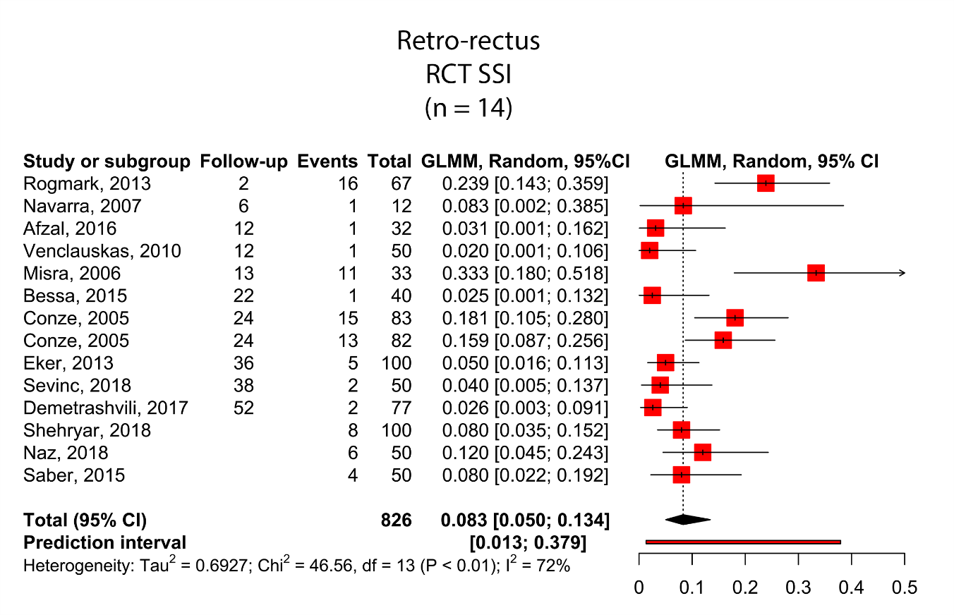

Supplement: search syntax

Embase
('stoppa approach'/exp OR 'Rives Stoppa repair'/de OR (rives OR stoppa):ab,ti,kw) OR ((((retro NEXT/1 (muscul* OR rect*)) OR retromusc* OR retrorect* OR sub-lay OR sublay OR underlay OR under-lay OR onlay OR on-lay OR pre-periton* OR preperiton* OR (behind NEAR/3 rect*)):ab,ti,kw) AND ('abdominal wall hernia'/de OR 'umbilical hernia'/de OR 'incisional hernia'/de OR (((abdom* OR ventral OR incision* OR cicatri* OR occult OR umbilic* OR paraumbilic*) NEAR/3 herni*)):ab,ti,kw)) NOT ([animals]/lim NOT [humans]/lim)

Medline
((rives OR stoppa).ab,ti,kf.) OR ((((retro ADJ (muscul* OR rect*)) OR retromusc* OR retrorect* OR sub-lay OR sublay OR underlay OR under-lay OR onlay OR on-lay OR pre-periton* OR preperiton* OR (behind ADJ3 rect*)).ab,ti,kf.) AND (Hernia, Abdominal/ OR exp Hernia, Ventral/ OR Incisional Hernia/ OR (((abdom* OR ventral OR incision* OR cicatri* OR occult OR umbilic* OR paraumbilic*) ADJ3 herni*)).ab,ti,kf.)) NOT (exp animals/ NOT humans/)

Cochrane
((rives OR stoppa):ab,ti,kw) OR ((((retro NEXT/1 (muscul* OR rect*)) OR retromusc* OR retrorect* OR sub-lay OR sublay OR underlay OR under-lay OR onlay OR on-lay OR pre-periton* OR preperiton* OR (behind NEAR/3 rect*)):ab,ti,kw) AND ((((abdom* OR ventral OR incision* OR cicatri* OR occult OR umbilic* OR paraumbilic*) NEAR/3 herni*)):ab,ti,kw))

Web of Science
TS=((("rives" OR "stoppa")) OR ((((retro NEAR/1 (muscul* OR rect*)) OR retromusc* OR retrorect* OR sub-lay OR sublay OR underlay OR under-lay OR onlay OR on-lay OR pre-periton* OR preperiton* OR (behind NEAR/2 rect*))) AND ((((abdom* OR ventral OR incision* OR cicatri* OR occult OR umbilic* OR paraumbilic*) NEAR/2 herni*)))))

Google Scholar
rives|stoppa|"retro muscular|rectal"|retromuscular|retrorectal "abdominal|ventral |incisional|cicatrical|occult|umbilical|paraumbilical hernia"
rives|stoppa|'retro muscular|rectal'|retromuscular|retrorectal 'abdominal|ventral |incisional|cicatrical|occult|umbilical|paraumbilical hernia'

Table 1. Baseline characteristics for all included comparative studies
BMI: Body Mass Index. IQR: interquartile range. O: open technique. L: laparoscopic technique. I: incisional hernia. P: primary hernia. B: both. IPOM: intraperitoneal onlay mesh. eTEP: (Laparoscopic) enhanced-view totally extraperitoneal procedure. TAR: transversus abdominis release. Age and BMI are listed as median (IQR), median (range), mean ± SD (range) or range, depending on how it was reported. BMI is listed in kg/m². Defect size is listed in centimeters (cm) in case hernia width or diameter was reported or as square centimeters (cm²) in case hernia area was reported. *: this study was analyzed as a prospective cohort study in the retro-rectus versus IPOM comparison, as it was only randomized for synthetic versus biological mesh and not for surgical technique.

Study / subgroup | N | N  male | Age | BMI | Tech-  nique | Hernia type | Defect size
Randomized controlled trial (n = 15)
Afzal 2016  Retro-rectus | 32 | 10 | 49.37 (IQR 22 - 68) | NA | O | B | 6.87 cm (range 4 - 10)
Onlay | 32 | 9 | 48.03 (range 20 - 66) | NA | O | B | 6.31 cm (range 3 - 10)
Bessa 2015  Retro-rectus | 40 | 5 | 37.9 ± 7.5 | 30.4 ± 2.3 (range 25 - 36) | O | P | 5.4 cm ± 1 (range 4 - 7.5)
Onlay | 40 | 6 | 38.5 ± 8.1 (range 26 - 57) | 31 ± 2.7 (range 25 - 37) | O | P | 5.7 cm ± 1.1 (range 4 - 8)
Conze 2005  Lightweight mesh | 83 | 39 | 58.2 ± 12.7 | 30.1 ± 5.1 | O | I | 13.6 cm ± 7.8 × 7.6 cm ± 3.8
Heavyweight mesh | 82 | 46 | 57.7 ± 11.7 | 29.3 ± 4.9 | O | I | 13.6 cm ± 7.8 × 7.6 cm ± 3.8
Demetrashvili 2017  Retro-rectus | 77 | 36 | 59.6 ± 13.1 | 29.4 ± 4.7 | O | I | 100.4 cm² ± 81.8
Onlay | 78 | 32 | 61.2 ± 16.7 | 28.8 ± 3.9 | O | I | 92.7 cm² ± 72.4
Eker 2013  Retro-rectus | 100 | 59 | 56.7 ± 12.8 | 29.3 ± 4.6 | O | I | 5 cm (IQR 4 - 10)
IPOM | 94 | 56 | 59.1 ± 12.8 | 28.3 ± 4.7 | L | I | 5 cm (IQR 4 - 8)
Misra 2006  Retro-rectus | 33 | 7 | 45.20 (IQR 25 - 65) | 25.43 (IQR 18 - 49.3) | O | B | 42.12 cm² (range 1 - 670)
IPOM | 33 | 11 | 45.96 (range 24 - 70) | 26.28 (IQR 17.48 - 41.1) | L | B | 65.55 cm² (range 1 - 875)
Navarra 2007  Retro-rectus | 12 | 3 | 64.1 (IQR 40 - 78) | NA | O | I | 45.2 cm² (range 16 - 100)
IPOM | 12 | 5 | 59.3 (range 34 - 73) | NA | L | I | 37.2 cm² (range 20 - 81)
Jameel 2020  Retro-rectus | 30 | 18 | 37 ± 10.32 | 27.17 ± 6.38 | O | I | NA
Onlay | 30 | 15 | 41.93 ± 11.75 (range 22 - 60) | 25.84 ± 5.3 | O | I | NA
Rogmark 2017  Retro-rectus | 17 | 6 | 62 ± 10 | 29.1 ± 4.6 | O | I | 7.6 cm ± 5.8 × 4.6 cm ± 2.4
IPOM | 20 | 9 | 62 ± 15 | 28.2 ± 3.9 | L | I | 9.0 cm ± 5.4 × 6.1 cm ± 2.8
Rogmark 2013  Retro-rectus | 67 | 28 | 58 ± 11.1 | 29.3 ± 4.7 | O | I | 5 cm (range 3 - 6)
IPOM | 64 | 27 | 58 ± 13.6 | 29.3 ± 4 | L | I | 5 cm (range 3 - 7)
Venclauskas 2010  Retro-rectus | 50 | 23 | 53 ± 11.6 | 28 ± 6 | O | I | 110 cm² ± 83.3
Onlay | 57 | 22 | 56.9 ± 11.5 | 30.5 ± 7.4 | O | I | 114.5 cm² ± 90.9
Shehryar 2018  Retro-rectus | 100 | 36 | 51.4 ± 9.8 | NA | O | B | NA
Onlay | 100 | 40 | 52.3 ± 10.1 | NA | O | B | NA
Naz 2018  Retro-rectus | 50 | 23 | 39.12 ± 4.58 | NA | O | P | NA
Onlay | 50 | 22 | 40.3 ± 4.52 | NA | O | P | NA
Sevinc 2018  Retro-rectus | 50 | 14 | 55.9 ± 12.1 | 26.4 ± 3.3 | O | I | 61.6 cm² ± 58.3
Onlay | 50 | 22 | 55.9 ± 11.8 | 25.5 ± 3.5 | O | I | 61.6 cm² ± 58.3
Saber 2015  Retro-rectus | 50 | 50 | 47.16 ± 10.4 | NA | O | I | NA
Onlay | 50 | 48 | 46.38 ± 10.58 | NA | O | I | NA
Miserez 2021*  Synthetic, open | 61 | 29 | 57 ± 15.4 | 29.4 ± 4.8 | O | B | 6.3 cm ± 2.9 x 5.0 cm ± 1.8
Biological, open | 61 | 36 | 53 ± 13.2 | 29.4 ± 4.9 | O | B | 6.6 cm ± 2.9 x 5.4 cm ± 2.4
Synthetic, laparosc. | 64 | 35 | 60 ± 12.1 | 29.2 ± 4.3 | L | B | 6.0 cm ± 2.4 x 4.9 cm ± 1.8
Biological, laparosc. | 62 | 29 | 57 ± 11.3 | 29.9 ± 5.1 | L | B | 6.3 cm ± 3.3 x 5.1 cm ± 2.1
Prospective cohort (n = 17)
Ammaturo 2005  Retro-rectus | 13 | 7 | 54 (range 36 - 78) | 31 | O | I | 1690 cm² ± 207
IPOM | 10 | 7 | 54 (range 36 - 78) | 33 | L | I | 1551 cm² ± 387
Berrevoet 2011  Retro-rectus | 56 | 27 | 54.8 ± 16 | 28.2 ± 3.1 | O | P | 2.6 cm²
IPOM | 60 | 25 | 48.1 ± 14.8 | 29.4 ± 2.4 | O | P | 2.3 cm²
Berrevoet 2010  Heavyweight mesh | 205 | NA | 66.9 ± 10.2 | 29.9 ± 3.1 | O | I | 56 cm² ± 34
Lightweight mesh | 235 | NA | 63.4 ± 17.4 | 27.2 ± 2.1 | O | I | 56 cm² ± 34
Bueno-Lledó 2017  Sutured mesh | 25 | 12 | 55.3 ± 21.6 | NA | O | I | 85 cm² ± 22
Self-adhering mesh | 25 | 11 | 53.6 ± 25.5 | NA | O | I | 85 cm² ± 22
Gleysteen 2009  Retro-rectus | 50 | NA | 55 ± 11 | NA | O | I | 10 cm ± 5
Onlay | 75 | NA | 57 ± 11 | NA | O | I | 10 cm ± 5
Lomanto 2006  Retro-rectus | 50 | 10 | 54.94 ± 12.7 | NA | O | B | 55.88 cm² ± NA
IPOM | 50 | 8 | 55.56 ± 10.9 | NA | L | B | 93.96 cm² ± NA
Reinpold 2018  Retro-rectus | 576 | 322 | 60.4 ± 13 | 29.7 ± 6.1 | L | I | NA
Retro-rectus | 576 | 328 | 60 ± 13.4 | 29.8 ± 6.3 | O | I | NA
Roth 2017  Retro-rectus | 41 | 46 | 54.7 ± 12 | 32.2 ± 4.5 | O | B | 115.7 cm² ± 80.6
Onlay | 24 | 46 | 54.7 ± 12 | 32.2 ± 4.5 | O | B | 115.7 cm² ± 80.6
Welty 2001  Heavyweight mesh A | 115 | 79 | 58 ± 12 | 27.2 ± 4.2 | O | I | NA
Heavyweight mesh B | 36 | 22 | 57 ± 11 | 28 ± 4.1 | O | I | NA
Low-weight mesh | 83 | 56 | 63 ± 10 | 28 ± 3.4 | O | I | NA
Kumar 2020  Retro-rectus | 46 | 29 | 44.24 ± 7.45 | 28.6 ± 4.15 | L | B | 3.89 cm ± 0.85
IPOM | 46 | 29 | 45.7 ± 7.64 | 30.57 ± 4.22 | L | B | 4 cm ± 0.76
Iljin 2019  Retro-rectus | 20 | 8 | 38 ± NA (range 25 - 53) | 30 ± 3.27 | O | I | 13.2 cm ± NA (range 10 - 15)
Onlay | 20 | 4 | 43.2 ± NA (range 27 - 55) | 29.56 ± 4.64 | O | I | 15.6 cm ± NA (range 12 - 18)
Alizai 2019  Retro-rectus | 71 | 36 | 63.2 ± 12.3 | 28.3 ± 6 | O | I | NA
IPOM | 31 | 20 | 62.1 ± 13.9 | 32.1 ± 7.2 | L | I | NA
Bellido Luque 2021  Retro-rectus | 40 | NA | 60.1 ± 12.3 | 27.2 ± 5 | L | B | 62.9 cm² ± 23.4
IPOM | 39 | NA | 54.9 ± 17.1 | 26.8 ± 4.7 | L | B | 57.3 cm² ± 24
Schroeder 2013  Retro-rectus | 43 | 27 | 54.7 ± 12 | 32.2 ± 4.5 | L | B | 23.8 cm² (range 4 - 100)
Retro-rectus | 50 | 19 | 54.7 ± 12 | 32.2 ± 4.5 | O | B | 24.5 cm² (range 4 - 132)
Gokcal 2019  eTEP with TAR | 54 | 24 | 59.1 ± 12.2 | 32.5 ± 6.7 | L | B | 35.3 cm² (IQR 19.4 - 87.9)
eTEP no TAR | 47 | 24 | 55.1 ± 13.6 | 30 ± 6.1 | L | B | 15.7 cm² (IQR 7 - 39.2)
Vix 1997  Contaminated | 47 | 17 | 62.4 ± 11.9 (range 29 - 88) | 30.4 ± 6.5 (range 18 - 48) | O | B | NA
Non-contaminated | 47 | 19 | 61 ± 9.8 (range 44 - 88) | 30.1 ± 5.2 (range 22 - 46) | O | B | NA
Retrospective cohort (n = 18)
Abdollahi 2010  Retro-rectus | 312 | 265 | 52 ± NA (range 2 - 85) | NA | O | I | NA
Onlay | 33 | 265 | 52 (range 2 - 85) | NA | O | I | NA
Fischer 2014  Retro-rectus | 45 | 26 | 52.6 ± 12 | 32 ± 7.5 | O | B | NA
IPOM | 27 | 14 | 54.2 ± 11.2 | 37.2 ± 13.8 | O | B | NA
Forte 2011  Retro-rectus | 207 | 158 | 62 ± NA (range 34 - 85) | NA | O | I | NA
IPOM | 30 | 158 | 62 ± NA (range 34 - 87) | NA | O | I | NA
Gurrado 2014  Retro-rectus | 23 | NA | NA | NA | O | NA | NA
Onlay | 53 | NA | NA | NA | O | NA | NA
Holihan 2016  Underlay | 308 | 146 | 51 ± 14 | 33.8 ± 8.1 | O | I | NA
Retro-rectus | 139 | 76 | 52 ± 12 | 33 ± 6.8 | O | I | NA
Khansa 2016  Sutured mesh | 12 | 4 | NA | NA | O | I | 7.9 cm ± NA
Self-adhering mesh | 14 | 9 | NA | NA | O | I | 7.9 cm ± NA
Ladurner 2011  Lightweight mesh | 12 | 9 | 58.3 ± 11.1 | 28.7 ± 3.5 | O | I | 226 cm² ± 301.5
Heavyweight mesh | 12 | 8 | 57.3 ± 11.8 | 29.8 ± 3.7 | O | I | 226 cm² ± 301.5
Rosen 2009  Retro-rectus | 30 | 12 | 59 (range 40 - 88) | 31 (IQR 18 - 51) | O | B | 116 cm² (range 6 - 420)
IPOM | 79 | 34 | 57 (range 28 - 80) | 34 (IQR 20 - 50) | L | B | 116 cm² (6 - 420)
Rosen 2013  Retro-rectus | 23 | 13 | 58.6 ± 13.5 | 30.8 ± 5.7 | O | B | 183.2 cm² ± 125
IPOM | 26 | 16 | 58.2 ± 13.4 | 31.1 ± 4.8 | O | B | 183.2 cm² ± 125
Bui 2021  Retro-rectus | 29 | 16 | 57 (range 48 - 69) | 30.5 (range 27.3 - 32.8) | O | B | 11.8 cm² ± 18.9
IPOM | 43 | 22 | 57 (range 49.5 - 67) | 30.5 (range 27.3 - 34.3) | L | B | 11.8 cm² ± 18.9
Bhellar 2020  Retro-rectus | 70 | 33 | 47.95 ± 9.75 | NA | O | P | NA
Onlay | 70 | 31 | 46.85 ± 8.42 | NA | O | P | NA
Köckerling 2019  Retro-rectus | 3965 | NA | 63.8 ± 12.7 | 29 ± 5.6 | O | B | NA
IPOM | 3965 | NA | 63.2 ± 12.8 | 29.7 ± 5.7 | L | B | NA
Raftopolous 2003  Lap. Retro-rectus | 50 | 17 | 47.8 | 32.62 | L | B | 124.6 cm²
Open Retro-rectus | 22 | 8 | 59.4 | 33.65 | O | B | 201.6 cm²
Warwick 2017  Synthetic retro-rect. | 28 | 17 | 64 | NA | O | B | NA
Biological retro-rect. | 29 | 16 | 64 | NA | O | B | NA
Penchev 2019  Retro-rectus | 27 | 15 | 58.7 ± 11.7 | 25.1 ± 3.9 | L | B | 71.4 cm² ± 47.1
IPOM | 27 | 16 | 55.6 ± 14.1 | 27.1 ± 3.2 | L | B | 76 cm² ± 53.2
Morrell 2020  eTEP primary | 31 | 14 | 48 (range 23 - 76) | 27.6 (range 21.3 - 37) | L | P | NA
eTEP incisional | 43 | 21 | 53.4 (range 28 - 75) | 30.3 (range 22 - 48) | L | I | NA
Lu 2020  eTEP laparoscopic | 120 | 74 | 53.2 ± 14.6 | 31.3 ± 5.7 | L | B | NA
eTEP robotic | 86 | 41 | 50.8 ± 12.8 | 29 ± 5.6 | L | B | NA
Dougaz 2020  Retro-rectus | 68 | 21 | 51.15 ± 13.47 | NA | O | B | 27.13 cm² ± 12.7
Pre-peritoneal | 92 | 56 | 48.53 ± 12.49 | NA | O | B | 18.59 cm² ± 9.84

Table 2. Baseline characteristics for all included non-comparative studies
BMI: Body Mass Index. BMI is listed in kg/m².
Study | Study type | Mesh position | Surgical technique | N | N (Male) | Age | BMI | Hernia type | Defect size (diameter in cm or area in cm2) | Follow-up (months)
Andreuccetti, 2021 | Prospective cohort | Retro-rectus | laparoscopic | 19 | 8 | 58.9 range 46-72 | 26.6 SD 2.8 | both | 21 cm2 | 16
Bauer, 2002 | Prospective cohort | Retro-rectus | open | 57 | 29 | 58, range 33-79 | NA | incisional | NA | 34,9
Belyansky, 2018 | Prospective cohort | Retro-rectus | laparoscopic | 29 | 13 | 54.1 SD 12.9 | 35.5 SD 8.3 | both | 16.7 cm2 | 31
Bittner, 2017 | Prospective cohort | Retro-rectus | hybrid | 41 | 35 | 57 range 31-76 | 30.4 (range 22.4-37.5) | both | 32.5 cm2 | NA
Canziani, 2009 | Prospective cohort | Retro-rectus | open | 40 | 26 | 56.5 (range 38-75) | NA | incisional | NA | 60
Costa, 2016 | Prospective cohort | Retro-rectus | laparoscopic | 15 | 4 | 51.2 range 39-65 | 29.5 (range 23-31..6) | incisional | NA | 17
Hicks, 2014 | Prospective cohort | Retro-rectus | open | 10 | 7 | 53.4 SE 3.4 | 30.3 SE 2.2 | incisional | 469 cm2 | 13,5
Köhler, 2020 | Prospective cohort | Retro-rectus | laparoscopic | 31 | 14 | 61.6 range 25.3-86.7 | 28.6 range 20.4-36.7 | both | 34.5 cm2 | 8
Kurzer, 2008 | Prospective cohort | Retro-rectus | open | 125 | 53 | 55.75 mean (range 18-78) | mean 33.5, range 22-39 | incisional | NA | 84
Lasheen, 2008 | Prospective cohort | Retro-rectus | open | 60 | 15 | mean 37.3 (range 23-50) | NA | primary | NA | 36
Martín-Duce, 2001 | Prospective cohort | Retro-rectus | open | 152 | 74 | mean 55.9 range 23-78 | NA | incisional | NA | 72
McLanahan, 1997 | Prospective cohort | Retro-rectus | open | 106 | 43 | median 56, range 33-89 | NA | both | NA | 24
Memon, 2010 | Prospective cohort | Retro-rectus | open | 200 | 50 | mean 43.7, range 23-65, median 45 | NA | both | NA | 15
Ngo, 2021 | Prospective cohort | Retro-rectus | laparoscopic | 112 | 76 | 55.8 range 23-92 | 27.4 (range 17.7-37.8) | both | 9 cm2 | 1
Oprea, 2013 | Prospective cohort | Retro-rectus | open | 275 | 98 | 58.75 median (range 21-78) | med 33.5 (range 22-41) | incisional | NA | 2
Paajanen, 2004 | Prospective cohort | Retro-rectus | open | 84 | 30 | mean 62 SD 13 range 25-84 | mean 31 SD 6 (range 22-52 | incisional | 130 cm2 | 36
Petersen, 2004 | Prospective cohort | Retro-rectus | open | 125 | 62 | 61.2 SD 12.2 | 29 SD 4.3 | incisional | 8.5 cm | 20
Plymale, 2017 | Prospective cohort | Retro-rectus | open | 31 | 14 | median 52 (IQR 44-62) | med 33 (IQR 28.6-38.4) | incisional | 105 cm2 | 13,8
Radu, 2019 | Prospective cohort | Retro-rectus | laparoscopic | 63 | NA | NA | NA | NA | NA | 12
Arer, 2017 | Retrospective cohort | Retro-rectus | open | 132 | 47 | 57.9 SD 11.8 | 30.6 SD 5.6, range 17.5-54 | incisional | 112 cm2 | 91
Bara, 2020 | Retrospective cohort | Retro-rectus | open | 139 | 56 | med 62.4, IQR 16.6 | med 32.4 iqr 7.6 | incisional | 23.5 cm | 36
Berry, 2007 | Retrospective cohort | Retro-rectus | open | 47 | 13 | 54.8 SD 1.6 range 37-76 | 34.3 SD 1.2 range 20-60 | incisional | 31.4 cm | 20
Bueno-Lledó, 2019 | Retrospective cohort | Retro-rectus | open | 213 | 108 | 51.6 SD 23.2 | 65 obese, 148 non-obese | incisional | NA | 57,6
Cheesborough, 2015 | Retrospective cohort | Retro-rectus | open | 32 | 3 | mean 53 | mean 26 | primary | 6.7 cm | 15,7
Christopher, 2021 | Retrospective cohort | Retro-rectus | open | 56 | 29 | med 61.2, IQR 50.5-68.5 | med 31, IQR 25.8-38.8 | both | NA | 36
Duce, 1997 | Retrospective cohort | Retro-rectus | open | 63 | 36 | mean 55 range 23-65 | NA | incisional | NA | 38
Eid, 2003 | Retrospective cohort | IPOM | laparoscopic | 79 | 37 | mean 55.8 range 28-81 | mean 31.4 range 18-74 | both | 103 cm2 | 34
Gangura, 2014 | Retrospective cohort | Retro-rectus | open | 77 | 14 | 62, range 24-81 | 26 were ‘obese’ | incisional | NA | 60
Hameed, 2009 | Retrospective cohort | Retro-rectus | open | 50 | 10 | NA | NA | NA | NA | 12
Lanier, 2016 | Retrospective cohort | Retro-rectus | open | 100 | 34 | 55.7 SD 10 | 29.1 SD 6.2 | both | NA | 25,8
Larson, 1996 | Retrospective cohort | Retro-rectus | open | 50 | 24 | mean 52, range 32-77 | NA | both | 6 cm | 24
Maman, 2012 | Retrospective cohort | Retro-rectus | open | 59 | 28 | mean 58.7 (range 24-86) | NA | incisional | NA | 40
Muse, 2018 | Retrospective cohort | Retro-rectus | open | 66 | 32 | 51 | 33,5 | both | NA | 13,9
Notash, 2007 | Retrospective cohort | Retro-rectus | open | 86 | 20 | 51.21, range 30-91 |  | incisional | 45.03 cm2 | 67,6
Pearson, 2016 | Retrospective cohort | Retro-rectus | open | 90 | 45 | 58.8 mean, 61.5 median | mean 32.4, median 31.5 | both | NA | 35
Petersen, 2001 | Retrospective cohort | Retro-rectus | open | 121 | 65 | 62 SD 12 | 29 SD 5 | incisional | NA | 23
Petro, 2015 | Retrospective cohort | Retro-rectus | open | 36 | 22 | 56.8 SD 10.8 | 32.4 SD 7.1 | incisional | 374 cm2 | 13,3
Quezada, 2021 | Retrospective cohort | Retro-rectus | laparoscopic | 43 | 30 | 58.5 SD 12 | 30.4 SD 4.5 | both | 24.7 cm2 | 22
Rogmark, 2017 | Retrospective cohort | Retro-rectus | open | 217 | 95 | 61 SD 13 | NA | incisional | NA | 87
Strambu, 2013 | Retrospective cohort | Retro-rectus | open | 45 | 22 | 52 range 27-76 | 23 patients had >40 bmi | both | NA | 7
Toniato, 2002 | Retrospective cohort | Retro-rectus | open | 77 | 41 | 56.6 (range 42-72) | NA | incisional | 15.8 cm | 38,3
Verhelst, 2015 | Retrospective cohort | Retro-rectus | open | 28 | 10 | median 48, iqr 40-64 | med 26.8 IQR 24.8-29.3 | both | NA | 12
Wheeler, 2009 | Retrospective cohort | Retro-rectus | open | 90 | 40 | 53 SD 14 | 33 SD 9 | both | 5 cm | 46

