Supplemental Figure 4. Six outcomes extracted based on the most common findings from reviewed studies
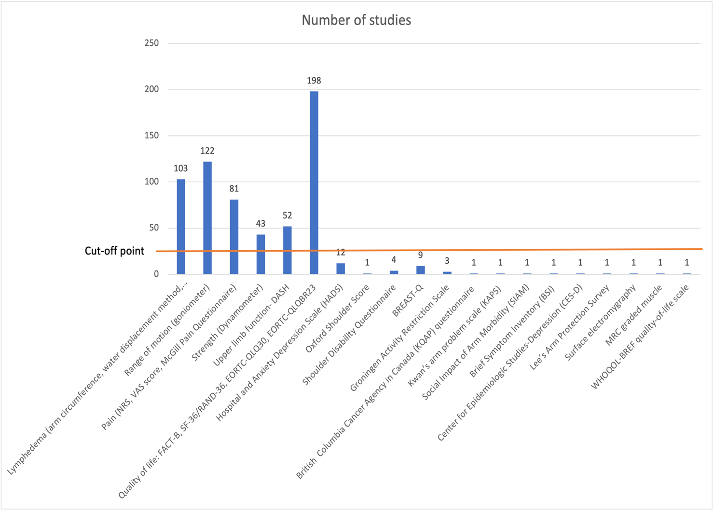

Figure 4. Outcomes measured in the literature. The six most-commonly reported outcomes were extracted. Cut-off point refers to >25 studies. Y-axis represents the number of studies with specific outcomes and x-axis represents the outcome reporting. (Numerical Rating Scale, NRS; Visual Analogue Scale, VAS; Disability of Arms, Shoulder and Hand, DASH; Functional Assessment of Cancer Therapy – Breast, FACT-B; 36-Item Short Form Survey, SF-36; European Organization for Research and Treatment of Cancer core quality of life, EORTC QLQ-C30; Breast cancer specific module, QLQ-BR23; Medical Research Council, MRC graded muscle; abbreviated World Health Organization Quality of Life, WHOQOL-Bref)

