R Code for Data Analysis

Meta-analysis
Ref: Balduzzi S, et al. Evid Based Ment Health 2019;22:153–160. doi:10.1136/ebmental-2019-300117
https://cran.r-project.org/web/packages/meta/meta.pdf

## Import excel file with LOS data-
# Get current working directory to place excel file in

getwd()

# If want to use a different directory for the excel file-use setwd()
# Note the addition of extra backslashes to what was copied from the directory location-This is necessary because of how R uses backslashes (\)-note alternate ways to use quotation marks and slashes. Also, the quotation marks are special and the ones typed in from MS word may be incorrect. Copy them from the R program screen to ensure they have the correct format.

#####setwd("C:\\Users\\ehlsu\\Downloads")
setwd("F:/Downloads")

# read the excel file into R
# load the package used for reading excel files

install.packages("readxl") #Only need to install once when first used by the R program
library("readxl") #Need to run library for every new R session

# Import the file

los <- read_excel("Data_LOSNoSurg.xlsx")

# To see the data that was imported into R

View(los)
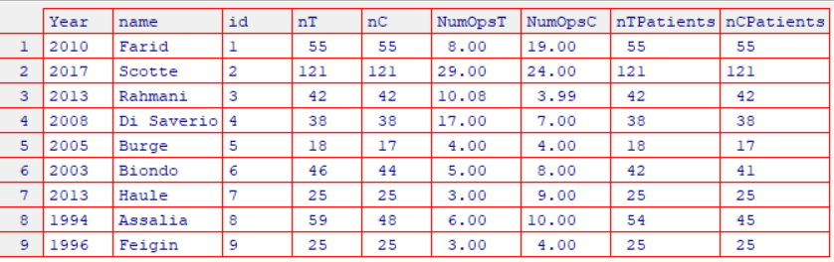
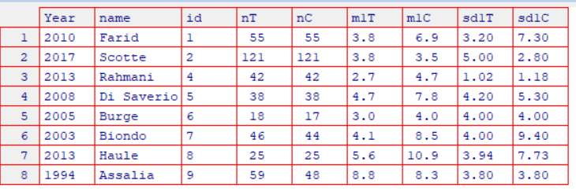

# To see the data structure for the object los
Str(los)

# Install packages need for MA
install.packages("meta")
library("meta")

# Perform Meta-analysis

M1 <- metacont(n.e=nT,mean.e=m1T,sd.e=sd1T,n.c=nC,mean.c=m1C,sd.c=sd1C,sm="MD",data=los) 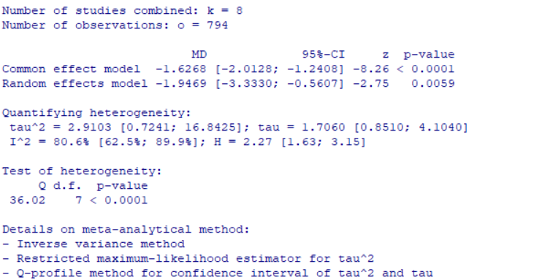
# add JAMA labels to the forest plot

settings.meta("jama")

#refs <- 1:5 #Create a vector of numbers with the reference numbers for the articles used in the MS
refs <- c(1,2,3,4,5)

lab <- JAMAlabels(los$name, los$Year, refs, data = los)

#forest.meta(M1, studlab = lab, layout = "JAMA", fontfamily = "Times", fontsize = 8, sortvar=los$Year, label.left="Favors WSC", label.right = "Favors Control")

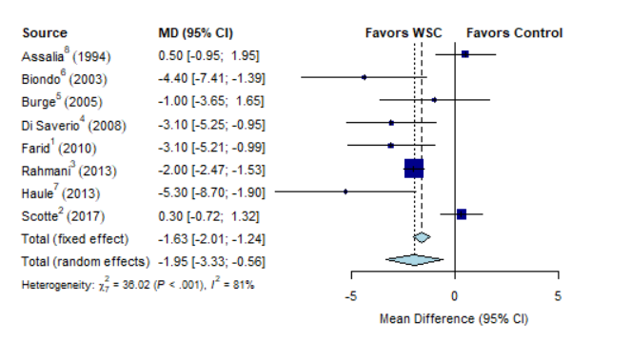

forest.meta(M1, studlab = lab, layout = "REvMan5", fontfamily = "Times", fontsize = 8, sortvar=los$Year, label.left="Favors WSC", label.right = "Favors Control")
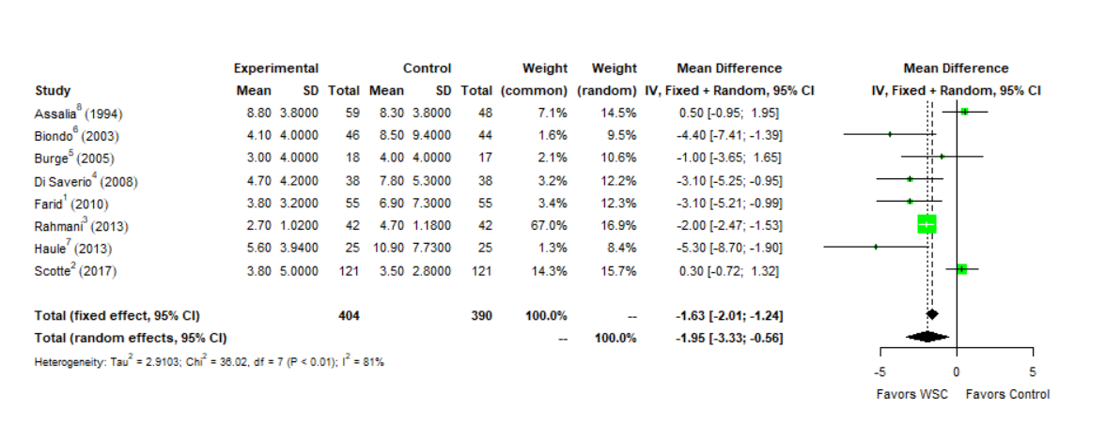

# funnel plot

install.packages("metafor") #Only need to install once when first used by the R program
library("metafor") #Need to run library for every new R session

funnel.meta(M1)
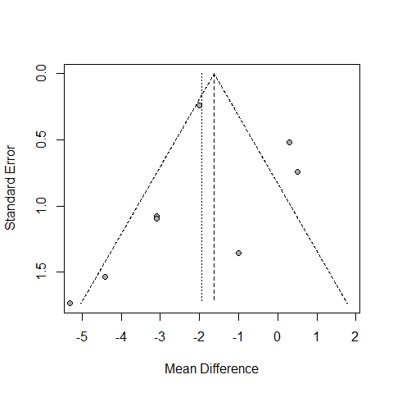

#Contour funnel plot
# https://wviechtb.github.io/metafor/reference/funnel.html

# Create vector to be used as labels for individual points
slab=paste(los$name, los$Year, sep=", ")

# Create funnel plot that also has study labels-shows 95% CI for fixed effect

cc <- funnel(M1, studlab = slab)

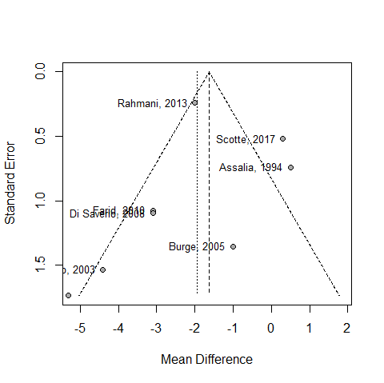

# Only show 95% CI for random effects
cc <- funnel(M1, studlab = slab,fixed=FALSE)

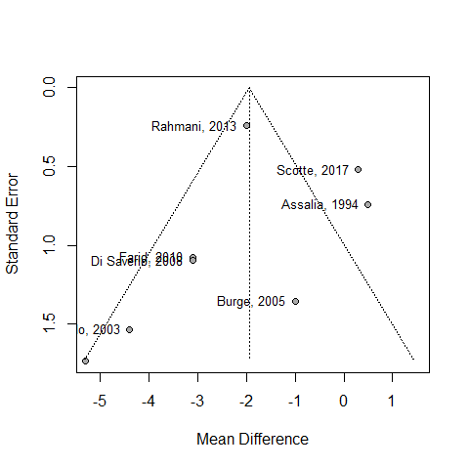

cc <- funnel(M1, random= TRUE, studlab= slab, level = 0.95, contour = c(0.9, 0.95, 0.99))$col.contour
legend(-1, 1.2, c("0.1 > p > 0.05", "0.05 > p > 0.01", "< 0.01"), fill = cc)

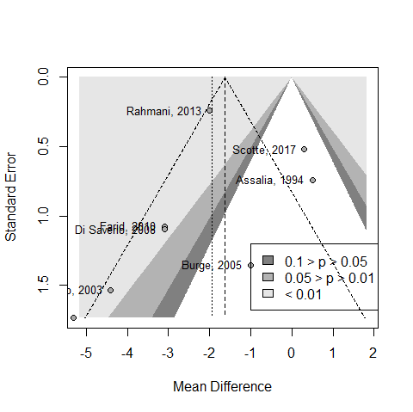

# Do not show fixed effect and move label and adjust x-axis

cc <- funnel(M1, random= TRUE, xlim=c(-8,5), fixed=FALSE, studlab= slab, level = 0.95, contour = c(0.9, 0.95, 0.99))$col.contour
legend(-.5, 1.2, c("0.1 > p > 0.05", "0.05 > p > 0.01", "< 0.01"), fill = cc)

https://www.rdocumentation.org/packages/meta/versions/0.5/topics/funnel
https://rdrr.io/cran/metafor/man/funnel.html

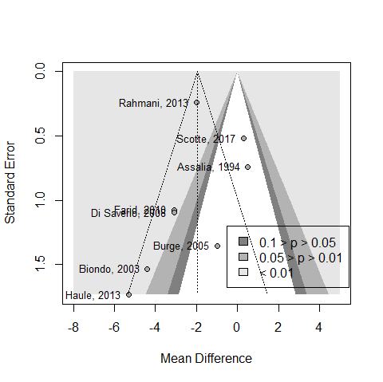

MA-Binary surgery/no surgery data
Same start up as Page 8
install.packages("readxl") #Only need to install once when first used by the R program

library("readxl") #Need to run library for every new R session

# Import the file

los <- read_excel("C:/Users/ehlsu/Documents/RCT LOSsurg NumOps Calcs.xlsx")

# will get Error: `path` does not exist: ‘C:/Users/ehlsu/Documents/RCT LOSsurg NumOps Calcs’ if forget the xls or xlsx extensions

los <- read_excel("C:/Users/ehlsu/Documents/RCT LOSsurg NumOps Calcs.xlsx", sheet="USE")

View(los)

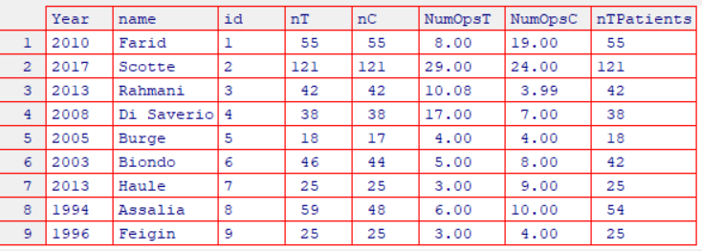

# To see the data structure for the object los
Str(los)

# Install packages need for MA
install.packages("meta")
library("meta")
M1 <- metabin(event.e=NumOpsT,n.e=nT,event.c=NumOpsC,n.c=nC,data=los)

Number of studies combined: k = 9
Number of observations: o = 829
Number of events: e = 174.1

RR 95%-CI z p-value
Common effect model 0.9363 [0.7181; 1.2209] -0.49 0.6270
Random effects model 0.8764 [0.5374; 1.4292] -0.53 0.5969

Quantifying heterogeneity:
tau^2 = 0.3228 [0.0287; 1.6871]; tau = 0.5682 [0.1695; 1.2989]
I^2 = 60.8% [18.6%; 81.1%]; H = 1.60 [1.11; 2.30]

Test of heterogeneity:
Q d.f. p-value
20.39 8 0.0090

Details on meta-analytical method:
- Mantel-Haenszel method
- Restricted maximum-likelihood estimator for tau^2
- Q-profile method for confidence interval of tau^2 and tau

forest.meta(M1, studlab = lab, layout = "REvMan5", fontfamily = "Times", fontsize = 8, sortvar=los$Year, label.left="Favors WSC", label.right = "Favors Control")

forest.meta(M1, studlab=name, layout = "REvMan5", fontfamily = "Times", fontsize = 8, sortvar=los$Year, label.left="Favors WSC", label.right = "Favors Control")

