Supplement Figure 1: Trial Sequential Analysis for HLOS for the use of WSC to treat aSBO. Contribution of studies to the analysis. TSA mimics an RCT that has a sample size equivalent the number of patients included in the meta-analysis. Each trial, in the order it was published, is considered as if it were an interim analysis. The blue solid line with square icons represents the cumulative Z value (mean difference between groups/SEM) for the intervention’s effect. The red lines with diamond icons are the O’Brien-Fleming stopping boundaries that correct for alpha-inflation resulting from multiple comparisons. If the Z value is above the curved line, a study has shown a statistically significant benefit in favor of the intervention. If below the curved line, the trial favors the control intervention and can be stopped. Z values between the curved lines indicate that statistical significance has not been reached and the trial should continue. If a Z value falls between the zero line and the triangular boundary, there is little likehood that continuing the trial will yield a statistically significant result and can be stopped for futility. In this analysis a trial of 822 patients would be needed to show the benefits of WSC for reducing HLOS when WSC is used to treat aSBO but after the last 2 trials were published, the Z value was greater than the O’Brien-Fleming boundary suggesting that further trials will not affect this conclusion and are not needed. In this figure, the trials are represented on the x-axis equally spaced. The figure in the main article is spaced relative
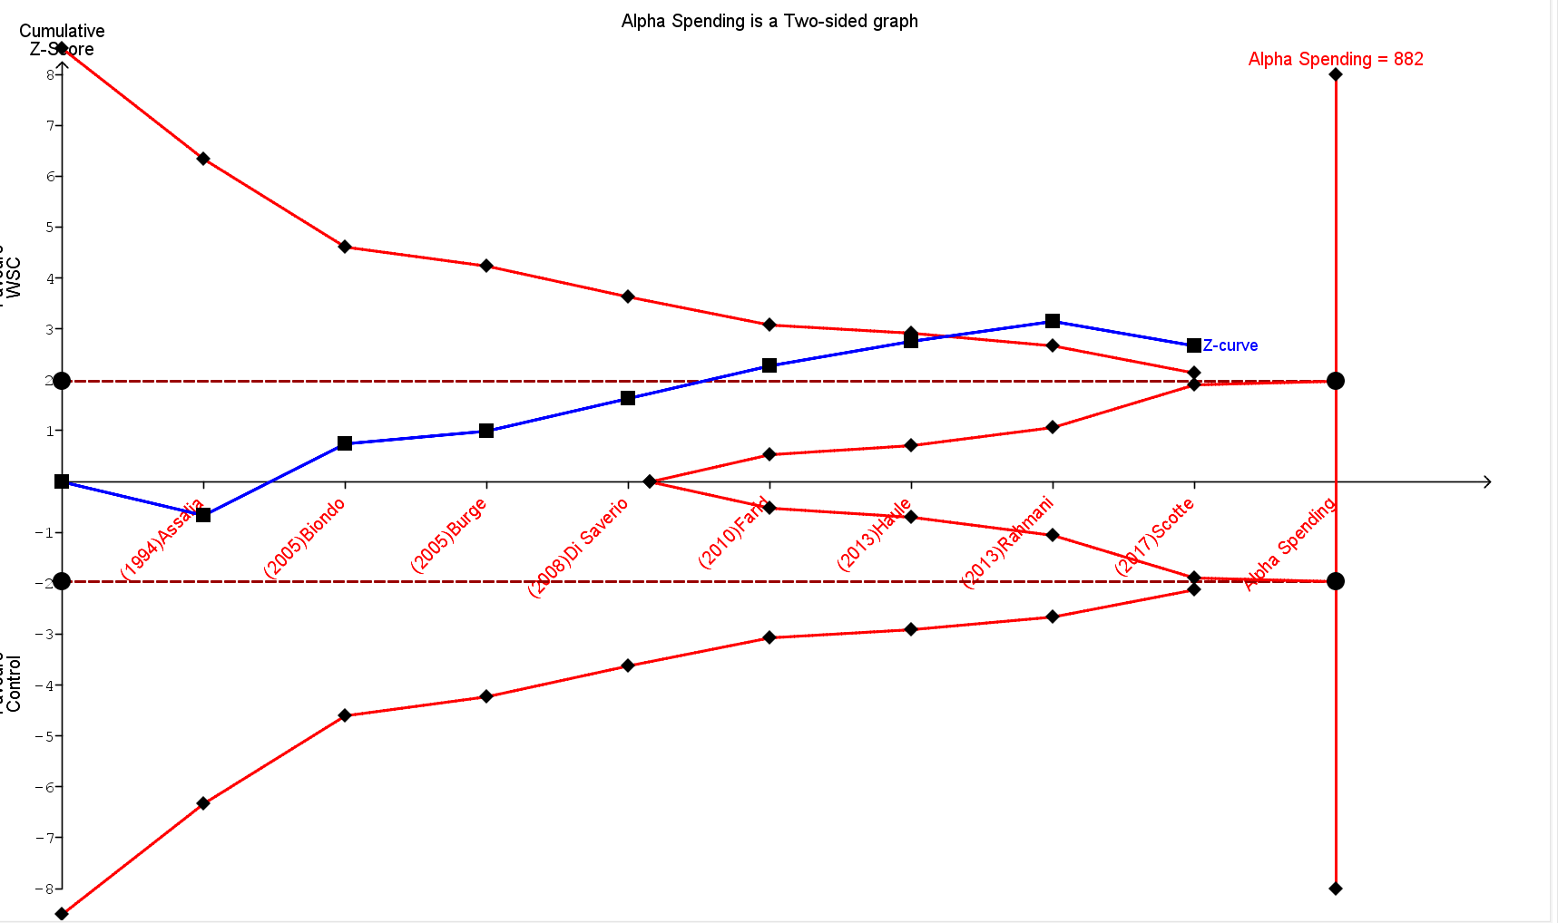
to the time period in years between publication of the articles.
Supplement Figure 2: Forest plot for the proportion of patients undergoing surgery in each group in the RCTs.

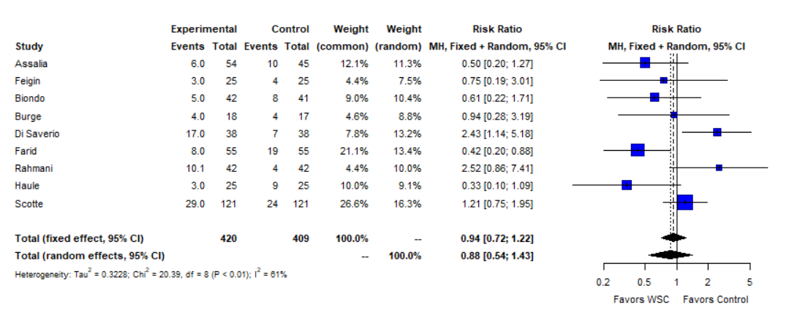

Supplement Figure 3: Forest plot for the proportion of patients undergoing surgery in each group in the observational studies.
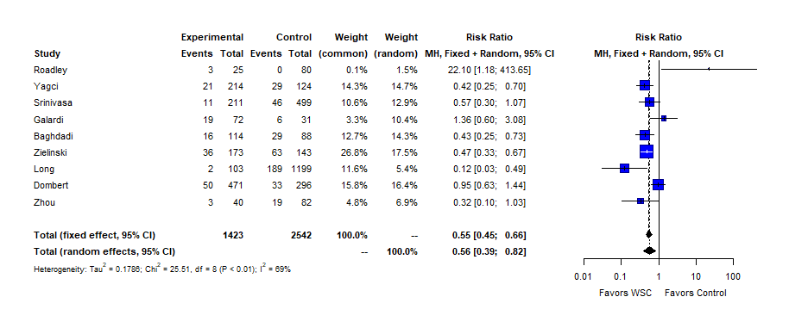

Supplement Figure 4. Forest plot for the rates of bowel resection in patients undergoing an operation in each group.
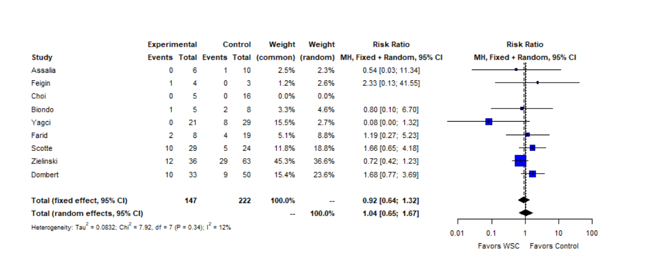

Supplement Figure 5. Forest plot for the rates of complications in each group.
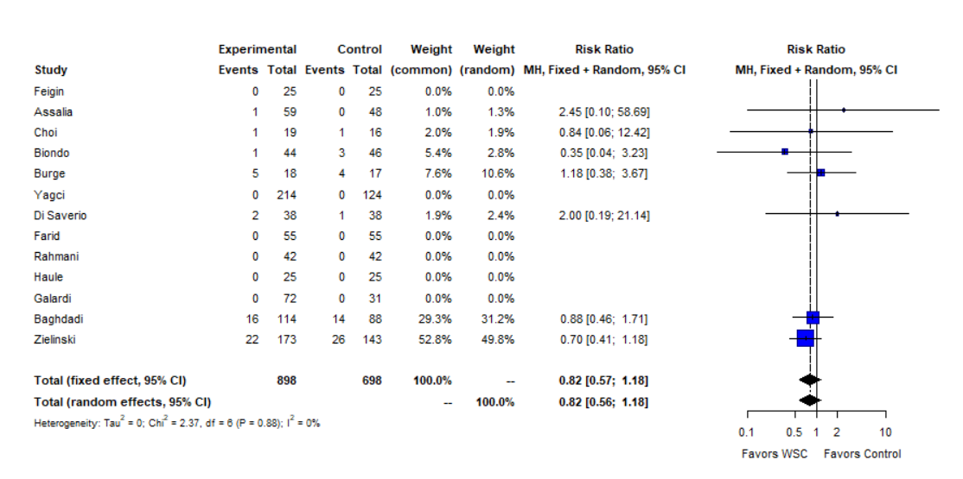

Supplement Figure 6. Forest plot for the mortality rates in each group.

