Supplementary Table 1: diseases of the pancreas in study patients
 | Group A  Pancreatoduodenectomy  with high-risk pancreatic anastomosis (n=31) | Group B  Total pancreatectomy  + IAT (n=30) | Group C  Pancreatoduodenectomy  with lower-risk pancreatic anastomosis (n=18)
Periampullary adenocarcinoma | 24 (77·4) | 21 (70) | 15 (83·3)
- Pancreatic ductal adenocarcinoma | 9 (29) | 5 (16·7) | 10 (55·6)
- Ampullary adenocarcinoma | 4 (12·9) | 3 (10) | 3 (16·7)
- Distal bile duct adenocarcinoma | 7 (22·6) | 9 (30) | 2 (11·1)
- Duodenum adenocarcinoma | 3 (9·7) | 4 (13·3) | 0 (0)
- Mixed Adenoneuroendocrine Carcinoma of the pancreas | 1 (3·2) | 0 (0) | 0 (0)
Other neoplastic, benign or borderline lesions | 7 (22·6) | 9 (30) | 3 (16·7)
- Leiomyosarcoma of the duodenum | 1 (3·2) | 0 (0) | 0 (0)
- Neuroendocrine neoplasm
- G1 | 0 (0) | 0 (0) | 1 (5·6)
- G≥2 | 2 (6·5) | 2 (6·7) | 0 (0)
- Duodenal gastrointestinal stromal tumor | 1 (3·2) | 0 (0) | 0 (0)
- Ampullary adenoma | 0 (0) | 2 (6·7) | 0 (0)
- Chronic pancreatitis | 1 (3·2) | 0 (0) | 0 (0)
- Distal bile duct pseudotumor | 0 (0) | 1 (3·3) | 0 (0)
- Gangliocytic paraganglioma | 0 (0) | 1 (3·3) | 0 (0)
- Mucinous cystadenoma | 2 (6·5) | 2 (6·7) | 2 (11·1)
- Serous cystoadenoma | 0 (0) | 1 (3·3) | 0 (0)

Supplementary Table 2. Islet isolation outcome and transplant characteristics stratified by study centres
 | TOT | Center 1 | Center 2 | p
N | 30 (100) | 12 (100) | 18 (100)
Trimmed Pancreas Weight (g) | 75 (59-83) | 72 (63-84·7) | 76 (56·5-81·5) | 0·859
Post purification IEQ | 170,000 (127,418-215,206) | 181,112 (137,146-226,475) | 147,175 (111,975-181,112) | 0·236
Post-purification IEQ/g pancreas | 2,305 (1,847-3,148) | 2,381 (1,973-3,520) | 2,300 (1,806-2,899) | 0·268
Islet transplanted | 29 (96·7) | 12 (100) | 17 (94·4) | 1
Islet purification (%) | 45 (28·7-70) | 52·5 (22·5-67·5) | 42·5 (28·7-72·5) | 0·966
Tissue volume (ml) | 1·5 (1-2·5) | 1·75 (1·05-2·59 | 1·5 (0·95-1·65) | 0·222
Fresh/culture islet | 4/25 | 4/12 | 0/17 | 0·021
Culture time (h) | 15 (13·4-16) | 16 (15-19·5) | 14 (12·7-15) | 0·014
Recipient weight | 70 (65·5-75) | 70 (60·5-75) | 70 (66·5-88·5) | 0·305
Recipient BMI | 25 (23·5-28·5) | 24 (22·25-26) | 28 (24-30) | 0·025
Islet infused (IEQ/kg) | 1,863 (1,410-2,285) | 2,143 (1,668-2,722) | 1,627 (697-2,098) | 0·075
Site (bone marrow/liver) | 2/27 | 2/10 | 0/17 | 0·163
 portal vein pressure (cm H2O) | 0 (0-1) | 0 (0-1) | 0 (0-1) | 0·792
Patients with complications related to islet infusion | 5 (17·2) | 2 (16·7) | 3 (17·6) | 1
- Hepatic bleeding or portal thrombosis | 4 (13·8) | 2 (16·7) | 2 (11·8) | 1
- Hemotorax | 1 (3·4) | 0 (0) | 1 (5·9) | 1

Supplementary Table 3. Intraoperative and postoperative data
 | Group A  Pancreatoduodenectomy  with high-risk pancreatic anastomosis | Group B  Total pancreatectomy  + IAT | p
N (%) | 31 (100) | 30 (100)
Intra-operative phase
Surgery duration (min) | 512 (391-604) | 443 (367-521) | 0·137
Duct size (mm) | 2·4 (2-3) | 2·5 (2-3) | 0·492
Blood loss (ml) | 500 (350-750) | 800 (450-950) | 0·086
Blood transfusion [N(%)] | 4 (12·9) | 17 (56·7) | <0·001
Blood volume (ml) | 1,125 (900-1570) | 900 (450-1350) | 0·229
Plasma transfusion [N(%)] | 5 (16·1) | 5 (16·7) | 1
Plasma volume (ml) | 520 (327-868) | 1,080 (585-1500) | 0·05
Splenectomy [N(%)] | 0 (0) | 4 (13·3) | 0·053
Pylorus preservation [N(%)] | 28 (90·3) | 26 (86·7) | 0·707
Post-operative phase
Intensive care unit (ICU) [N(%)] | 7 (22·6) | 9 (30) | 0·57
ICU duration (days) | 3 (1-8) | 1 (1-2·5) | 0·234
Death within 90 days [N(%)] | 3 (9·7) | 1 (3·3) | 0·52
Postoperative hospital stay (days) | 16 (12-30) | 10·5 (9-13·25) | <0·001
Readmission after surgery [N(%)] | 11 (35·5) | 7 (23·3) | 0·402
Time to readmission (days) | 22 (20-46) | 26 (12-29) | 0·338

Supplementary Table 4. Comparison of complications after PD in patients with high-risk anastomosis (Group A) and patients intraoperatively excluded for lower-risk anastomosis (Group C)
 | Group A  Pancreatoduodenectomy  with high-risk pancreatic anastomosis  [N (%)] | Group C  Pancreatoduodenectomy  with lower-risk pancreatic anastomosis [N (%)] | p
N | 31 (100) | 18 (100)
Abdominal | 28 (90·3) | 12 (66·7) | 0·058
Pancreatic fistula | 23 (74·2) | 11 (61·1) | 0·36
- Grade A  - Grade B  - Grade C | 4 (17·4)  13 (56·5)  6 (26·1) | 6 (54·5)  3 (27·3)  2 (18·2) | 0·08
Delayed gastric emptying | 6 (19·4) | 4 (22·2) | 1
Post-pancreatectomy hemorrhage | 7 (22·6) | 1 (5·6) | 0·229
Relaparotomy | 4 (12·9) | 2 (11·1) | 1
Splenectomy | 0 (0) | 0 (0) | -
Duodeno-jejunal anastomosis leakage | 3 (9·7) | 0 (0) | 0·288
Ileocolic anastomosis leakage | 2 (6·5) | 0 (0) | 0·526
Biliary fistula | 5 (16·1) | 2 (11·1) | 1
Lymphatic fistula | 0 (0) | 0 (0) | -
Abdominal fluid collections | 4 (12·9) | 3 (16·7) | 0·697
Liver ischemia | 1 (3·2) | 0 (0) | 1
Acute pancreatitis | 3 (9·7) | 0 (0) | 0·288
Colangitis | 1 (3·2) | 0 (0) | 1
Portal trombosis | 0 (0) | 0 (0) | -
Intestinal obstruction | 1 (3·2) | 0 (0) | 1
Wound infection | 4 (12·9) | 0 (0) | 0·282
Hepatic ematoma | 0 (0) | 0 (0) | -
Ascites | 1 (3·29) | 0 (0) | 1
TOT abdominal complications | 65 | 23
Other | 12 (38·7) | 6 (33·3) | 0·767
Pneumonia | 2 (6·5) | 2 (11·1) | 0·618
Sepsis | 6 (19·4) | 2 (11·1) | 0·693
Arrhythmia | 1 (3·2) | 0 (0) | 1
Embolism | 1 (3·2) | 0 (0) | 1
Urinary retention | 0 (0) | 0 (0) | -
Urinary infection | 0 (0) | 2 (11·1) | 0·13
Pleural effusion | 2 (6·5) | 0 (0) | 0·526
Pancytopenia | 1 (3·2) | 0 (0) | 1
Acute peripheral arterial occlusion | 1 (3·2) | 0 (0) | 1
Jugular vein thrombosis | 1 (3·2) | 0 (0) | 1
Stroke | 1 (3·2) | 0 (0) | 1
TOT other complications | 16 | 6
TOT complications | 81 | 29

Supplementary Table 5. Group A vs Group C univariate logistic regression analysis of complications adjusted for age and sex
 | ITT
 | Odd ratio | 95% C.I. |  | p
Any complications | 3·162 | 0·576 | 17·34 | 0·185
Abdominal complications | 4·99 | 1·01 | 24·4 | 0·048
Other complications | 1·429 | 0·405 | 5·043 | 0·579
At least 2 complications | 3·048 | 0·86 | 10·8 | 0·084
Complications with grade ≥2 | 12·298 | 1·9 | 79 | 0·008
Complications with grade ≥3 | 3·275 | 0·829 | 12·93 | 0·09
Grade B-C fistula | 4·553 | 1·229 | 16·860 | 0·023
Relaparotomy | 1·406 | 0·219 | 9·031 | 0·72
Readmission after surgery | 2·744 | 0·621 | 12·136 | 0·183

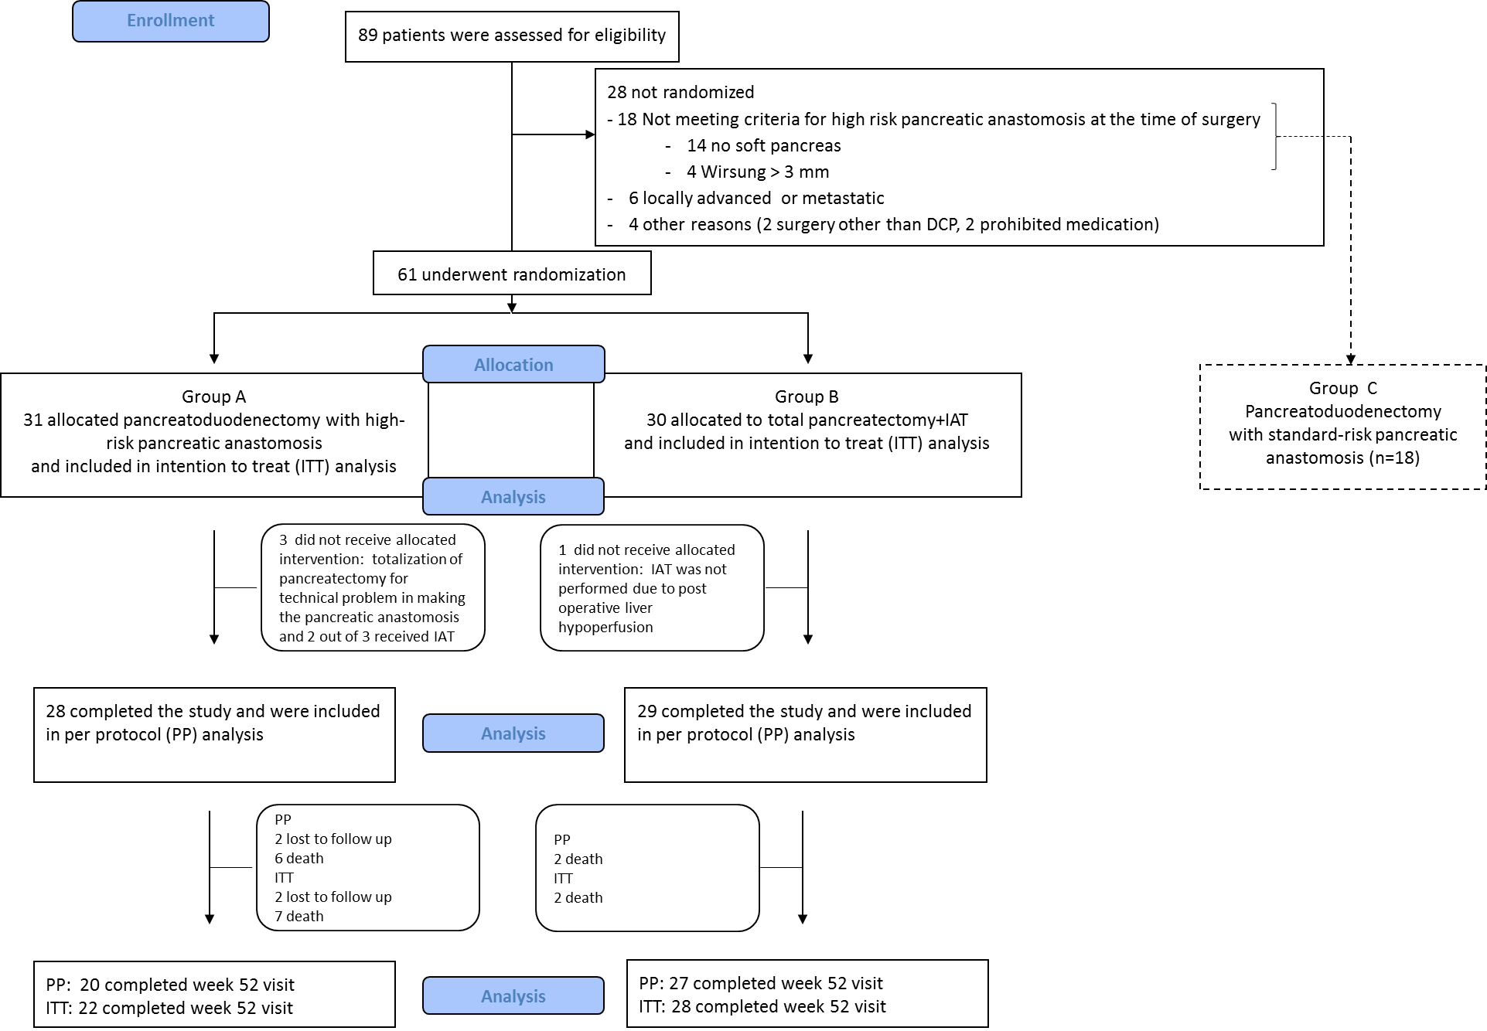
Supplementary Figure 1. Patient disposition flow chart showing patient recruitment, random assignment to treatment, and discontinuations.

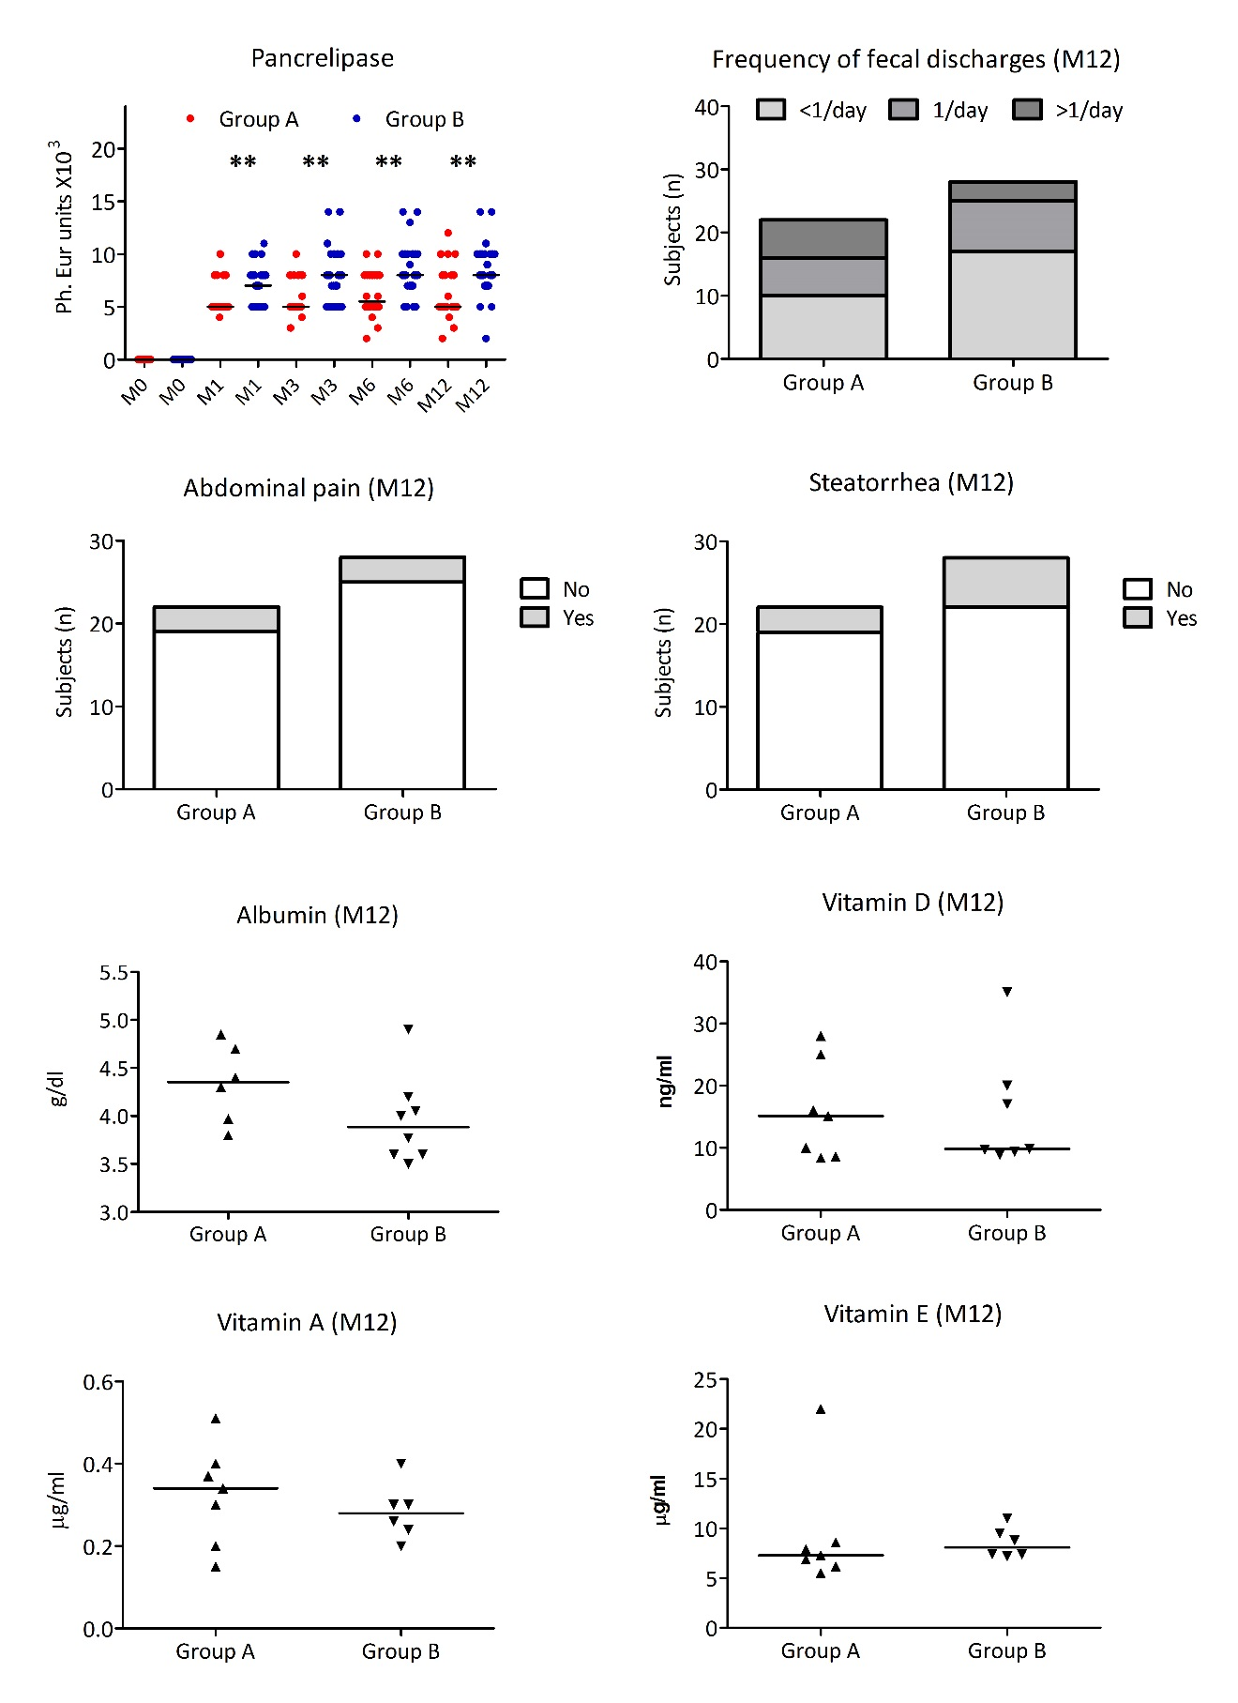Supplementary Figure 2. Exocrine function after pancreatic surgery. Pancreatic enzyme replacement therapy is reported as dot plot before and at month 1, 3, 6 and 12 after surgery. Symptoms of exocrine insufficiency, serum levels of albumin and fat-soluble vitamins are reported as histogram and dot plot, respectively, at month 12 (M12) after surgery. Group A consists of 20 patients assigned to pancreaticoduodenectomy with pancreatic anastomosis who completed week 52 visit. Group B consists of 17 patients assigned to total pancreatectomy with islet autotransplantation who completed week 52 visit. Analysis were performed by two-sided Fisher’s exact test or Mann Whitney test. *<0·05, **<0·01.
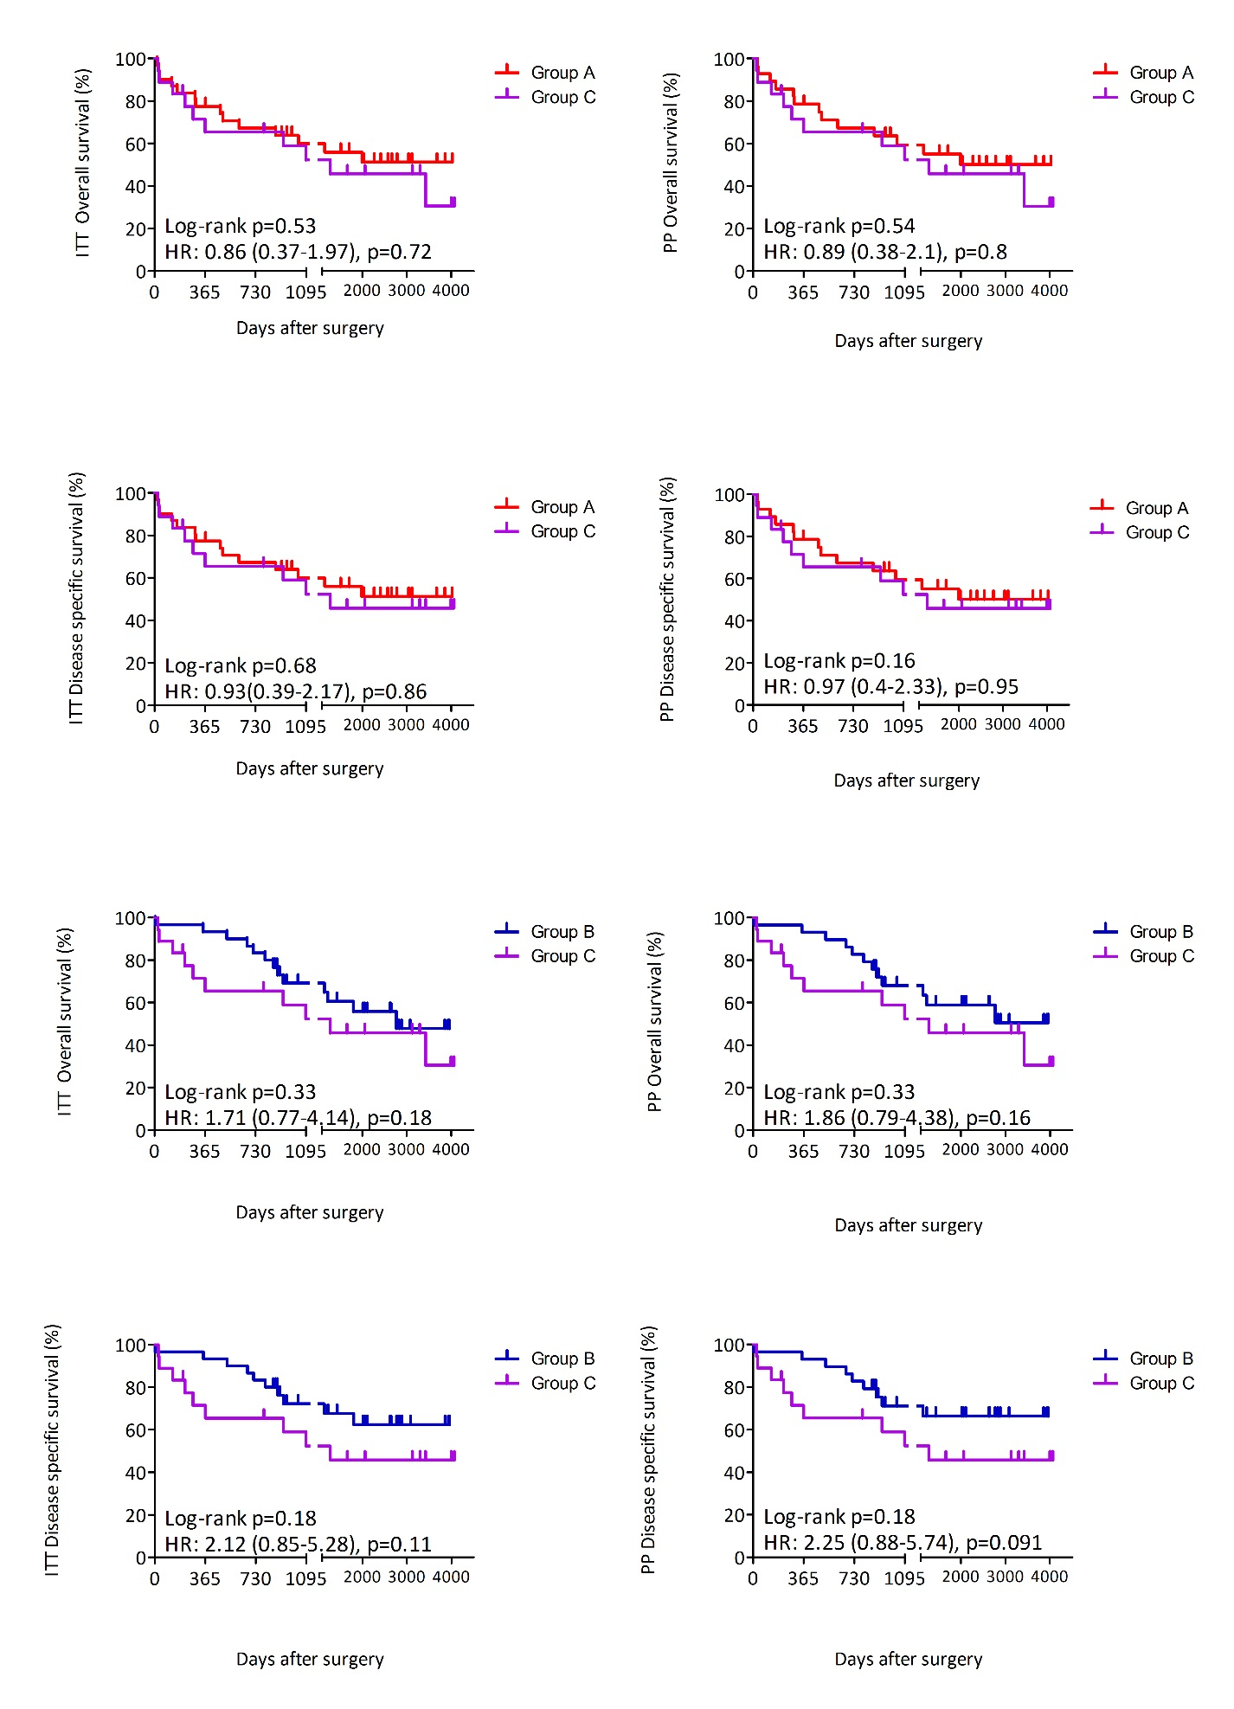
Supplementary Figure 3. Patient survival. Intention to treat (ITT) and per protocol (PP) probability of overall and disease specific survival after surgery, according to Kaplan-Meier. Analysis was performed by Log-rank (Mantel-Cox) test. The Univariate hazard ratios (HRs) adjusted for age and sex were reported.

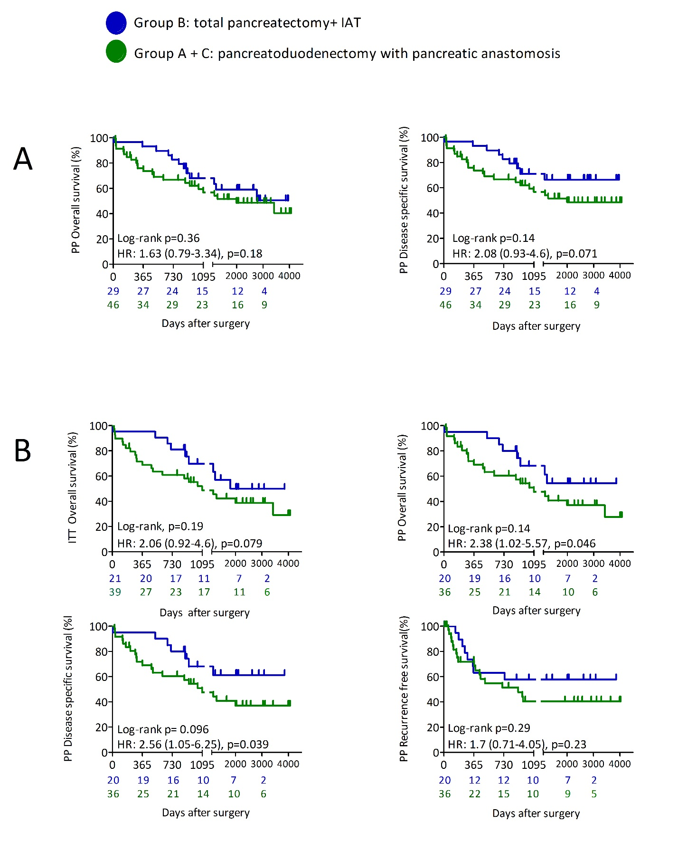
Supplementary Figure 4. Patient survival and oncologic follow-up. Panel A. Per protocol (PP) probability of overall and disease specific survival after surgery, according to Kaplan-Meier. Panel B. Intention to treat (ITT) and per protocol (PP) probability of overall, PP disease-specific, PP disease-free free survival after surgery in subjects with epithelial malignancy, according to Kaplan-Meier. Analysis was performed by Log-rank (Mantel-Cox) test. The Univariate hazard ratios (HRs) adjusted for age and sex (and tumor grade in patients with malignant neoplasm) were reported.

