Supplementary material

Hospital concentration of esophagectomy, pancreatectomy, and cystectomy in Maryland and control states
Maryland | Control States
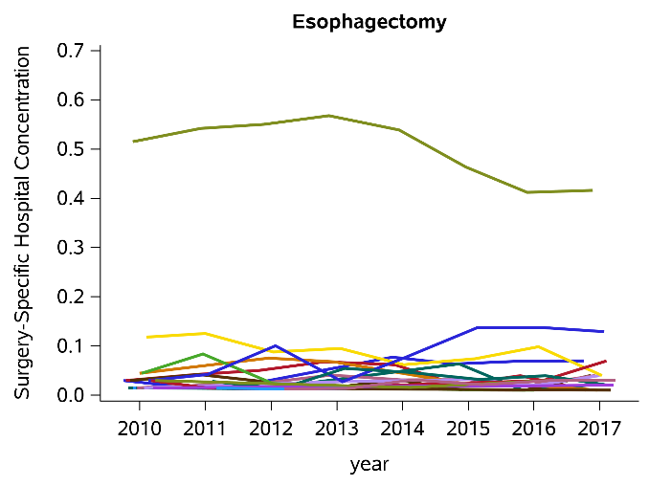 | 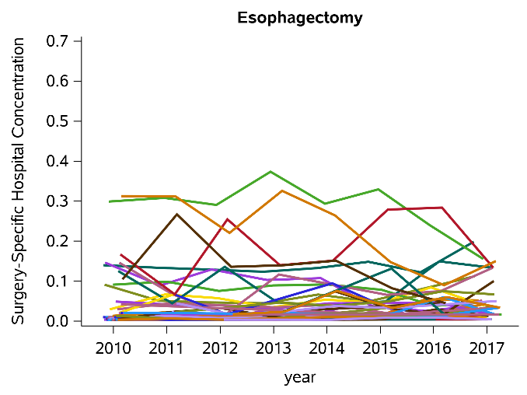
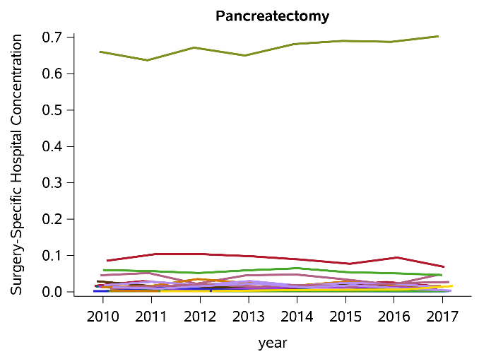 | 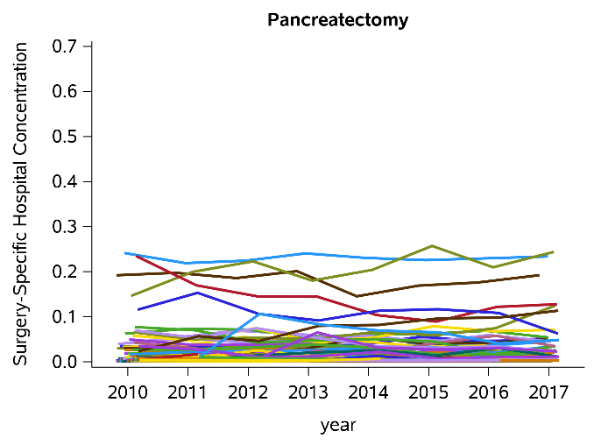
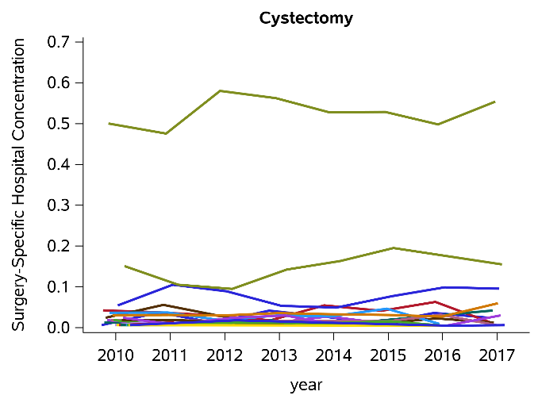 | 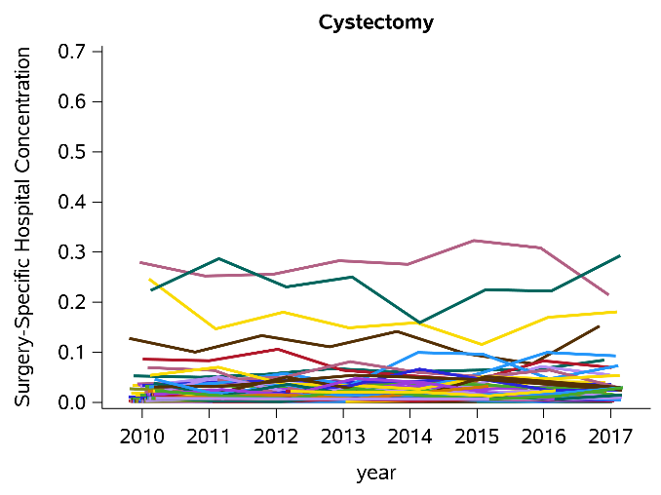
Figure S1. Hospital concentration trends of esophagectomy, pancreatectomy, and cystectomy in Maryland (left panel) and control states (right panel). Each line represents a hospital. Concentration each year was calculated as the hospital volume divided by the total volume in the state.
Table S1. Hospital concentration cutoff for being an HCH, by surgery
Surgery | Hospital concentration cutoff (%)
Gastrectomy | 7.7
Pneumonectomy/Lobectomy | 8.5
Proctectomy | 6.7
Hip/Knee Revision | 7.1
Esophagectomy | 29.9
Pancreatectomy | 24.1
Cystectomy | 27.9

Figure S1 shows esophagectomy, pancreatectomy and cystectomy have been highly concentrated in one Maryland hospital since 2010 and the concentrations are much higher than any hospital in control states in all years. Not surprisingly, for these 3 surgeries, the concentration cutoff for a hospital to be defined as an HCH is very high (Table S1). Because of these high cutoffs, in some years, there are no HCHs in control states. Therefore, in those years, the proportion of patients receiving surgery in an HCH is zero. Due to this reason, we did not study these 3 surgeries in this paper.

Model specification for estimating difference-in-differences for centralization
The difference-in-differences (D-i-D) for centralization, i.e., the proportion of patients receiving the complex surgery in a high-concentration hospital, was estimated using a linear probability model which has the form:
$$Y=β_{0}+β_{1}MD+β_{2}Post+δMD•Post +β_{3}Patient_factors+β_{4}Hospital_factors+e$$
where Y is the proportion of patients receiving the complex surgery in a high-concentration hospital; MD is a dummy variable that is equal to 1 if the patient is in Maryland; Post is a dummy variable that is equal to 1 if the year is after 2014; MD•Post is the interaction between the two aforementioned terms and the parameter δ estimates the D-i-D of the centralization; Patient_factors is a vector of patient characteristics (age, sex, race/ethnicity, insurance type, and comorbidity); Hospital_factors is a vector of hospital characteristics (teaching status, system membership, bed size, and location).

Counterfactual assumption
Before estimating the D-i-D, we examined whether patients in Maryland shared a similar trend before 2014 as those in control states, using the data between 2010 and 2013.
In the following equation, MD•Year is the interaction between the Maryland indicator and year. A significant interaction indicates different year trends between Maryland and control states between 2010 and 2013. For each complex surgery, we modeled year in two ways: (1) as a continuous variable and (2) as dummies. Both models gave the same conclusion.
$$Y=β_{0}+β_{1}MD+β_{2}Year+αMD•Year +β_{3}Patient_factors+β_{4}Hospital_factors+e$$

Estimating difference-in-differences assuming persistent differential trends
When the parallel trends assumption is violated, we cannot draw conclusion from the D-i-D estimate in section C. However, we can use the following equation to account for the differential trends between patients in Maryland and control states¹. Year is the calendar year in continuous form; MD•Year is the interaction between the Maryland indicator and year. For this D-i-D estimator, the counterfactual is that patients in Maryland and control states would have followed their different pre-GBR trends in the post period.
$$Y=β_{0}+β_{1}MD+β_{2}Post+β_{3}Year+β_{4}MD•Year+δMD•Post +β_{5}Patient_factors+β_{6}Hospital_factors+e$$

Sensitivity analyses: Including discharges from TPR hospitals
Table S2. Impact of Maryland Global Budget Revenue program on centralization of complex surgeries
 | % Patients in HCHs, Pre GBR |  | % Patients in HCHs, Post GBR |  | p value for pre-trends | DID Estimates#
 | Maryland | Control states | Maryland | Control states |  | DID | 95% CI | p value
Gastrectomy | 42.77 | 28.39 | 57.03 | 30.19 | 0.1177 | 6.5 p.p. | 3.2, 9.7 | < 0.0001
Pneumonectomy / Lobectomy | 26.83 | 27.40 | 38.84 | 27.88 | 0.3608 | 11.4 p.p. | 9.1, 13.7 | < 0.0001
Proctectomy | 37.80 | 22.64 | 49.80 | 29.53 | < 0.0001 | 3.7 p.p. | 1.0, 6.4 | 0.0072
Hip/Knee Revision | 27.23 | 22.57 | 36.12 | 19.95 | < 0.0001 | 8.6 p.p. | 7.0, 10.2 | < 0.0001
Control states include New Jersey, and New York.
p.p. = percentage points
#The model adjustment included patient age, sex, race/ethnicity, insurance type, comorbidity, hospital teaching status, system membership, bed size, and location (rural or urban).

Table S3. Impact of Maryland Global Budget Revenue program on centralization of complex surgeries, excluding 2014 data from the post period
 | % Patients in HCHs, Pre GBR |  | % Patients in HCHs, Post GBR |  | DID Estimates#
 | Maryland | Control states | Maryland | Control states | DID | 95% CI | p value
Gastrectomy | 42.77 | 28.39 | 55.41 | 29.63 | 5.3 p.p. | 1.9, 8.6 | 0.0021
Pneumonectomy / Lobectomy | 26.83 | 27.40 | 41.36 | 27.50 | 14.3 p.p. | 11.8, 16.8 | < 0.0001
Proctectomy | 37.80 | 22.64 | 54.69 | 28.54 | 8.5 p.p. | 5.5, 11.4 | < 0.0001
Hip/Knee Revision | 27.23 | 22.57 | 39.04 | 20.37 | 9.9 p.p. | 8.2, 11.6 | < 0.0001
Control states include New Jersey, and New York.
p.p. = percentage points
#The model adjustment included patient age, sex, race/ethnicity, insurance type, comorbidity, hospital teaching status, system membership, bed size, and location (rural or urban).

Table S4. Impact of Maryland Global Budget Revenue program on centralization of hip/knee revision, assuming persistent trends
2014 data in the post period | DID Estimates#
 | DID | 95% CI | p value
Yes | 4.9 p.p. | 1.6, 8.2 | 0.0035
No | 8.4 p.p. | 4.3, 12.6 | 0.0001
Control states include New Jersey and New York.
p.p. = percentage points
#The model adjustment included patient age, sex, race, insurance type, comorbidity, hospital teaching status, system membership, bed size, and location (rural or urban).

Use Herfindahl-Hirschman Index to measure market competition
For each surgery, the HHI at the state level each year was calculated and plotted (Figure S2).² Table S5 shows the HHI in Maryland and control states, pre and post GBR, and the difference in differences.
Table S5. Herfindahl-Hirschman Index in Maryland and control states, pre and post GBR.
 | HHI, Pre GBR |  | Include 2014 in the post period |  |  | Exclude 2014 in the post period
 |  |  | HHI (%), Post GBR |  | Observed DiD (p.p.) | HHI (%), Post GBR |  | Observed DiD (p.p.)
 | Maryland | Control states | Maryland | Control states |  | Maryland | Control states
Gastrectomy | 11.05 | 5.95 | 19.55 | 6.17 | 8.28 | 20.90 | 6.06 | 9.74
Pneumonectomy / Lobectomy | 6.98 | 5.72 | 7.63 | 6.35 | 0.02 | 7.85 | 6.38 | 0.21
Proctectomy | 6.95 | 4.23 | 9.90 | 5.00 | 2.19 | 11.03 | 5.05 | 3.26
Hip/Knee Revision | 6.30 | 5.45 | 5.71 | 4.53 | 0.33 | 5.65 | 4.46 | 0.33

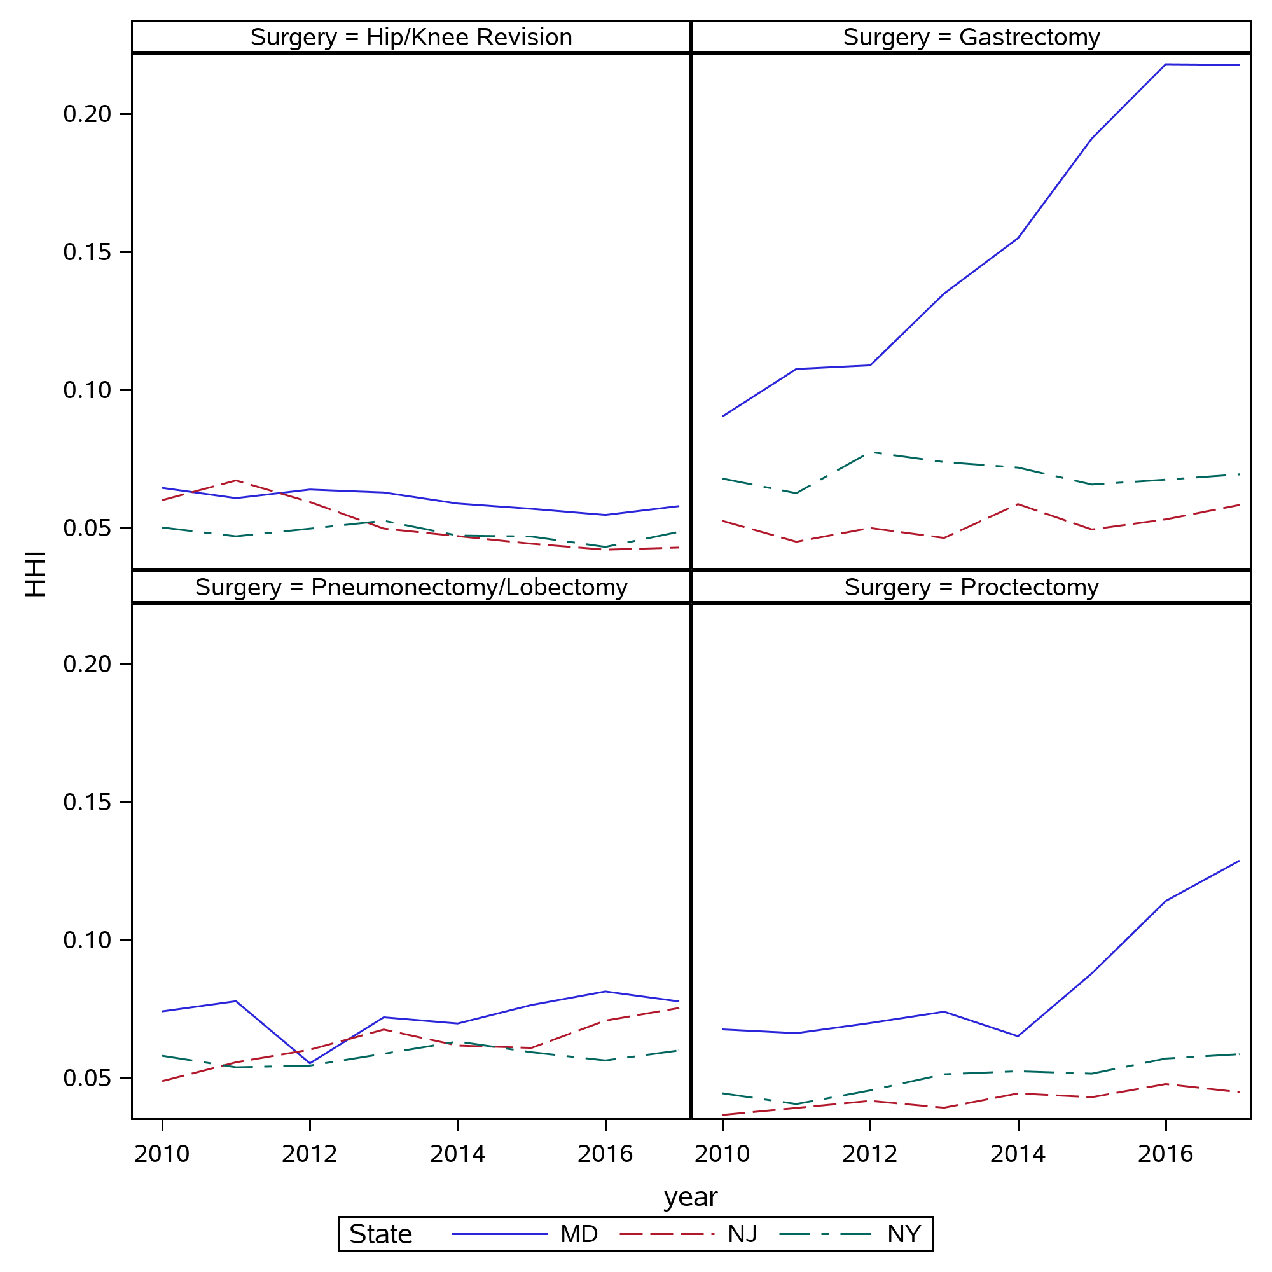
Figure S2. HHIs for hip or knee revision, gastrectomy, pneumonectomy or lobectomy, and proctectomy at the state level by year, 2010-2017.

Reference
- Dimick JB, Nicholas LH, Ryan AM, Thumma JR, Birkmeyer JD. Bariatric surgery complications before vs after implementation of a national policy restricting coverage to centers of excellence. JAMA. 2013 Feb 27;309(8):792-9. doi: 10.1001/jama.2013.755. PMID: 23443442; PMCID: PMC3785293.
- Gourin CG, Vosler PS, Mandal R, Pitman KT, Fakhry C, Eisele DW, Frick KD, Austin JM. Association Between Hospital Market Concentration and Costs of Laryngectomy. JAMA Otolaryngol Head Neck Surg. 2019 Oct 1;145(10):939-947. doi: 10.1001/jamaoto.2019.2303. Erratum in: JAMA Otolaryngol Head Neck Surg. 2020 Jan 1;146(1):85. PMID: 31465102; PMCID: PMC6716289.

