|  |  |  |  |  |
| --- | --- | --- | --- | --- |
| **Supplementary Table 1.** Patient demographic and clinical parameters in the study | | | | |
|  | Group L (10 mmHg)  (n=71) | Group S (15 mmHg)  (n=70) | Total (n=141) | P-value |
| Age, mean (SD), y | 50.73 (12.76) | 53.74 (12.18) | 52.11 (12.48) | 0.154 |
| Gender, n (%) |  |  |  | 0.537 |
| Female | 31 (43.7) | 26 (37.1) | 57 (40.4) |  |
| Male | 40 (56.3) | 44 (62.9) | 84 (59.6) |  |
| BMI, mean (SD) | 23.15 (3.04) | 23.60 (2.75) | 23.37 (2.90) | 0.354 |
| ASA physical status classification, n (%) |  |  |  | 0.935 |
| I | 37 (52.1) | 36 (51.4) | 73 (51.8) |  |
| II | 30 (42.3) | 29 (41.4) | 59 (41.8) |  |
| III | 4 (5.6) | 5 (7.1) | 9 (6.3) |  |
| ARISCAT score, n (%) |  |  |  | 0.639 |
| <26 | 39 (54.9) | 33 (47.1) | 72 (51.1) |  |
| 26-44 | 28 (39.4) | 33 (47.1) | 61 (43.3) |  |
| >44 | 4 (5.6) | 4 (5.7) | 8 (5.7) |  |
| Tobacco use, n (%) | 12 (16.9) | 18 (25.7) | 30 (21.3) | 0.283 |
| Alcohol use, n (%) | 12 (16.9) | 17 (24.3) | 29 (20.6) | 0.381 |
| Recent respiratory infection, n (%) | 6 (8.5) | 5 (7.1) | 11 (7.8) | 1.000 |
| Hypertension, n (%) | 10 (14.1) | 17 (24.3) | 27 (19.1) | 0.185 |
| Diabetes, n (%) | 7 (9.9) | 8 (11.4) | 15 (10.6) | 0.977 |
| Obstructive sleep apnea, n (%) | 2 (2.8) | 1 (1.4) | 3 (2.1) | 1.000 |
| Chronic obstructive pulmonary disease, n (%) | 0 (0.0) | 1 (1.4) | 1 (0.7) | 0.496 |
| Coronary atherosclerotic heart disease, n (%) | 4 (5.6) | 3 (4.3) | 7 (5.0) | 1.000 |
| Preoperative abnormalities on electrocardiogram, n (%) | 1 (1.4) | 2 (2.9) | 3 (2.1) | 0.990 |
| Preoperative abnormalities on echocardiography, n (%) |  |  |  | 0.234 |
| Atrioventricular enlargement, n (%) | 3 (4.3) | 8 (11.6) | 11 (7.8) |  |
| Myocardial abnormality, n (%) | 1 (1.4) | 0 (0.0) | 1 (0.7) |  |
| Valve disorder, n (%) | 1 (1.4) | 3 (4.3) | 4 (2.8) |  |
| Degrees of liver fibrosisa, n (%) |  |  |  | 0.762 |
| Hepatofibrosis | 11 (15.5) | 14 (20.0) | 25 (17.7) |  |
| Cirrhosis | 17 (23.9) | 17 (24.3) | 34 (24.1) |  |
| History of abdominal surgery, n (%) | 23 (32.4) | 23 (32.9) | 46 (32.6) | 0.892 |
| Preoperative use of aspirin, n (%) | 5 (7.0) | 4 (5.7) | 9 (6.4) | 1.000 |
| Preoperative hemoglobin, median [IQR], g/L | 136.00 [122.00, 150.00] | 142.50 [128.25, 151.00] | 139 [124, 151] | 0.298 |
| Types of liver space-occupying lesions, n (%) |  |  |  | 0.519 |
| Focal nodular hyperplasia | 10 (14.1) | 5 (7.1) | 15 (10.6) |  |
| Hepatic cyst | 1 (1.4) | 2 (2.9) | 3 (2.1) |  |
| Hepatic hemangioma | 14 (19.7) | 9 (12.9) | 23 (16.3) |  |
| Hepatocellular carcinoma | 33 (46.5) | 42 (60.0) | 75 (53.2) |  |
| Cholangiocarcinoma | 3 (4.2) | 3 (4.3) | 6 (4.3) |  |
| Metastatic carcinoma | 10 (14.1) | 9 (12.9) | 19 (13.5) |  |
| Active cancer, n (%) | 46 (65.7) | 54 (77.1) | 100 (70.9) | 0.190 |
| Locations of liver space-occupying lesions |  |  |  | 0.265 |
| Anterolateral segments (2, 3, 4b, 5 and 6) | 49 (69.0) | 41 (58.6) | 90 (63.8) |  |
| Posterosuperior segments (1, 4a, 7 and 8) | 22 (31.0) | 29 (41.4) | 51 (36.2) |  |
| Liver resections adjacent to the second hepatic hilus (2, 4a, 7 and 8) | 43 (60.56) | 51 (72.86) | 94 (66.7) | 0.171 |
| Numbers of liver space-occupying lesions, n (%) |  |  |  | 0.279 |
| Single | 56 (78.9) | 61 (87.1) | 117 (83.0) |  |
| Multiple | 15 (21.1) | 9 (12.9) | 24 (17.0) |  |
| Sizes of liver space-occupying lesionsb, n (%) |  |  |  | 0.913 |
| ＜3 cm | 32 (45.7) | 35 (50.0) | 67 (47.5) |  |
| 3-5 cm | 19 (27.1) | 16 (22.9) | 35 (24.8) |  |
| 5-10 cm | 16 (22.9) | 16 (22.9) | 32 (22.7) |  |
| ＞10 cm | 4 (5.7) | 3 (4.3) | 7 (5.0) |  |
| Types of liver resection |  |  |  | 0.983 |
| Majorc | 4 (5.6) | 5 (7.1) | 9 (6.4) |  |
| Minor | 67 (94.4) | 65 (92.9) | 132 (93.6) |  |
| Difficulties of liver resectiond |  |  |  | 0.355 |
| Low difficulty | 29 (40.8) | 25 (35.7) | 54 (38.3) |  |
| Intermediate difficulty | 29 (40.8) | 25 (35.7) | 54 (38.3) |  |
| High difficulty | 13 (18.3) | 20 (28.6) | 33 (23.4) |  |
| Duration of operation, median [IQR], min | 98.00 [74.50, 138.50] | 113.50 [83.50, 158.75] | 105 [78, 145] | 0.086 |
| Note: Data were presented as mean (SD) tested with Student’s t-test, median [IQR] tested with the Wilcoxon rank-sum test or frequency (percentage) tested with the χ2 test, as appropriate.  a Degrees of fibrosis was assessed with the liver stiffness measurement by liver elastography during preoperative ultrasound examination.  b Sizes of multiple nodules was measured according to the largest one.  c Defined as the resection of 3 or more contiguous segments.  d Surgical difficulty level was classified according to the classification described by Kawaguchi et al.24  Low difficulty surgeries include wedge resection and left lateral sectionectomy (resection of segments 2 and 3). Intermediate difficulty surgeries include left hepatectomy (resection of segments 2, 3, and 4±1) and anterolateral segmentectomy (segments 2, 3, 4b, 5, or 6). High difficulty surgeries include central hepatectomy (resection of segments 5 and 8, or segments 4, 5, and 8), extended left hepatectomy (resection of segments 1, 2, 3, 4, 5, and 8), extended right hepatectomy (resection of segments 4, 5, 6, 7, and 8±1), right hepatectomy (resection of segments 5, 6, 7, and 8±1), right posterior sectionectomy (resection of segments 6 and 7) and posterosuperior segmentectomy (segments 1, 4a, 7, or 8).  BMI, body mass index; ASA, American Society of Anesthesiologists; ARISCAT, Assess Respiratory Risk in Surgical Patients in Catalonia; SpO2: peripheral oxygen saturation; SD, standard deviation; IQR, inter-quartile range. | | | | |

|  |  |  |  |  |  |
| --- | --- | --- | --- | --- | --- |
| **Supplementary Table 2.** Sensitivity analysis of primary outcome | | | | | |
|  | No. of Events (%) | |  |  |  |
| Group L (10 mmHg)  (n=71) | Group S (15 mmHg)  (n=70) | Risk difference  (95% CI) | Risk Ratio  (95% CI) | P-value |
| Primary Outcome |  |  |  |  |  |
| Gas embolism ≥ Grade 3, n (%) |  |  |  |  |  |
| ITT analysis | 29 (40.8) | 47 (67.1) | -0.26 (-0.41 to -0.10) | 0.61 (0.44 to 0.85) | 0.003* |
| PPS analysis | 28 (40.0) | 46 (67.6) | -0.28 (-0.42 to -0.11) | 0.59 (0.42 to 0.82) | 0.002* |
| Note: Note: * P<0.05; Data were presented as frequency (percentage) tested with the χ2 test.  ITT, intention-to-treat; PPS, per-protocol set. | | | | | |

|  |  |  |  |  |
| --- | --- | --- | --- | --- |
| **Supplementary Table 3.** Perioperative arterial blood gas measurements | | | | |
|  | Mean changes from baseline | | Treatment difference  (95% CI) | P-value | |
| Group L (10 mmHg)  (n=71) | Group S (15 mmHg)  (n=70) |
| pH, mean (SD) |  |  |  |  | |
| At the beginning of the hepatic parenchymal transection | -0.27 (1.23) | -0.07 (0.05) | -0.21 (-0.49 to 0.09) | 0.165 | |
| At the end of the hepatic parenchymal transection | -0.32 (1.22) | -0.24 (0.88) | -0.09 (-0.45 to 0.26) | 0.604 | |
| PACU | -0.06 (0.04) | -0.07 (0.04) | 0.01 (-0.01 to 0.02) | 0.388 | |
| PaCO2, mean (SD), mm Hg |  |  |  |  | |
| At the beginning of the hepatic parenchymal transection | 2.75 (8.46) | 4.90 (5.53) | -2.33 (-4.51 to 0.15) | 0.076 | |
| At the end of the hepatic parenchymal transection | 8.31 (12.41) | 10.55 (9.96) | -2.42 (-6.05 to 1.19) | 0.186 | |
| PACU | 5.23 (4.10) | 5.76 (4.24) | -0.67 (-1.81 to 0.47) | 0.247 | |
| PaO2, mean (SD), mm Hg |  |  |  |  | |
| At the beginning of the hepatic parenchymal transection | 84.39 (51.31) | 82.34 (51.31) | 2.05 (-12.93 to 17.02) | 0.787 | |
| At the end of the hepatic parenchymal transection | 87.77 (51.63) | 70.01 (54.14) | 16.42 (0.72 to 32.11) | 0.040* | |
| PACU | 82.96 (47.56) | 78.38 (61.09) | 6.29 (-10.02 to 22.61) | 0.446 | |
| Lactate, mean (SD), mmol/L |  |  |  |  | |
| At the beginning of the hepatic parenchymal transection | 0.27 (0.42) | 0.28 (0.54) | -0.06 (-0.21 to 0.09) | 0.437 | |
| At the end of the hepatic parenchymal transection | 1.03 (2.92) | 0.98 (0.93) | -0.03 (-0.76 to 0.70) | 0.936 | |
| PACU | 0.71 (0.63) | 0.94 (1.08) | -0.25 (-0.55 to 0.05) | 0.100 | |
| Glu, mean (SD), mmol/L |  |  |  |  | |
| At the beginning of the hepatic parenchymal transection | 1.80 (1.93) | 1.90 (2.22) | -0.14 (-0.84 to 0.55) | 0.681 | |
| At the end of the hepatic parenchymal transection | 3.62 (2.99) | 4.44 (3.02) | -0.91 (-1.91 to 0.08) | 0.070 | |
| PACU | 4.22 (2.11) | 3.95 (1.79) | 0.23 (-0.43 to 0.88) | 0.495 | |
| Hb, mean (SD), g/L |  |  |  |  | |
| At the beginning of the hepatic parenchymal transection | -0.50 (2.57) | -0.24 (1.62) | -0.39 (-1.09 to 0.31) | 0.270 | |
| At the end of the hepatic parenchymal transection | -0.14 (-0.50) | -0.49 (2.34) | 0.23 (-1.00 to 1.47) | 0.711 | |
| PACU | -0.41 (0.89) | -0.52 (1.06) | 0.06 (-0.26 to 0.39) | 0.693 | |
| Na+, mean (SD), mmol/L |  |  |  |  | |
| At the beginning of the hepatic parenchymal transection | -4.41 (23.05) | -0.61 (2.07) | -3.82 (-9.31 to 1.67) | 0.171 | |
| At the end of the hepatic parenchymal transection | -4.79 (22.92) | -2.60 (16.80) | -2.23 (-8.95 to 4.49) | 0.514 | |
| PACU | -0.77 (1.63) | -0.67 (2.08) | -0.13 (-0.71 to 0.44) | 0.645 | |
| K+, mean (SD), mmol/L |  |  |  |  | |
| At the beginning of the hepatic parenchymal transection | 0.08 (0.70) | 0.20 (0.33) | -0.11 (-0.29 to 0.06) | 0.206 | |
| At the end of the hepatic parenchymal transection | 0.15 (0.76) | 0.24 (0.54) | -0.09 (-0.30 to 0.13) | 0.432 | |
| PACU | 0.26 (0.25) | 0.25 (0.34) | 0.01 (-0.10 to 0.11) | 0.885 | |
| Cl-, mean (SD), mmol/L |  |  |  |  | |
| At the beginning of the hepatic parenchymal transection | -2.49 (18.24) | 0.27 (2.40) | -2.91 (-7.22 to 1.40) | 0.185 | |
| At the end of the hepatic parenchymal transection | -2.63 (18.16) | -1.57 (13.12) | -1.21 (-6.47 to 4.05) | 0.651 | |
| PACU | 0.13 (2.97) | 0.17 (2.36) | -0.16 (-0.88 to 0.56) | 0,663 | |
| Ca2+, mean (SD), mmol/L |  |  |  |  | |
| At the beginning of the hepatic parenchymal transection | -0.06 (0.20) | -0.01 (0.05) | -0.04 (-0.09 to 0.001) | 0.056 | |
| At the end of the hepatic parenchymal transection | -0.07 (0.20) | -0.03 (0.15) | -0.02 (-0.08 to 0.04) | 0.433 | |
| PACU | -0.19 (0.06) | -0.19 (0.06) | -0.01 (-0.01 to 0.02) | 0.561 | |
| Base excess, mean (SD), mmol/L |  |  |  |  | |
| At the beginning of the hepatic parenchymal transection | -2.09 (2.14) | -2.47 (2.45) | 0.09 (-0.57 to 0.74) | 0.795 | |
| At the end of the hepatic parenchymal transection | -3.52 (2.57) | -4.15 (2.63) | 0.28 (-0.44 to 0.99) | 0.440 | |
| PACU | -2.44 (2.14) | -2.95 (2.38) | 0.17 (-0.42 to 0.75) | 0.574 | |
| Note: * P<0.05; Data were presented as mean (SD). Data were tested with analysis of covariance, with baseline as a covariate.  SD, standard deviation; CI, confidence interval; pH: potential of hydrogen; PACU, post-anesthesia care unit; PaO2, partial pressure of oxygen; PaCO2, partial pressure of carbon dioxide; Glu, [glucose](http://shortof.com/suolueci/glu-glucose); Hb, hemoglobin. | | | | |

|  |  |  |  |  |
| --- | --- | --- | --- | --- |
| **Supplementary Table 4.** Laboratory examinations, inflammatory factors and tumor markers | | | | |
|  | Mean changes from baseline | | Treatment difference  (95% CI) | P-value |
| Group L (10mmHg)  (n=71) | Group S (15mmHg)  (n=70) |
| Alanine transaminase, mean (SD), U/L |  |  |  |  |
| POD1 | 205.98 (141.78) | 191.97 (127.31) | 8.70 (-52.05 to 69.44) | 0.777 |
| POD3 | 126.35 (197.31) | 127.97 (162.78) | -1.36 (-46.81 to 44.07) | 0.953 |
| Aspartate transaminase, mean (SD), U/L |  |  |  |  |
| POD1 | 189.41 (182.41) | 190.04 (162.85) | -0.61 (-58.61 to 57.40) | 0.984 |
| POD3 | 42.85 (65.87) | 45.09 (54.53) | -2.99 (-23.17 to 17.19) | 0.770 |
| Bilirubin, mean (SD), μmol/L |  |  |  |  |
| POD1 | 7.82 (0.94) | 9.34 (1.53) | -1.67 (-4.07 to 0.73) | 0.170 |
| POD3 | 9.90 (0.94) | 12.66 (1.54) | -2.80 (-6.41 to 0.81) | 0.127 |
| Creatinine, mean (SD), umol/L |  |  |  |  |
| POD1 | -8.57 (1.11) | -6.53 (1.43) | -2.04 (-5.88 to 1.80) | 0.215 |
| POD3 | -5.51 (1.33) | -6.27 (1.89) | 0.35 (-3.49 to 4.20) | 0.876 |
| Hemoglobin, mean (SD), g/L |  |  |  |  |
| POD1 | -12.39 (14.00) | -14.03 (11.60) | 2.22 (-1.30 to 5.73) | 0.527 |
| POD3 | -11.28 (21.23) | -13.61 (9.11) | 0.36 (-4.90 to 4.18) | 0.837 |
| Albumin, mean (SD), g/L |  |  |  |  |
| POD1 | -0.71 (0.60) | -1.12 (0.54) | 0.16 (-1.27 to 1.59) | 0.826 |
| POD3 | 0.48 (0.57) | 0.40 (0.55) | 0.52 (-0.91 to 1.96) | 0.469 |
| Globulin, mean (SD), g/L |  |  |  |  |
| POD1 | -2.14 (2.83) | -3.27 (2.80) | 0.96 (0.08 to 1.84) | 0.033* |
| POD3 | -2.64 (2.84) | -3.95 (3.13) | 0.95 (0.08 to 1.81) | 0.031* |
| White blood cells, mean (SD), ×109/L |  |  |  |  |
| POD1 | 3.10 (2.13) | 3.15 (2.40) | -0.72 (-1.77 to 033) | 0.177 |
| POD3 | 6.06 (2.61) | 6.81 (3.59) | -0.05 (-0.82 to 0.72) | 0.897 |
| PT, mean (SD), s |  |  |  |  |
| POD1 | 1.45 (0.77) | 1.55 (1.42) | -0.25 (-0.57 to 0.07) | 0.111 |
| POD3 | 1.13 (0.77) | 1.39 (1.09) | -0.12 (-0.45 to 0.20) | 0.606 |
| APTT, mean (SD), s |  |  |  |  |
| POD1 | -0.71 (0.21) | -0.28 (0.56) | -0.48 (-1.65 to 0.69) | 0.418 |
| POD3 | 2.13 (0.27) | 1.95 (0.33) | 0.15 (-0.70 to 0.99) | 0.733 |
| INR, mean (SD) |  |  |  |  |
| POD1 | 0.12 (0.13) | 0.14 (0.14) | -0.01 (-0.06 to 0.08) | 0.861 |
| POD3 | 0.07 (0.17) | 0.08 (0.28) | -0.03 (-0.07 to 0.01) | 0.115 |
| Fibrinogen, mean (SD), mg |  |  |  |  |
| POD1 | 7.18 (7.23) | 0.74 (6.87) | 14.43 (-3.74 to 32.60) | 0.119 |
| POD3 | 227.51 (120.52) | 214.35 (127.09) | 24.78 (-16.46 to 66.02) | 0.237 |
| D-dimer, mean (SD), mg/L |  |  |  |  |
| POD1 | 2.63 (2.67) | 2.84 (2.57) | -0.60 (-1.43 to 0.24) | 0.160 |
| POD3 | 2.93 (2.53) | 3.31 (0.35) | -0.29 (-1.17 to 0.58) | 0.509 |
| Changes from preoperation to POD1, median [IQR] |  |  |  |  |
| IL-1β, pg/mL | 2.74 (3.86) | 3.52 (5.53) | -0.78 (-2.37 to 0.81) | 0.334 |
| IL-6, pg/mL | 21.84 (24.28) | 28.76 (40.75) | -6.92 (-18.07 to 4.23) | 0.233 |
| IL-8, pg/mL | 131.00 (231.50) | 94.49 (141.20) | 17.24 (-32.05 to 66.54) | 0.490 |
| IL-10, pg/mL | 1.57 (2.02) | 2.11 (2.76) | -0.53 (-1.34 to 0.27) | 0.191 |
| cTnT, μg/L | 0.0003 (0.001) | 0.0009 (0.001) | -0.001 (-0.001 to 5.02) | 0.068 |
| CK-MB, U/L | 0.37 (0.76) | 0.74 (1.48) | -0.25 (-0.65 to 0.15) | 0.217 |
| NT-proBNP, pg/L | 214.30 (215.00) | 224.30 (303.90) | -10.04 (-98.04 to 77.95) | 0.822 |
| hs-CRP, mg/L | 19.29 (34.32) | 18.09 (28.13) | 1.20 (-9.45 to 11.86) | 0.824 |
| Changes from preoperation to POD30, median [IQR] |  |  |  |  |
| PIVKA-II, mAU/mL | 26.06 (456.7) | -148.1 (707.2) | 121.23 (-65.72 to 308.19) | 0.202 |
| AFP, ng/mL | -38.11 (124.3) | -69.09 (351.8) | 6.74 (-20.82 to 34.31) | 0.629 |
| CEA, ng/mL | -0.84 (3.52) | -0.66 (1.25) | -0.08 (-0.33 to 0.17) | 0.517 |
| CA199, ng/mL | -5.35 (39.41) | -1.84 (12.05) | -3.51 (-13.53 to 6.50) | 0.572 |
| Serum protein electrophoresis γ, % | -1.37 (1.90) | -1.19 (2.16) | -0.05 (-0.62 to 0.52) | 0.861 |
| Note: *P<0.05; Data were presented as mean (SD) or median [IQR], as appropriate. Changes from preoperation to POD1 and changes from preoperation to POD30 were tested with the Wilcoxon rank-sum test, other data were tested with analysis of covariance, with baseline as a covariate.  POD, postoperative day; SD, standard deviation; CI, confidence interval; PT, prothrombin time; APTT, activated partial thromboplastin time; INR, international normalized ratio; IL, interleukin; cTnT, troponin T; CK-MB, creatine kinase-MB; NT-proBNP, N-terminal pro-B-type natriuretic peptide; hs-CRP, hypersensitive C-reactive protein; IQR, inter-quartile range; PIVKA-II, protein Induced by Vitamin K absence or antagonist-II; AFP, α-fetoprotein; CEA, carcinoembryonic antigen; CA, carbohydrate antigen. | | | | |

**Supplementary Figure 1**

**.**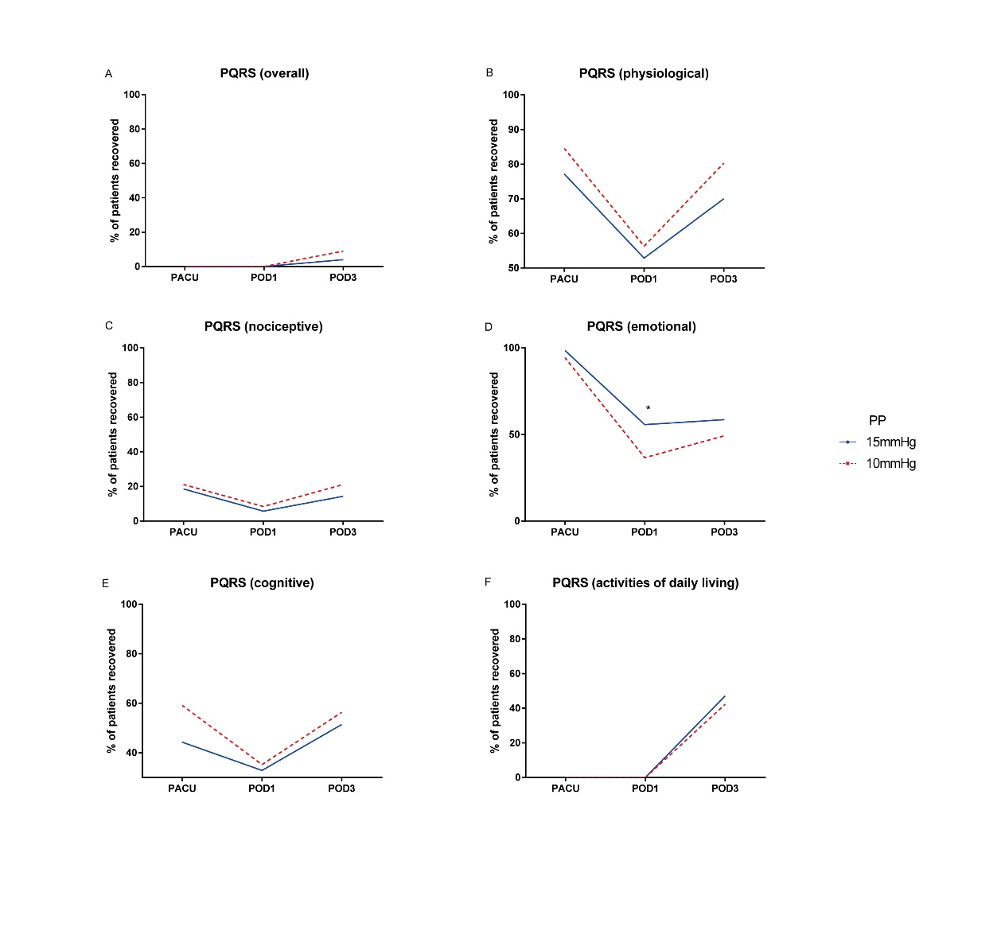

**Supplementary Figure 1.** Postoperative PostopQRS scores. A, overall; B, physiological; C, nociceptive (pain and nausea); D, emotional (anxiety and depression) and E, cognitive recovery; F, recovery of activities of daily living (eating, walking, standing, and dressing) in Group L (10 mmHg) and Group S (15 mmHg). Data were tested with analysis of covariance, with baseline as a covariate. PostopQRS, Postoperative Quality of Recovery Scale; PACU, post-anesthesia care unit; POD, postoperative day; PP, pneumoperitoneum pressure. \**P*<0.05.