Online Supplement Material for:

Assessment of Left Ventricle Myocardial Deformation in a Hemorrhagic Shock Swine Model by Two-Dimensional Speckle Tracking Echocardiography

Henrique Doria de Vasconcellos, MD, MSc; Karen Ruggeri Saad; Paulo Fernandes Saad, MD, PhD; Denise Aya Otsuki, VMD, PhD; Luisa A Ciuffo, MD; Laeben Lester, MD; Marcia K Koike, PhD; Anderson da Costa Armstrong, MD, MSc, PhD; Joao A C Lima, MD, MBA; Edna Frasson de Souza Montero, MD, PhD.

- Supplemental Methods:

Anesthetic protocol
The animals were fasted for 12 hours with free water access before being pre-medicate with a combination of midazolam 0.25 mg/kg (Dormire®, Cristalia Laboratory, Sao Paulo, Brazil) and ketamine hydrochloride (Cetamin®, Cristalia Laboratory, Sao Paulo, Brazil) 5 mg/kg, administrated intramuscularly immediately after the animal arrived in the laboratory.
After achieving adequate sedation, the animals were placed over a thermal blanket in the supine position with the legs fixed to both sides of the surgical table. Non-invasive monitoring of the heart rate, electrocardiography, and pulse oximetry was acquired continuously by a Philips MP50 IntelliVue® multi-parameter monitor (Phillips Medical Systems, Germany) (Supplemental Figure S1 - A). Peripherical intravenous access was obtained by catheterizing the right marginal ear vein using a 20 G caliber catheter (Abbocath®, Abbott hospital products, Sao Paulo, Brazil).
Anesthetic induction was carried out with Propofol (Propovan®, Cristalia Laboratory, São Paulo, Brazil), 5 mg/kg intravenous (IV) administration, followed by endotracheal intubation with an appropriate diameter endotracheal tube. Balanced anesthesia was accomplished and maintained using a Dräger anesthesia workstation Primus® (Drägerwerk AG & Co., Lübeck, Germany) (Supplemental Figure S1 - B) with Isoflurane at expired concentrations of 1.2% to 1.4% and Fentanyl (Fentanest®, Cristalia Laboratory, Sao Paulo, Brazil) 3 ug/kg IV as needed. Muscle relaxation was assured by continuous infusion of 5 ug/kg/min IV of Pancuronium (Pacuron®, Cristalia Laboratory, Sao Paulo, Brazil).
Volume-limited ventilation was employed throughout the procedure, setting tidal volume (VT) of 8 ml/kg, positive end-expiratory pressure (PEEP) of 5 cmH₂0, fraction of inspired oxygen (F_{i}O₂) of 40%, and the respiratory rate (RR) adjusted to maintain an expired fraction of carbon dioxide (P_{E}CO₂) between 35 and 45 mmHg.
After anesthetic induction, endotracheal intubation, and surgical instrumentation, the animals were under observation for 15 minutes for hemodynamic stabilization, during which Ringer's Lactated solution (Baxter Hospital Ltda., Sao Paulo, Brazil) was administrated at an infusion rate of 15 mL/kg IV to restore the fluid losses due to prolonged fasting and replace the blood loss due to sternotomy. Continuous infusion of the same type of crystalloid solution at 5 mL/kg/ h IV was utilized during the surgical procedures aiming to restore the insensitive and sensible fluid losses.

Instrumentation and monitoring
After skin antisepsis and placement of sterile surgical drapes, dissections of the right internal jugular vein, right femoral artery, left femoral vein, and cystostomy was performed (Supplemental Figure S2 – A and B). Subsequently, it was inserted: a) Intracath® 18G polyethylene catheter (Abbocath, Abbot Produtos Hospitalares, Sao Paulo, Brazil) into the right femoral artery to obtain continuous invasive arterial blood pressure monitorization, arterial blood gas collection, and a via for inducing the experimental controlled hemorrhagic shock; b) 18G polyethylene catheter in the left femoral vein to allow fast blood volume replacement; c) pulmonary artery catheter number 7.5F / 110 cm (Swan -Ganz CCOmbo®, Edwards, California, USA) in the right internal jugular vein, guided by the pressures curves analysis of the right atrial (RA), right ventricle (RV), pulmonary artery (PA), and pulmonary artery occlusion pressure (PAOP), allowing continuous cardiac output and mixed venous oxygen saturation (S_{v}O₂) assessment using the Vigilance® cardiac output monitor (Edwards, California, USA) ) (Supplemental Figure S1 - C). A total sternotomy (manubrium, body, and xiphoid process) was made, and the heart was exposed with preservation of the pericardium involucrum. (Supplemental Figure S2 - C)

Right Heart Catheterization
Cardiac output (CO) and cardiac index (CI): The CO was obtained by the thermodilution method. The CO evaluation was performed continuously and manually injecting 10 ml of 5% glucose solution at a temperature of 0° to 5° C on the proximal catheter lumen on three consecutive measurements. The CI will be calculated using the following formula:

CI = CO / BSA⁻¹, where:
CI = Cardiac index, in L/min⁻¹/m²
CO = Cardiac output, in L/min⁻¹
Animal body surface area (BSA), in m², was determined by the formula:
BSA = K x W^{2/3} where:
K = constant of 0,09 for animals above 4 kg
W = animal weight in kg.
Right ventricle end-diastolic volume (RVEDV): The RVEDV and RV ejection fraction was continuously obtained by thermodilution method using the volumetric pulmonary artery catheter.
Right Atrium Pressure (RAP), Pulmonary Artery Pressure (PAP), Pulmonary Artery Occlusion Pressure (PAOP): The proximal and the distal catheter lumens were connected to the pressure transducers to obtain RAP and PAP, respectively. The POAP was intermittently obtained by inflating the balloon at the distal end of the catheter
Continuous mixed venous blood oxygen saturation (_{c}S_{V}O₂): _{c}S_{V}O₂ was obtained continuously through the pulmonary artery catheter and displayed in the cardiac output monitor.

Blood Gas Analysis
The blood gas analyzes were performed at T0, T1, T3, and T4 times. Blood samples were collected from the femoral artery access aiming to determine the partial pressure of oxygen dissolved in the arterial blood (P_{a}O₂), partial pressure of carbon dioxide dissolved in the arterial blood (P_{a}CO₂), arterial blood pH (pH), base excess (BE), bicarbonate, lactate, sodium, potassium, and calcium plasma concentration using a blood gas analyzer (Radiometer ABL 555, Radiometer Medical, Copenhagen, Denmark).

Troponin I
Cardiac troponin I was measured at T0, T2, and T4 times using a two-site chemiluminescent enzyme immunoassay (Immulite Kit®, Diagnostic Products Corporation, Los Angeles, CA, USA).

Euthanasia and animal discarding
After the study was completed, the animals were euthanized by IV of 10 mL of potassium chloride. At the end of the experimental procedure, the research animals were conditioned in identified disposal plastic bags and sent to the FMUSP biological waste deposit for posterior incineration.

- Supplemental Figures:

Supplemental - Figure S1.
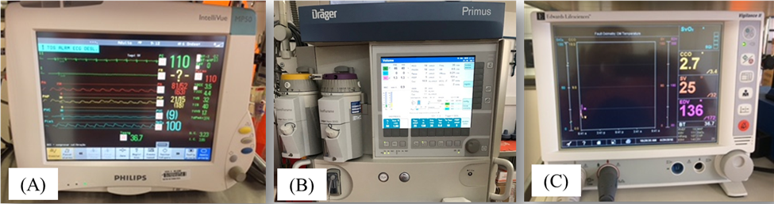
Multi-parameter monitor for continuous evaluation of systemic and pulmonary blood pressure, heart rate, EKG, central venous pressure, and pulse oximetry (A); anesthesia workstation (B); multi-parameter monitor for continuous evaluation of cardiac output, end-diastolic volume, systemic vascular resistance and continuous mixed venous blood oxygen saturation (_{c}SVO₂).

Supplemental - Figure S2.
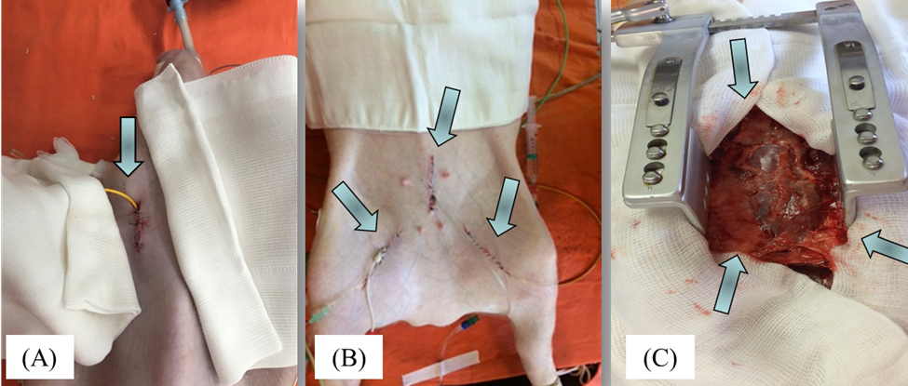 Surgical dissections of the right internal jugular vein (A); right femoral artery, left femoral vein, and cystostomy (B); and total sternotomy (manubrium, body, and xiphoid process) with preservation of the pericardium involucrum (C) during the experimental hemorrhagic shock swine model.

Supplemental - Figure S3.
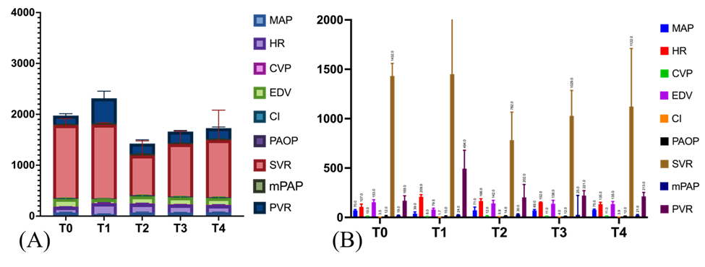
Grouped (A) and individuals (B) bars plots showing the hemodynamic variables data of study animals during the experimental hemorrhagic shock swine model.
Abbreviations: MAP: mean arterial blood pressure, HR: heart rate, CVP: central venous pressure, EDV: end-diastolic volume, CI: cardiac index, PAOP: pulmonary artery occluded pressure, SVR: systemic vascular resistance, mPAP: mean pulmonary arterial pressure, PVR: pulmonary vascular resistance, T0: after anesthetic induction and hemodynamic stabilization, T1: one hour after a severe hemorrhagic shock status was established, T2: immediately after complete blood volume replacement, T3: one hour after complete blood volume replacement, T4: two hours after complete blood volume replacement

Supplemental - Figure S4.
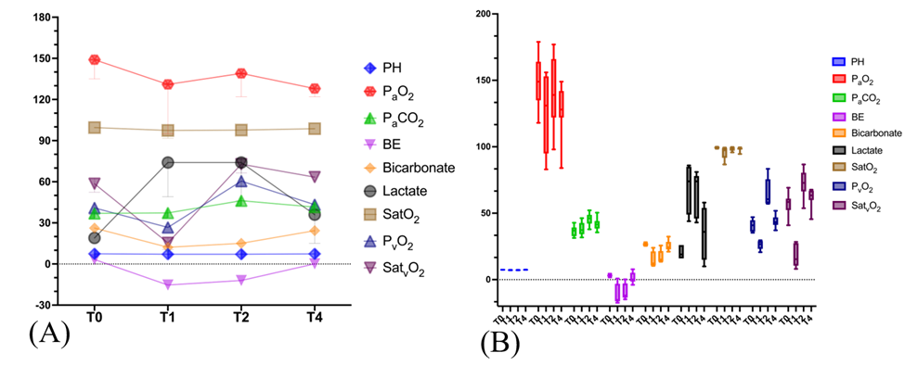Dot plots (A) and whisker plots (B) showing blood gases variables data of study animals during the experimental hemorrhagic shock swine model.
Abbreviations: PH: acidity, P_{a}O₂: partial arterial pressure of oxygen, P_{a}CO₂: partial arterial pressure of carbon dioxide, S_{a}O₂: arterial oxygen saturation, BE: base excess, P_{v}O₂: partial venous pressure of oxygen, S_{v}O₂: mix-venous oxygen saturation, T0: after anesthetic induction and hemodynamic stabilization; T1: one hour after a severe hemorrhagic shock status was established, T2: immediately after complete blood volume replacement, T4: two hours after complete blood volume replacement.

Supplemental - Figure S5.
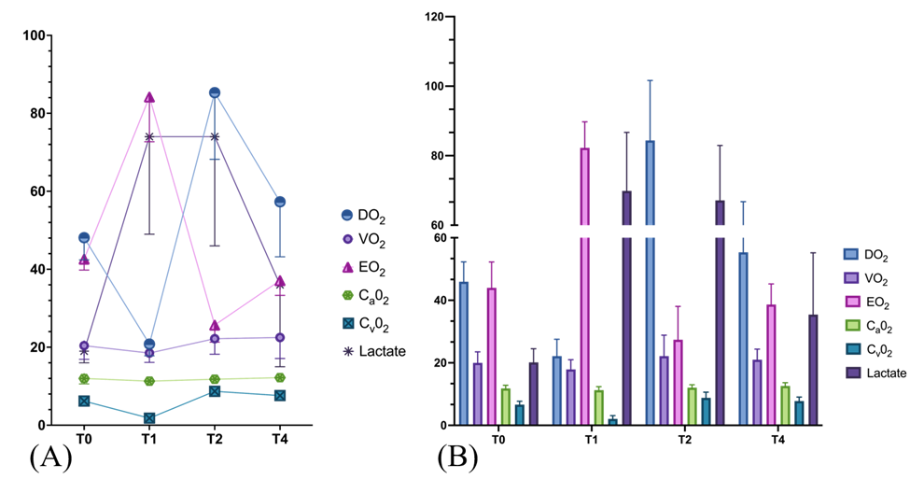
Dot plots (A) and bar plot (B) showing the micro-dynamic tissue oxygen variables data of study animals during the experimental hemorrhagic shock swine model.
Abbreviations: CaO2: arterial oxygen content, CvO2: mix-venous oxygen content, DO2: oxygen deliver, VO2: oxygen consumption, EO2: oxygen extraction ratio, T0: after anesthetic induction and hemodynamic stabilization, T1: one hour after a severe hemorrhagic shock status was established, T2: immediately after complete blood volume replacement, T4: two hours after complete blood volume replacement

Supplemental - Figure S6.
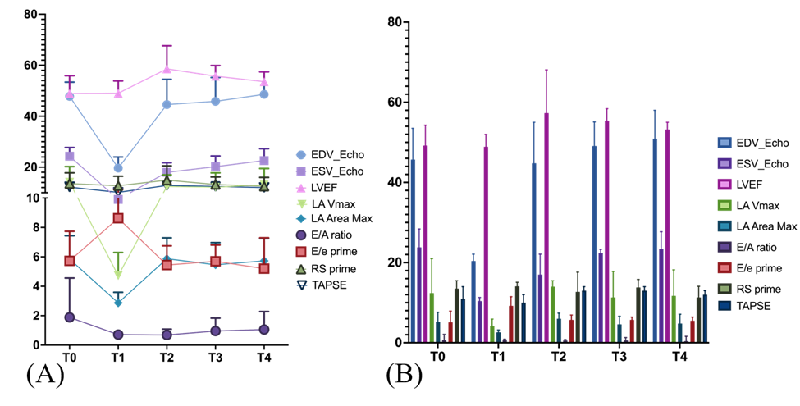
Dot plots (A) and bars plots showing the two-dimension echocardiogram variables data of study animals during the experimental hemorrhagic shock swine model.
Abbreviations: EDV: end-diastolic volume, ESV: end-systolic volume, EF: ejection fraction, LA: left atrium , Vmax: maximum volume, Max: maximum, E/A: ratio between peak transmitral flow velocities from the early (E) and late (A) diastolic phase, E/e prime: ratio between peak transmitral flow velocities from the early (E) diastolic phase and average between early septal and lateral mitral annular diastolic peak velocities, , RS prime: right ventricle annular systolic peak velocity, TAPSE: tricuspid annulus plane systolic excursion, GCS: global circumferential strain, GLS: global longitudinal strain, T0: after anesthetic induction and hemodynamic stabilization, T1: one hour after a severe hemorrhagic shock status was established, T2: immediately after complete blood volume replacement, T3: one hour after complete blood volume replacement, T4: two hours after complete blood volume replacement.

- Supplementary Tables

Supplemental Table S1. Hemodynamic variables data of study animals during the experimental hemorrhagic shock swine model.
Variable ^{a, c} | T0 | T1 | T2 | T3 | T4 | p-value ^{b}
SBP, (mmHg) | 94 (86, 101) | 53 (45, 59) | 102 (90, 119) | 92 (87, 95) | 97 (84, 103) | 0.50
DBP, (mmHg) | 58 (51, 65) | 31 (27, 39) | 52 (49, 59) | 52 (48, 62) | 60 (47, 66) | 0.93
MAP, (mmHg) | 70 (67, 80) | 39 (36, 46) | 71 (67, 83) | 69 (63, 76) | 75 (63, 82) | 0.74
HR, (bpm) | 107 (92, 116) | 209 (199, 228) | 166 (145, 185) | 152 (122, 153) | 135 (119, 153) | 0.028
CO, (L/min) | 4.1 (3.3, 4.3) | 1.9 (1.8, 2.3) | 6.5 (5.8, 8.7) | 4.8 (4.3, 5.2) | 4.2 (3.7, 5.1) | 0.05
CI, (L/min/m²) | 3.5 (2.6, 4.1) | 1.7 (1.6, 2.0) | 5.9 (5.4, 7.8) | 4.0 (3.6, 4.8) | 3.9 (3.0, 4.6) | 0.05
EDV, (mL) | 153 (140, 174) | 79.5 (67, 89) | 142 (108, 169) | 138 (100, 160) | 135 (118, 159) | 0.043
ESV, (mL) | 111 (92, 138) | 67 (57.5, 77) | 107 (67, 127) | 109 (73, 136) | 108 (84, 128) | 0.31
SVR, (dyn/seg/cm⁻⁵) | 1432 (1101, 1559) | 1450 (1174, 1489) | 782 (713, 1066) | 1029 (971, 1286) | 1122 (987, 1710) | 0.74
_{S}PAP, (mmHg) | 25 (23, 28) | 27 (25, 28) | 46 (36, 47) | 32 (31, 36) | 32 (28, 37) | 0.018
_{d}PAP, (mmHg) | 18 (14, 18) | 20 (15, 23) | 28 (26, 29) | 19 (17, 22) | 18 (16, 21) | 0.13
_{m}PAP, (mmHg) | 19 (18, 22) | 24 (19, 25) | 30 (29, 36) | 25 (21, 25) | 21 (19, 26) | 0.09
CVP, (mmHg) | 10 (10, 11) | 8 (8, 9) | 12 (11, 13) | 11 (11, 12) | 11 (9, 12) | 0.41
PAOP, (mmHg) | 12 (11, 15) | 10 (10, 12) | 14 (13, 14) | 12 (12, 13) | 12 (12, 14) | 0.28
PVR, (dyn/seg/cm⁻⁵) | 169 (121, 205) | 494 (374, 634) | 202 (138, 277) | 221 (149, 243) | 213 (205, 236) | 0.11

ª Data are presented as median (interquartile range).
^{b} P values were calculated by Wilcoxon rank sum test comparing T0 and T4 evaluation times. P<0.05 was considered significant.
^{c} Abbreviations: SBP: systolic blood pressure, DBP: diastolic blood pressure, MAP: mean arterial blood pressure, HR: heart rate, CO: cardiac output, CI: cardiac index, EDV: end-diastolic volume, ESV: end-systolic volume, SVR: systemic vascular resistance, _{s}PAP: systolic pulmonary arterial pressure, _{d}PAP: diastolic pulmonary arterial pressure, _{m}PAP: mean pulmonary arterial pressure, CVP: central venous pressure, PAOP: pulmonary artery occluded pressure, PVR: pulmonary vascular resistance, T0: after anesthetic induction and hemodynamic stabilization, T1: one hour after a severe hemorrhagic shock status was established, T2: immediately after complete blood volume replacement, T3: one hour after complete blood volume replacement, T4: two hours after complete blood volume replacement.

Supplemental Table S2. Arterial and venous blood gases variables data of study animals during the experimental hemorrhagic shock swine model.
Variable ^{a, c} | T0 | T1 | T2 | T4 | p-value ^{b}
PH | 7.46 (7.44, 7.55) | 7.15 (7.10, 7.33) | 7.15 (7.13, 7.31) | 7.40 (7.34, 7.42) | 0.022
P_{a}O_{2,} (mmHg) | 149 (135, 164) | 131 (94.5, 153) | 131 (94.5, 153) | 128 (122. 142) | 0.018
P_{a}CO₂, (mmHg) | 36.9 (32.7, 39.3) | 37.3 (34.2, 42.7) | 46.2 (42.2, 48.8) | 41.5 (38.5, 44.1) | 0.018
S_{a}O_{2,} (%) | 99.5 (98.8, 99.9) | 97.4 (91.7, 99.0) | 97.7 (97.1, 99.6) | 98.7 (97.9, 99.1) | 0.028
BE | 3.3 (2.4, 3.4) | -15.3 (-16.3, -3.1) | -12 (-13.5, -2.9) | 0.1 (-1.4, 5.2) | 0.18
Bicarbonate, (mEq/L) | 26.2 (25.6, 27.5) | 12.2 (10.8, 21.3) | 15.1 (1.38, 21.5) | 24.3 (22.8, 28.4) | 0.50
Lactate, (mg/dL) | 19 (16, 26) | 74 (49, 85) | 74 (46, 78) | 36 (15, 54) | 0.24
P_{v}O₂, (mmHg) | 40.9 (36.1, 44.7) | 26.7 (23.2, 29.1) | 60.5 (57.7, 72.9) | 43.3 (41.2, 46.9) | 0.043
S_{v}O₂, (%) | 58.5 (52.4, 61) | 15.4 (10.5, 27.5) | 72.8 (66.4, 80.5) | 63.4 (59.9, 67) | 0.043
Hematocrit, (%) | 27 (23.7, 28.3) | 26.3 (24.3, 29.3) | 26.9 (25.4, 31.32) | 27.8 (27.4, 31.1) | 0.043
Hemoglobin, (g/L) | 8.7 (7.6, 9.1) | 8.5 (7.8, 9.5) | 8.7 (8.2, 9.8) | 9 (8.8, 10.1) | 0.042
Sodium, (mEq/L) | 137 (136, 138) | 133 (132, 137) | 138 (135, 139) | 134 (131, 135) | 0.018
Potassium, (mEq/L) | 3.8 (3.5, 3.8) | 4.7 (4, 5.8) | 3.7 (3.2, 4.0) | 4.5 (4.1, 5.4) | 0.018
Chloride, (mEq/L) | 103 (102, 106) | 104 (101, 106) | 104 (103, 106) | 101 (99, 101) | 0.017
Calcium, (mg/dL) | 4.3 (3.7, 4.4) | 3.5 (3.4, 4.5) | 3.8 (2.9, 4.4) | 4.2 (4.1, 4.5) | 0.61
Glucose, (g/dL) | 102 (85, 117) | 255 (87, 322) | 173 (90, 235) | 128 (92, 146) | 0.24
Troponin, (ng/mL) | 84 (14, 218) | 553 (1760, 3330) | 1760 (969, 3150) | 3330 (1480, 10520) | 0.018

ª Data are presented as median (interquartile range).
^{b} P values were calculated Wilcoxon rank sum test comparing T0 and T4 evaluation times.
^{c} Abbreviations: PH: acidity, P_{a}O₂: partial arterial pressure of oxygen, P_{a}CO₂: partial arterial pressure of carbon dioxide, S_{a}O₂: arterial oxygen saturation, BE: base excess, P_{v}O₂: partial venous pressure of oxygen, S_{v}O₂: mix-venous oxygen saturation, T0: after anesthetic induction and hemodynamic stabilization; T1: one hour after a severe hemorrhagic shock status was established, T2: immediately after complete blood volume replacement, T4: two hours after complete blood volume replacement

Supplemental Table S3. Micro-dynamic tissue oxygen variables data of study animals during the experimental hemorrhagic shock swine model.
Variable ^{a, c} | T0 | T1 | T2 | T4 | p-value ^{b}
C_{a}O₂, (mL/dL) | 12.1 (10.6, 12.6) | 11.3 (10.4, 11.8) | 11.8 (11.3, 13.1) | 12.2 (11.7, 13.6) | 0.09
C_{v}O₂, (mL/dL) | 6.2 (5.8, 7.2) | 1.8 (1.3, 3.4) | 8.7 (7.6, 9.8) | 7.6 (7.1, 9.0) | 0.018
DO₂, (mL/min) | 48.1 (42.4, 51.3) | 20.8 (17.8, 26.5) | 85.3 (68.2, 98.1) | 57.3 (43.2, 66.9) | 0.018
VO₂, (mL/min) | 20.4 (16.9, 22.7) | 18.5 (16.1, 19.9) | 22.2 (18.2, 26.6) | 22.5 (17.1, 23.0) | 0.05
EO₂, (%) | 42.6 (39.8, 48.4) | 84.2 (72.7, 89) | 25.7 (21.3, 32.7) | 37.1 (33.3, 39.8) | 0.018

ª Data are presented as median (interquartile range).
^{b} P values were calculated by Wilcoxon rank sum test comparing T0 and T4 evaluation times.
^{c} Abbreviations: C_{a}O₂: arterial oxygen content, C_{v}O₂: mix-venous oxygen content, DO₂: oxygen deliver, VO₂: oxygen consumption, EO₂: oxygen extraction ratio, T0: after anesthetic induction and hemodynamic stabilization, T1: one hour after a severe hemorrhagic shock status was established, T2: immediately after complete blood volume replacement, T4: two hours after complete blood volume replacement.

Supplemental Table S4. Two-dimension echocardiogram variables data of study animals during the experimental hemorrhagic shock swine model.
Variable ^{a, c} | T0 | T1 | T2 | T3 | T4 | p-value ^{b}
LV EDV, (mL) | 45.7 (43.1, 53.5) | 20.4 (16.6, 22.1) | 44.8 (35.9, 55.0) | 49.1 (37.3,55.1) | 50.9 (38.7, 58) | 0.84
LV ESV, (mL) | 23.8 (21.9, 28.4) | 10.4 (8.1, 11.3) | 17 (14.3, 22.1) | 22.4 (15.5,23.3) | 23.4 (19.9, 27.7) | 0.18
LV EF, (%) | 49.2 (44.0, 54.3) | 48.9 (45.1, 52) | 57.3 (54.2, 68.1) | 55.4 (52.6,58.4) | 53.2 (51.5, 55.0) | 0.09
HR, (bpm) | 116 (92, 125) | 196 (191, 198) | 165 (130, 192) | 152 (132, 166) | 131 (116, 153) | 0.13
CO, (mL/min) | 2.3 (2.1, 3.1) | 2.0 (1.3, 2.4) | 4.2 (2.5, 6.3) | 3.9 (2.5, 4.7) | 3.4 (2.9, 3.8) | 0.06
E/A | 0.7 (0.5, 2.1) | 0.8 (0.6, 0.9) | 0.6 (0.4, 0.8) | 0.6 (0.5, 1.3) | 0.4 (0.4, 1.6) | 0.74
E prime, (cm/s) | 9.8 (8, 13) | 5.8 (4.8, 7.5) | 14.1 (10.2, 15.1) | 10.1 9.2 11.1) | 11. (7.9, 12.4) | 0.50
E/e prime | 5.1 (4.4, 7.9) | 9.2 (6.2, 11.5) | 5.7 (4.4, 6.9) | 5.7 (4.7, 6.4) | 5.5 (4.0, 6.4) | 0.87
LA area, (cm²) | 5.2 (4.7, 7.6) | 2.6 (2.4, 3.2) | 6 (4.5, 7.4) | 4.6 (4.4, 6.6) | 4.8 (4.4, 7.1) | 0.40
LA volume, (mL) | 12.4 (10.7, 21) | 4.2 (3.8, 5.9) | 14 (6.6, 45.5) | 11.3 (6.7, 17.8) | 11.7 (7.4, 18.2) | 0.40
RS prime, (cm/s) | 13.5 (10.4, 15.5) | 14.1 (7.9, 15.1) | 12.7 (10.2, 17.6) | 13.8 (10.1, 15.8) | 11.3 (10.3, 14.1) | 0.40
TAPSE, (mm) | 11 (11, 14) | 10 (9, 12) | 13 (11, 14) | 13 (12, 14) | 12 (10, 13) | 0.93
LV GCS, (%) | -9.6 (-10.7, -8.0) | -3.8 (-5.2, -2.5) | -10.4 (-12.4, -8.2) | -8.9 (-13.0, -8.4) | -7.9 (-8.1, -7.4) | 0.06
LV GLS, (%) | -10.7 (-14.4, -9.0) | -5.3 (-6.6, -4.6) | -9.0 (-12.1, -8.0) | -8. (-10.5, -7.7) | -8.5 (-8.6, -5.2) | 0.028

ª Data are presented as median (interquartile range).
^{b} P values were calculated by Wilcoxon rank sum test comparing T0 and T4 evaluation times.
^{c} Abbreviations: LV: left ventricle, EDV: end-diastolic volume, ESV: end-systolic volume, EF: ejection fraction, HR: heart rate, CO: cardiac output, E/A: ratio between peak transmitral flow velocities from the early (E) and late (A) diastolic phase, e prime: average between early septal and lateral mitral annular diastolic peak velocities, E/e prime: ratio between peak transmitral flow velocities from the early (E) diastolic phase and average between early septal and lateral mitral annular diastolic peak velocities, LA: left atrium, RS prime: right ventricle annular systolic peak velocity, TAPSE: tricuspid annulus plane systolic excursion, GCS: global circumferential strain, GLS: global longitudinal strain, T0: after anesthetic induction and hemodynamic stabilization, T1: one hour after a severe hemorrhagic shock status was established, T2: immediately after complete blood volume replacement, T3: one hour after complete blood volume replacement, T4: two hours after complete blood volume replacement.

Supplemental Table S5. Association between hemodynamics, metabolic, and 2D echocardiogram parameters one hour after a severe hemorrhagic shock status was established with left ventricle longitudinal strain two hours after complete blood volume replacement.
Variable ^{a, c} | β | 95% CI | R square | p-value ^{b}
Hemodynamic
MAP, (mmHg) | 0.03 | (-0.10, 0.16) | 0.06 | 0.56
HR, (bpm) | 0.04 | (-0.01, 0.09) | 0.49 | 0.08
EDV, (mL) | -0.05 | (-0.27, 0.19) | 0.04 | 0.66
ESV, (mL) | -0.19 | (-0.75, 0.36) | 0.14 | 0.41
CI, (L/min/m²) | -0.59 | (-3.6, 2.42) | 0.05 | 0.64
SVR, (dyn/seg/cm⁻⁵) | 0.001 | (-0.002, 0.004) | 0.14 | 0.42
_{S}PAP, (mmHg) | -0.11 | (-0.29, 0.78) | 0.31 | 0.20
Blood Gases
P_{a}O_{2,} (mmHg) | 0.01 | (-0.02, 0.04) | 0.08 | 0.53
P_{a}CO₂, (mmHg) | -0.02 | (-0.22, 0.17) | 0.02 | 0.76
S_{a}O_{2,} (%) | 0.03 | (-0.17, 0.23) | 0.03 | 0.71
BE | 0.03 | (-0.10, 0.17) | 0.08 | 0.54
Lactate, (mg/dL) | -0.03 | (-0.08, 0.02) | 0.31 | 0.18
P_{v}O₂, (mmHg) | 0.11 | (-0.18, 0.40) | 0.16 | 0.38
S_{v}O₂, (%) | 0.06 | (-0.05, 0.16) | 0.28 | 0.22
Microdynamic Tissue Oxygenation
C_{a}O₂, (mL/dL) * | 0.64 | (0.10, 1.17) | 0.65 | 0.029
C_{v}O₂, (mL/dL) | 0.53 | (-0.21, 1.28) | 0.40 | 0.13
DO₂, (mL/min) | 0.04 | (-0.14, 0.22) | 0.06 | 0.59
VO₂, (mL/min) | 0.02 | (-0.30, 0.34) | 0.001 | 0.87
EO₂, (%) | -0.06 | (-0.18, 0.05) | 0.30 | 0.21
ª Univariable linear regression analysis.
^{b} P<0.05 was considered significant
^{c} Abbreviations: MAP: mean arterial pressure, HR: hear rate, EDV: end-diastolic volume, ESV: end-systolic volume, CI: cardiac index, SVR: systemic vascular resistance, _{S}PAP: systolic pulmonary artery pressure, P_{a}O₂: partial arterial pressure of oxygen, P_{a}CO₂: partial arterial pressure of carbon dioxide, S_{a}O₂: arterial oxygen saturation, BE: base excess, P_{v}O₂: partial venous pressure of oxygen, S_{v}O₂: mix-venous oxygen saturation, C_{a}O₂: arterial oxygen content, C_{v}O₂: mix-venous oxygen content, DO₂: oxygen deliver, VO₂: oxygen consumption, EO₂: oxygen extraction ratio.

- Supplemental Speckle Tracking Echocardiography Movies

Supplemental STE Video S-1.

Supplemental STE Video S-2.

