Supplemental digital content

Supplementary methods. Data cleaning and quality control

Figure S1. Geographical distribution of the participating centers in this study

Table S1. List of the participating centers and site principal investigators in this study

Table S2. Patient and hospital characteristics of all participants by management group within 48 hours of admission (Additional information)

Table S3. Subgroup analysis: univariant comparison of delayed pseudoaneurysm formation by management group within 48 hours of admission

Figure S2. Dotplot showing A) diameter of pseudoaneurysm, and B) distance from spleen/liver capsule to pseudoaneurysm by AAST grade of injury (1994 version)

Supplementary methods. Data cleaning and quality control

Study data were collected and managed through the REDCap (Research Electronic Data Capture, Vanderbilt University, Nashville, TN) tool hosted at Kameda Medical Center, Chiba, Japan. REDCap is a secure, web-based software platform designed to support data capture for research studies. Data registered in REDCap were grouped according to the timing of completed data registration, and data entry errors were checked according to a pre-developed data cleaning logic.^{30,31} All facilities were requested to perform this data cleaning process at least twice to crosscheck for inconsistencies, outliers, and missing data by the research investigator per site and correct them. The cleaning logic was updated each time, and the final data cleaning process was conducted simultaneously at all facilities after the data registration of all enrolled cases was completed. This repeated data cleaning for quality control allowed for differences in the quality of data collection between the 83 participating centers to be corrected before data locking.^{31,32} All items corrected in the data cleaning process were kept on record.

References
31. Van den Broeck J, Cunningham SA, Eeckels R, Herbst K. Data cleaning: detecting, diagnosing, and editing data abnormalities. PLoS Med. 2005;2(10):e267.
32. Caloto T; Multicentre Project for Tuberculosis Research Study Group. Quality control and data-handling in multicentre studies: the case of the Multicentre Project for Tuberculosis Research. BMC Med Res Methodol. 2001;1:14.

Figure S1. Geographical distribution of the participating centers in this study
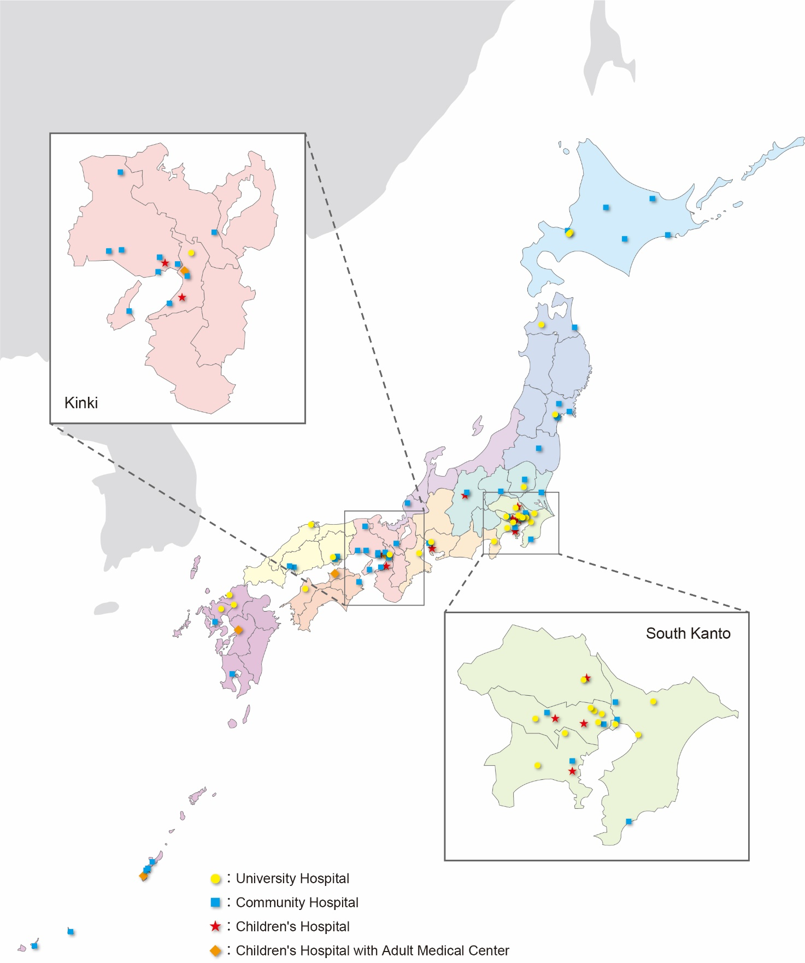

Table S1. A list of the participating centers and site principal investigators in this study (in alphabetical order by site)
No. | Institution name | Site principal investigators
1 | Aichi Children's Health and Medical Center | Tomoya Ito
2 | Aizawa Hospital | Motoyoshi Yamamoto | Yoshihiro Yamamoto
3 | Asahikawa Red Cross Hospital | Hiroto Manase
4 | Chiba University Hospital | Nozomi Takahashi
5 | Chukyo Hospital | Akinori Osuka
6 | Ehime University Hospital | Suguru Annen
7 | Fukui Prefectural Hospital | Nobuki Ishikawa
8 | Fukuoka University Hospital | Kazushi Takayama
9 | Hachinohe City Hospital | Keita Minowa
10 | Hirosaki University Hospital | Kenichi Hakamada
11 | Hiroshima Prefectural Hospital | Akari Kusaka
12 | Hokkaido university hospital | Mineji Hayakawa | Shota Kawahara
13 | Hyogo Emergency Medical Center | Marika Matsumoto
14 | Hyogo Prefectural Amagasaki General Medical Center | Kohei Kusumoto
15 | Hyogo Prefectural Awaji Medical Center | Hiroshi Kodaira
16 | Hyogo Prefectural Kakogawa Medical Center | Chika Kunishige
17 | Hyogo Prefectural Kobe Children's Hospital | Keiichiro Toma | Yusuke Seino
18 | Ishinomaki Red Cross Hospital | Michio Kobayashi
19 | JA Hiroshima General Hospital | Masaaki Sakuraya
20 | Jichi Medical University Hospital | Takafumi Shinjo | Shigeru Ono
21 | Jichi Medical University Saitama Medical Center | Hideto Yasuda | Haruka Taira
22 | Juntendo University Shizuoka Hospital | Kazuhiko Omori
23 | Juntendo University Urayasu Hospital | Yutaka Kondo
24 | Kagoshima City Hospital | Yoshio Kamimura
25 | Kameda Medical Center | Atsushi Shiraishi | Rei Tanaka
26 | Kanagawa Children's Medical Center | Yukihiro Tsuzuki
27 | Keio University Hospital | Yukio Sato
28 | Kitami Red Cross Hospital | Noriaki Kyogoku
29 | Kobe City Medical Center General Hospital | Masafumi Onishi | Kaichi Kawai
30 | Japanese Red Cross Kumamoto Hospital | Kazuyuki Hayashida | Keiko Terazumi
31 | Kurashiki Central Hospital | Akira Kuriyama | Susumu Matsushime
32 | Kurume University Hospital | Osamu Takasu | Toshio Morita
33 | Kushiro City General Hospital | Nagato Sato
34 | Kyoto Second Red Cross Hospital | Wataru Ishii | Michitaro Miyaguni
35 | Maebashi Red Cross Hospital | Yosuke Nakabayashi | Yoshimi Ohtaki
36 | Matsudo City General Hospital | Kiyoshi Murata | Masayuki Yagi
37 | Mie University Hospital | Tadashi Kaneko
38 | Nagano Children's Hospital | Shigeru Takamizawa
39 | Nagoya University Hospital | Akihiro Yasui
40 | Nakagami Hospital | Yasuaki Mayama
41 | National Center for Child Health and Development | Masafumi Gima
42 | National Hospital Organization Disaster Medical Center | Ichiro Okada
43 | National Hospital Organization Mito Medical Center | Asuka Tsuchiya | Koji Ishigami
44 | National Hospital Organization Nagasaki Medical Center | Yukiko Masuda
45 | National Hospital Organization Sendai Medical Center | Yasuo Yamada
46 | Nippon Medical School Chiba Hokusoh Hospital | Hiroshi Yasumatsu
47 | Nippon Medical School Hospital | Kenta Shigeta
48 | Obihiro Kosei Hospital | Kohei Kato
49 | Ohta Nishinouchi Hospital | Fumihito Ito
50 | Okayama Red Cross Hospital | Atsuyoshi Iida
51 | Okayama University Hospital | Tetsuya Yumoto | Hiromichi Naito
52 | Okinawa Chubu Hospital | Morihiro Katsura | Yoshitaka Saegusa
53 | Okinawa Hokubu Hospital | Tomohiko Azuma
54 | Okinawa Miyako Hospital | Shima Asano
55 | Okinawa Nanbu Medical Center & Children's Medical Center | Takehiro Umemura | Norihiro Goto
56 | Okinawa Yaeyama Hospital | Takao Yamamoto
57 | Osaka City General Hospital | Junichi Ishikawa
58 | Osaka Red Cross Hospital | Elena Yukie Uebayashi
59 | Osaka University Hospital | Shunichiro Nakao
60 | Osaka Women's and Children's Hospital | Yuko Ogawa
61 | Osaki Citizen Hospital | Takashi Irinoda
62 | Rinku General Medical Center | Yuki Narumi
63 | Saga University Hospital | Miho Asahi
64 | Saiseikai Utsunomiya Hospital | Takayuki Ogura | Takashi Hazama
65 | Saiseikai Yokohamashi Tobu Hospital | Shokei Matsumoto
66 | Saitama Children's Medical Center | Daisuke Miyamoto
67 | Sapporo Medical University Hospital | Keisuke Harada | Narumi Kubota
68 | Sendai City Hospital | Yusuke Konda
69 | Shikoku Medical Center for Children and Adults | Takeshi Asai
70 | Shimane University Hospital | Tomohiro Muronoi
71 | St. Luke's International Hospital | Toru Hifumi | Kasumi Shirasaki
72 | St. Marianna University School of Medicine Hospital | Shigeyuki Furuta | Atsuko Fujikawa
73 | Steel Memorial Hirohata Hospital | Makoto Takaoka
74 | Teikyo University Hospital | Kaori Ito
75 | Teine Keijinkai Hospital | Satoshi Nara
76 | Tohoku University Hospital | Shigeki Kushimoto | Atsushi Tanikawa
77 | Tokai University Hachioji Hospital | Masato Tsuchikane
78 | Tokai University Hospital | Naoya Miura | Naoki Sakoda
79 | Tokushima Red Cross Hospital | Tadaaki Takada
80 | Tokyo Bay Urayasu Ichikawa Medical Center | Shogo Shirane
81 | Tokyo Medical and Dental University Hospital of Medicine | Akira Endo | Keita Nakatsutsumi
82 | Tokyo Metropolitan Children's Medical Center | Kenta Sugiura | Yusuke Hagiwara
83 | Toyooka Hospital | Tamotsu Gotou

Table S2. Patient and hospital characteristics of all participants by management group within 48 hours of admission (Additional information)
 |  | Management group by intervention within 48hr
 | Overall cohort  (n = 1,407) | NOM  without IR  (n = 1,056) | NOM  with IR  (n = 276) | OM  (n = 53) | Combined IR/OM  (n = 22) | P value
Laboratory data on admission
Hb, median [IQR],  g/dL | 12.4  [11.3–13.3] | 12.5  [11.6–13.4] | 12.1  [11.0-13.2] | 11.0  [8.8-12.3] | 11.3  [9.5-12.1] | <0.001
Hct, median [IQR],  % | 36.4  [33.5–39.0] | 36.7  [34.1–39.2] | 35.7  [32.5–38.7] | 32.7  [25.7–36.6] | 32.9  [26.9–35.6] | <0.001
PLT count, median [IQR],  in ten thousands/mcL | 27.5  [22.5–33.3] | 28.2  [23.1-34.3] | 26.0  [22.0-31.1] | 22.2  [16.1-28.1] | 22.0  [17.1-33.1] | <0.001
INR, median [IQR] | 1.10  [1.04–1.19] | 1.09  [1.03–1.16] | 1.15  [1.07–1.25] | 1.25  [1.13–1.70] | 1.32  [1.12–1.48] | <0.001
Imaging data on admission
Hemoperitoneum volume*, n (%) |  |  |  |  |  | <0.001
zero | 533 (38%) | 495 (47%) | 37 (13%) | 1 (2%) | 0 (0%)
small volume | 325 (23%) | 257 (24%) | 63 (23%) | 3 (6%) | 2 (9%)
moderate volume | 242 (17%) | 164 (16%) | 68 (25%) | 8 (15%) | 2 (9%)
large volume | 307 (22%) | 140 (13%) | 108 (39%) | 41 (77%) | 18 (82%)
Hospital characteristics, n (%) |  |  |  |  |  | <0.001
University hospital (adult center) | 403 (29%) | 274 (26%) | 107 (39%) | 17 (32%) | 5 (23%)
Community hospital (adult center) | 666 (47%) | 479 (45%) | 148 (54%) | 25 (47%) | 14 (64%)
Children's hospital | 209 (15%) | 190 (18%) | 10 (4%) | 7 (13%) | 2 (9%)
Mixed adult/pediatric center | 129 (9%) | 113 (11%) | 11 (4%) | 4 (8%) | 1 (5%)
Primary service, n (%) |  |  |  |  |  | <0.001
Emergency medicine | 723 (51%) | 490 (46%) | 192 (70%) | 27 (51%) | 14 (64%)
Pediatric emergency medicine | 32 (2%) | 31 (3%) | 1 (0.4%) | 0 (0%) | 0 (0%)
General surgery | 218 (15%) | 162 (15%) | 40 (15%) | 11 (21%) | 5 (23%)
Pediatric surgery | 278 (20%) | 235 (22%) | 34 (12%) | 8 (15%) | 1 (5%)
Pediatric critical care | 131 (9%) | 117 (11%) | 5 (2%) | 7(13%) | 2 (9%)
Others | 25 (18%) | 21 (2%) | 4 (1%) | 0 (0%) | 0 (0%)

Abbreviations: NOM, non-operative management; IR, interventional radiology; OM, operative management, Hb, hemoglobin; Hct, hematocrit; PLT, platelet; IQR, interquartile range; INR, International Normalized Ratio.

IQR presents the 25th and 75th percentiles, as appropriate.

P-values of the Table are for four-group comparisons using the Kruskal-Wallis test or chi-squared test.

* Hemoperitoneum volume was estimated by totaling the number of intra-abdominal regions, which were adapted (right upper quadrant, left upper quadrant, right paracolic gutter, left paracolic gutter, and pelvis) when free fluid was identified on initial imaging. The definitions were: small, one region; moderate, two regions; large, three or more regions.

Table S3. Subgroup analysis: univariate comparison of delayed pseudoaneurysm formation by management group within 48 hours of admission
 |  | Management group by intervention within 48hr
Subgroup  Outcome | Overall cohort*  (n = 1,353) | NOM  without IR  (n = 1,031) | NOM  with IR  (n = 258) | OM  (n = 46) | Combined IR/OM  (n = 18) | P value
Spleen injury
Delayed PA formation | 50/532 (9.4%) | 26/345 (7.5%) | 22/156 (14%) | 2/26 (7.7%) | 0/5 (0%) | <0.001
Liver injury
Delayed PA formation | 29/821 (3.5%) | 16/686 (2.3%) | 10/102 (9.8%) | 0/20 (0%) | 3/13 (23%) | <0.001

Abbreviations: PA, pseudoaneurysm of splenic/hepatic artery; NOM, non-operative management; IR, interventional radiology; OM, operative management
* Patients who sustained both liver and spleen injuries were excluded from this subgroup analysis because the organ in which the pseudoaneurysm originated could not be determined.

Figure S2. Dotplot showing A) diameter of pseudoaneurysm, and B) distance from spleen/liver capsule to pseudoaneurysm by AAST grade of injury (1994 version)
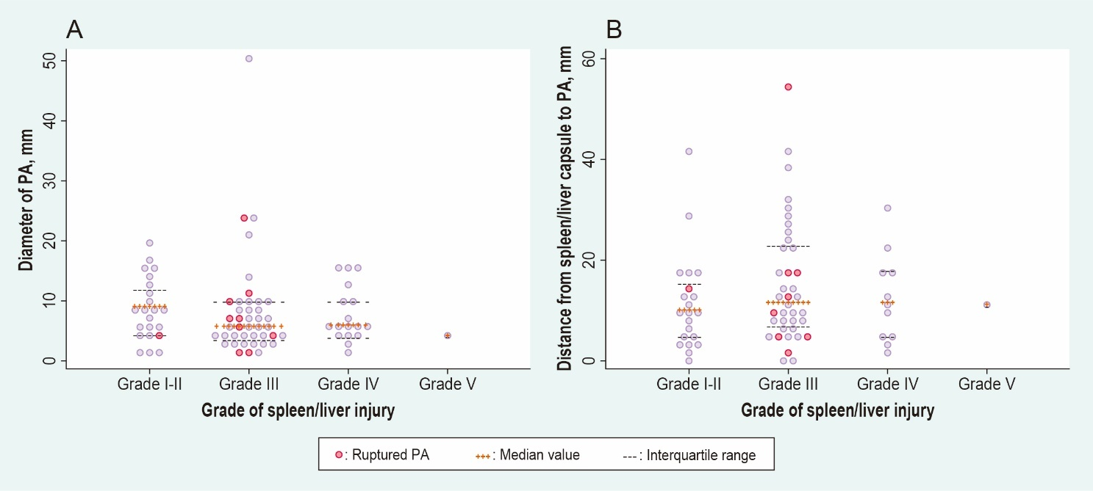
Abbreviations: PA, pseudoaneurysm of splenic and/or hepatic artery

