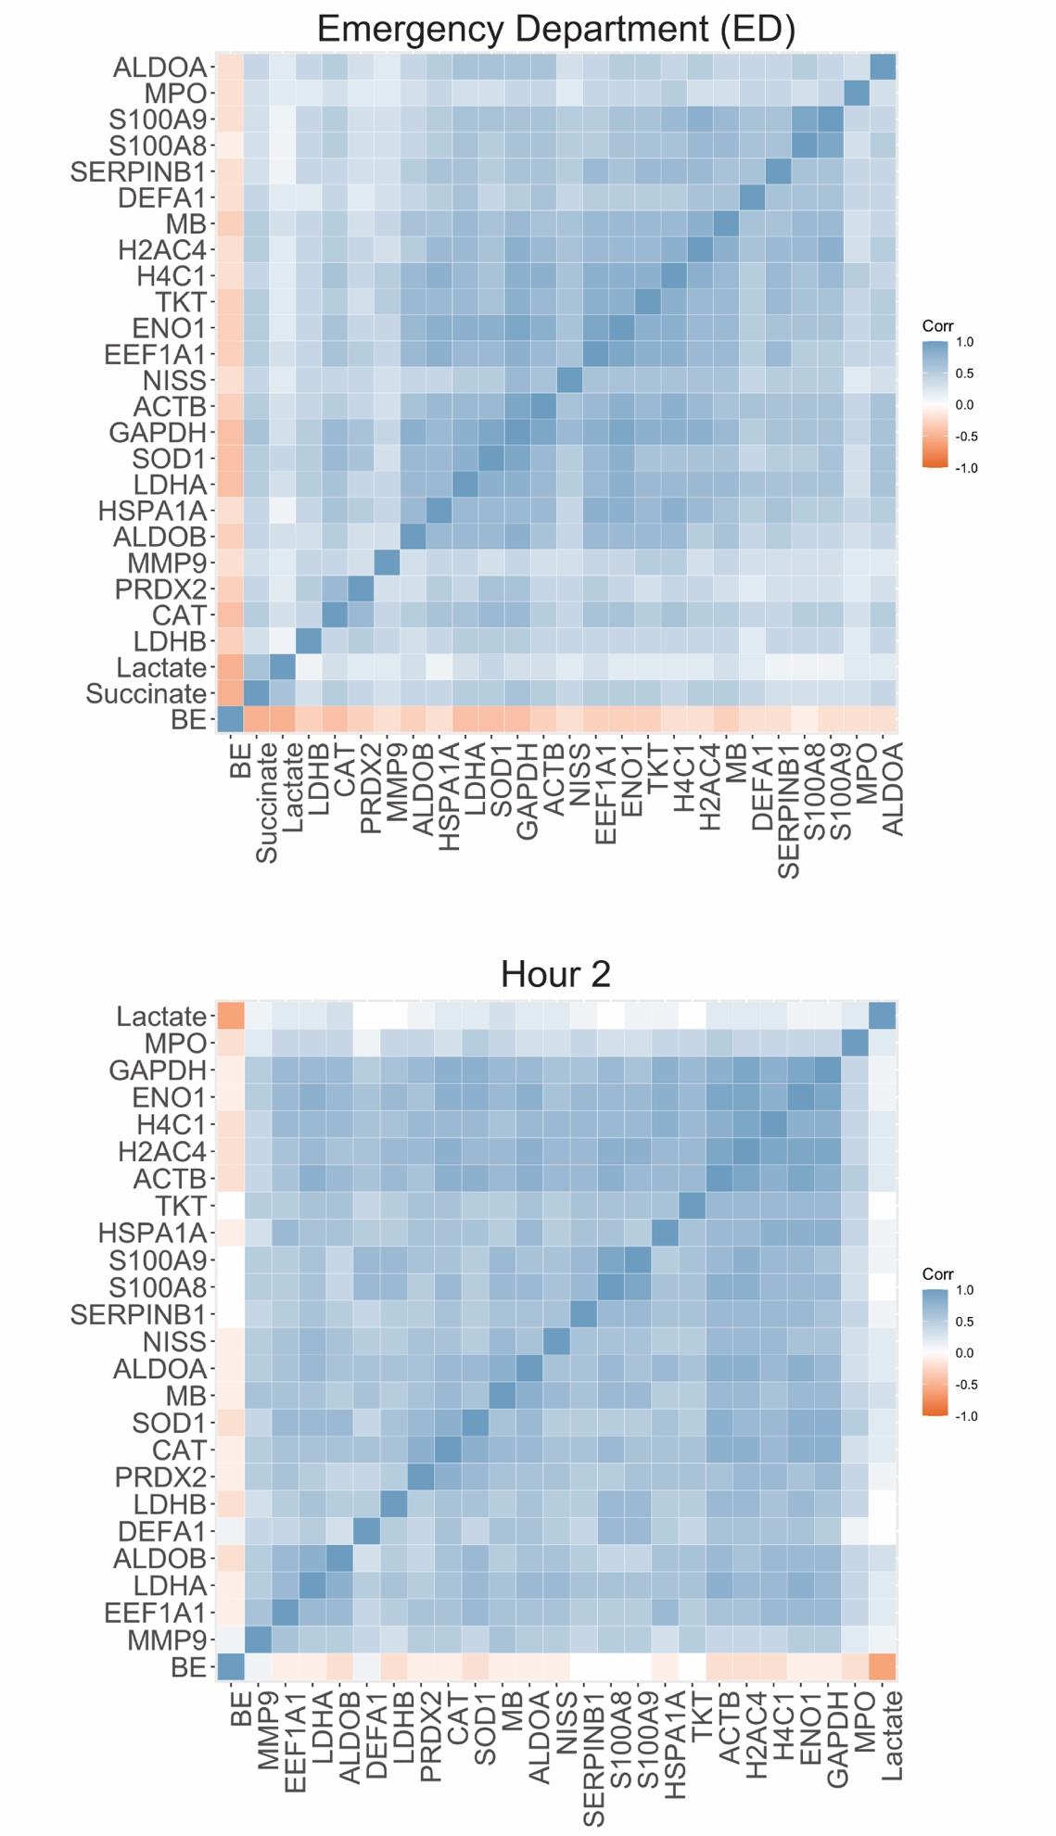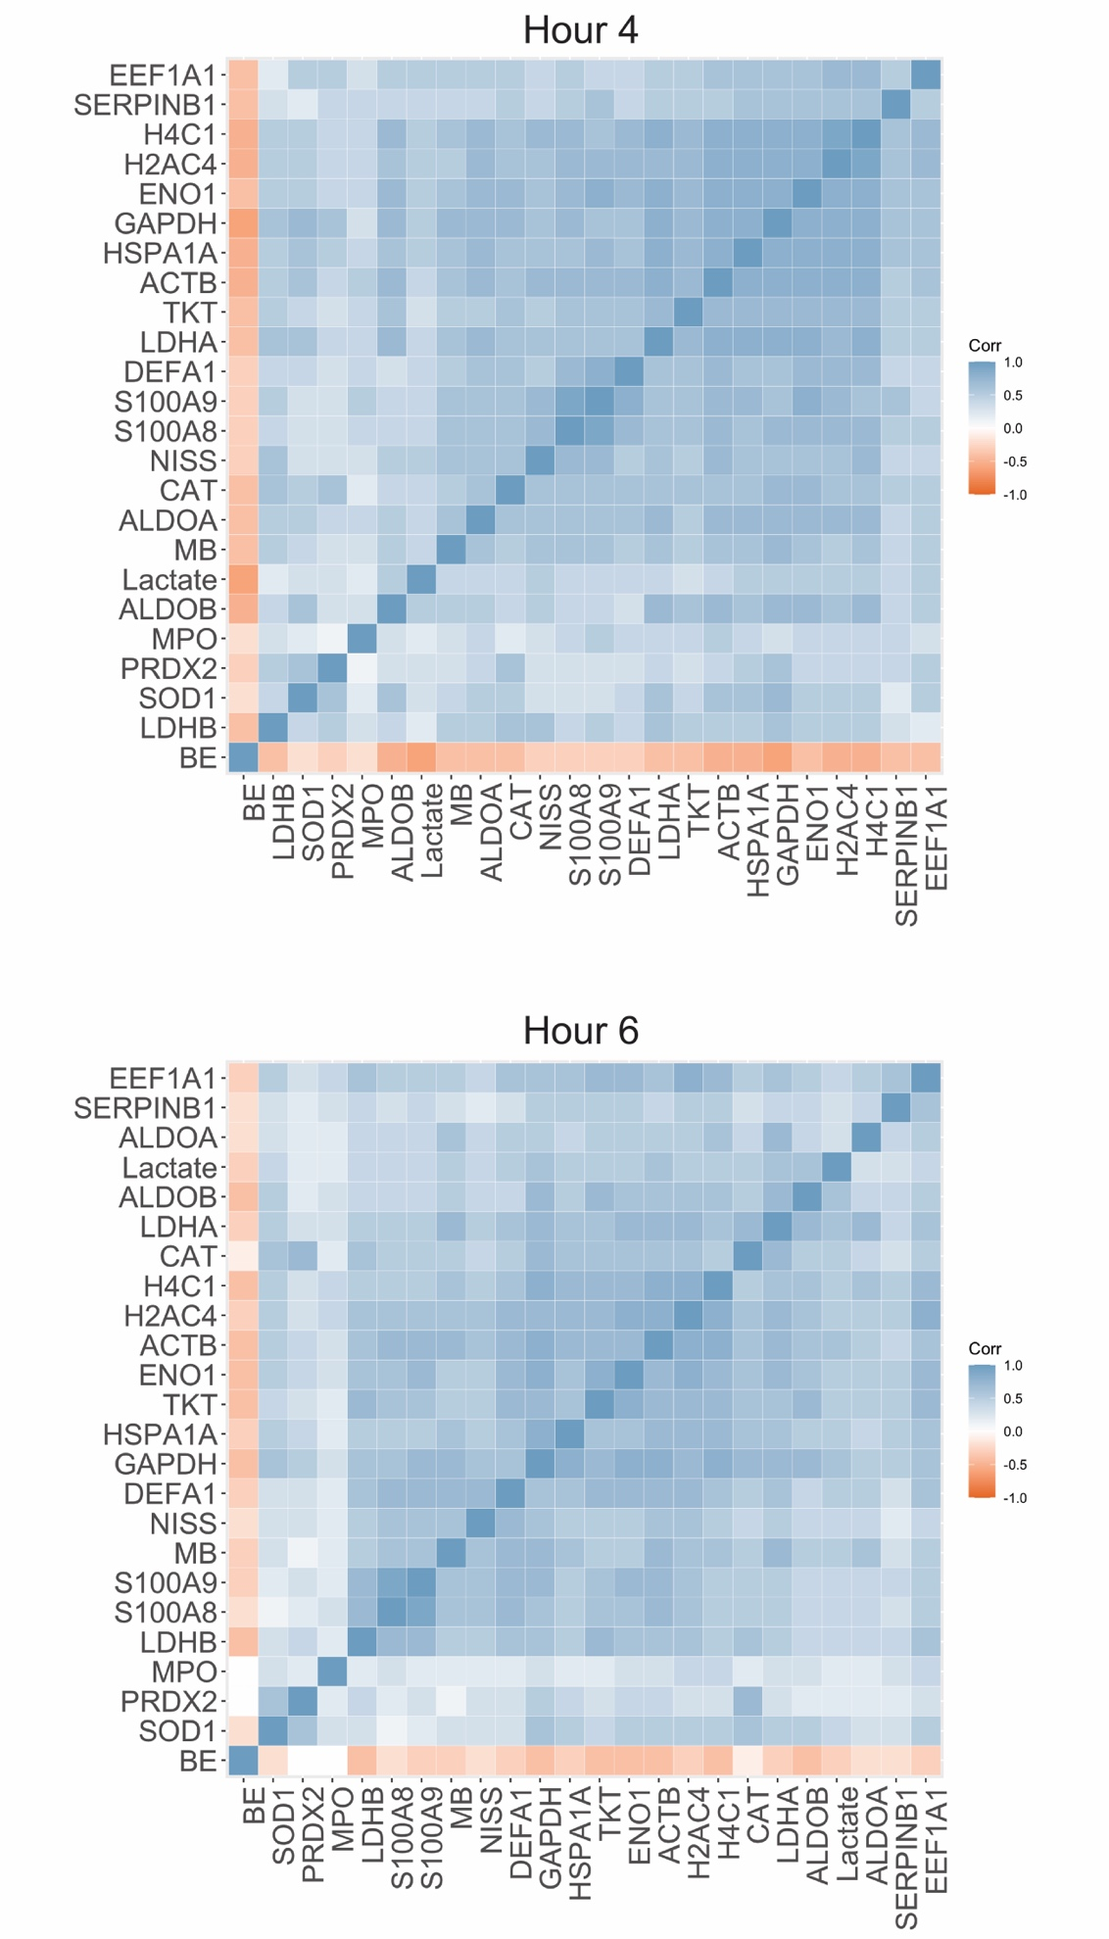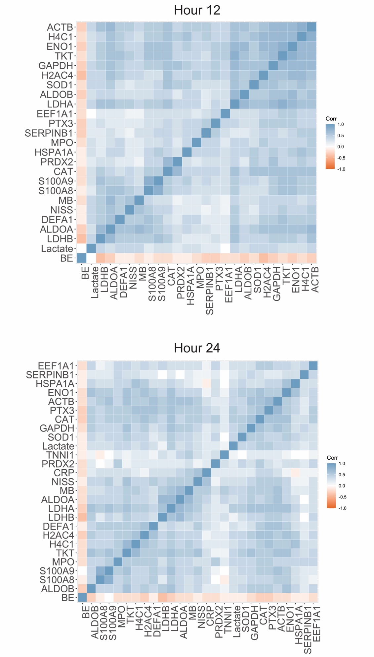
SDC 2. Correlograms of all NETosis and tissue damage markers at different timepoints over the first 24 hours demonstrating correlations holding over this time interval. NISS was included as an additional measure of injury severity, and arterial base excess (BE) on ED arrival as well as metabolomics measures of lactate and succinate were included as additional markers of hypoperfusion. Correlate NET proteins comprise the proteomic signature of trauma-induced NETosis. Overall, NETosis markers also more strongly correlate with NISS and tissue damage proteins than BE and markers of hypoperfusion, suggesting a stronger influence of tissue damage on post-injury NETosis than hemorrhagic shock and hypoperfusion. For each timepoint correlogram, variables with near-zero correlation coefficients were excluded, and the remaining variables were ordered hierarchically using the complete method. Correlogram legends define tile color by correlation coefficient (Corr).

