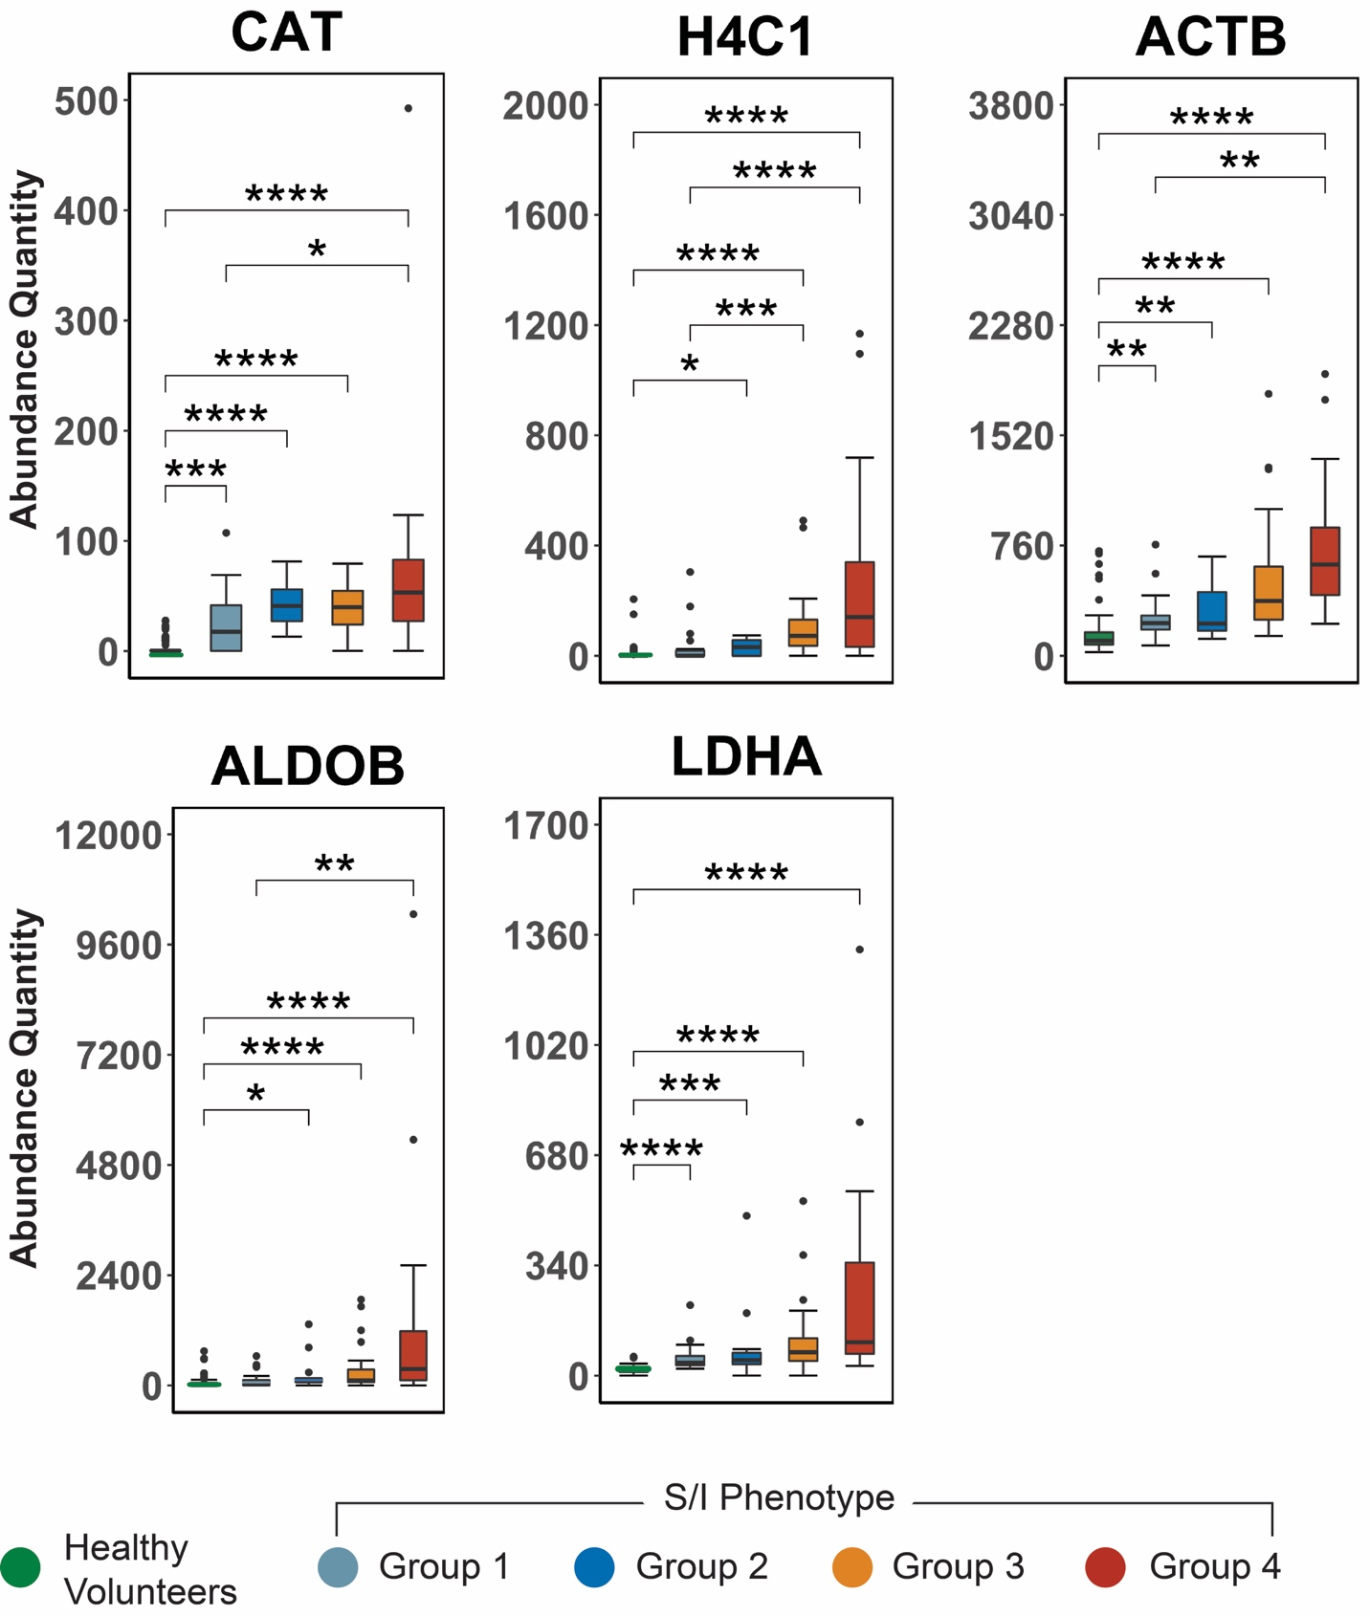
SDC 3. ED levels of additional NETosis markers by shock/injury (S/I) phenotype (Groups 1-4, defined in Table 1) with comparisons to healthy volunteers, further demonstrating increased NETosis in more severely injured patients. See Panel B of Figure 1 for protein identification. Abundance quantity refers to the label-free quantification of protein level. Plots contain boxes displaying the median and interquartile range (IQR) with whiskers denoting the highest and lowest values within 1.5xIQR; values outside this whisker range were considered outliers and indicated by individual points. ****P<0.0001, **P<0.01, *P<0.05

