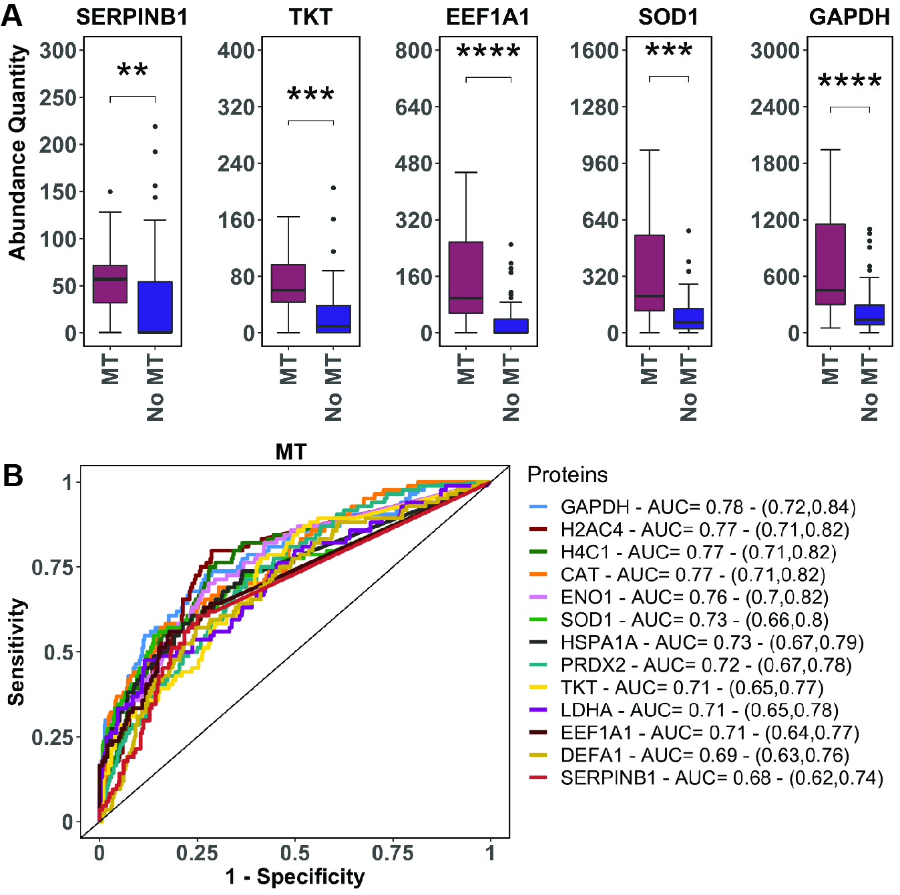
SDC 4. Elevated SerpinB1 and NETosis markers on ED arrival are associated with need for massive transfusion (MT). A: SerpinB1 and NETosis markers are elevated on ED arrival in patients who met MT criteria versus those who did not. Displayed proteins were those with the greatest statistical significance in Mann-Whitney tests between groups; see Panel B of Figure 1 for protein identification. Abundance quantity refers to the label-free quantification of protein level. Plots contain boxes displaying the median and interquartile range (IQR) with whiskers denoting the highest and lowest values within 1.5xIQR; values outside this whisker range were considered outliers and indicated by individual points. B: Receiver operating characteristic (ROC) curves from proteome-wide ROC analysis of top predictors of MT based on levels measured on ED arrival. The legend shows corresponding areas under the curves (AUC) with 95% confidence intervals. Displayed proteins were NETosis markers with the highest AUC’s among top predictors of MT. ****P<0.0001, ***P<0.001, **P<0.01

