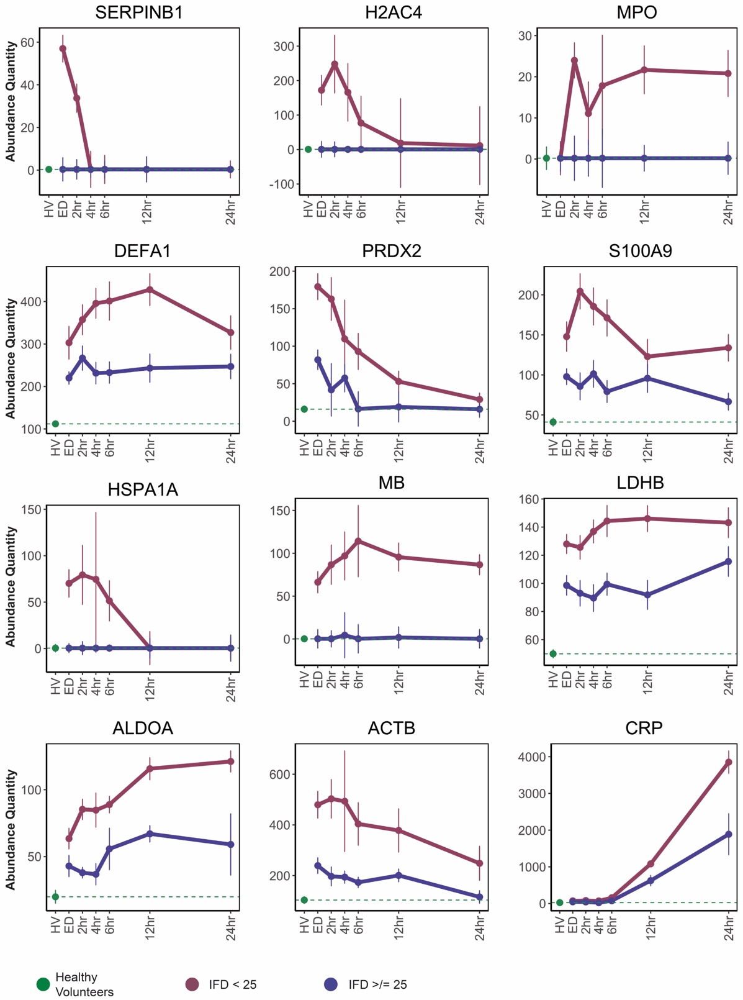
SDC 6. Temporal trends of serpinB1, NETosis markes, and tissue damage proteins compared between patients with <25 ICU-free days (IFD), those with ≥25 IFD, and healthy volunteer levels. While elevated early with other NETosis markers, among the other NETosis markers, early measures of serpinB1 exhibited the greatest separation between outcome groups. Most other NETosis and tissue damage markers remained elevated through 24 hours in patients with <25 IFD. These temporal trends can be viewed in the context of the acute phase response, as indicated by the trend of C-reactive protein (CRP). See Panel B of Figure 1 for protein identification. Abundance quantity refers to the label-free quantification of protein level. Error bars represent standard error of the mean.

