Supplementary Text
Details of the statistical analysis performed for the cost-effectiveness analysis
Model structure
We conducted a decision-analytic model from a health-system perspective in China to assess the cost-effectiveness of TDM using TreeAge Pro 2011 (TreeAge Software, Inc., MA, USA). For each patient, the frequency of vancomycin trough concentrations less than or equal to 20 mg/L and greater than 20 mg/L was determined from our prospective study. The TDM group consisted of patients whose TDM were implemented during vancomycin therapy. The non-TDM group consisted of patients administered the standard dosing regimen with the assumption that no dosage changes would be performed without monitoring.
Model inputs
The probabilities of VAN data were derived from our study. The costs were obtained from the National Health and Family Planning Commission of the People’s Republic of China (http://www.nhfpc.gov.cn). Cost accrued during the monitoring of vancomycin levels was calculated using the following: cost of the serum vancomycin assays (drug assay kits, calibration, quality control, and other medical supplies); costs of time spent by nurses; costs of laboratory test; pharmacists performing these monitoring activities; and treatment of AKI. Discounting was not considered as benefits and costs occurred in the same time period.
Outcomes and sensitivity analysis
The outcomes of interest were treating nephrotoxicity costs and the nephrotoxic episode prevented. The incremental cost effectiveness ratio (ICER) per nephrotoxic episode prevented was calculated using the frequencies of nephrotoxicity found in the two groups. Treatment strategies with an ICER of less than CNY 64,644 (i.e., Chinese gross domestic product [GDP] per capita in 2017) per nephrotoxic episode prevented were deemed acceptable. One-way sensitivity analyses were used to investigate how variations in one variable could affect the model results. Probabilistic sensitivity analysis was carried out with 1,000 Monte Carlo simulations to simultaneously evaluate the impact of all variables.

Table S1 The RIFLE criteria for diagnosing and classifying the stage of acute kidney injury
RIFLE criteria | Stage | Creatinine-based criteria | Urine output-based criteria
 | R | Increase in serum creatinine ≥50%  within 7 days or a GFR decrease by  25% | <0.5 ccs/kg/h for 6 consecutive  hours
 | I | Increase in serum creatinine >100%  or a GFR decrease by 50% | <0.5 ccs/kg/h for 12 consecutive  hours
 | F | Increase in serum creatinine >200%  or a GFR decrease by 75% or renal  replacement therapy | <0.3 ccs/kg/h for 24 h or  anuria for 12 h
 | L | Complete loss of function for more than 4 weeks
 | E | End stage renal disease

Table S2 Data on the pathogens involved and their MIC values
Pathogens | MIC
 | ≤0.5 | 1 | 2 | 4
Enterococcus faecium, n (%) | 82
MSSA, n (%) | 24 | 10
Staphylococcus epidermidis, n (%) |  | 22 | 2
Enterococcus faecalis, n (%) | 2 | 9 | 2
MRSA, n (%) | 5 | 2
Staphylococcus haemolyticus, n (%) | 3 |  | 1
Other gram-positive bacteria, n (%) | - | - | - | -

MIC, minimum inhibitory concentration; MSSA, methicillin-sensitive Staphylococcus aureus; MRSA, methicillin-resistant Staphylococcus aureus.

Table S3 Outcomes associated with the receipt of TDM compared to receipt of non-TDM in the matched cohort
Outcome | non-TDM  (n=69) | TDM  (n=69) | P value
Bacteria eradication, n (%) | 16 (23%) | 20 (28%) | 0.438
Length of hospital stay, days | 27 (23-32) | 23 (19-26) | 0.035
Vancomycin treatment failure, n (%) | 21 (30%) | 16 (23%) | 0.337

TDM, therapeutic drug monitoring; PK/PD, pharmacokinetic/pharmacodynamic.

Table S4 Decision-analytic model variables
Parameter | Base case | Sensitivity Range | References
Model inputs
TDM
Frequency of troughs ＞20 mg/L | 0.262 | 0.105-0.502 (Beta) |  | Prospective study
Nephrotoxicity | 1.000 |  |  | Prospective study
No nephrotoxicity | 0 |  |  | Prospective study
Frequency of troughs ≤20 mg/L | 0.738 | 0.423-0.901 (Beta) |  | Prospective study
Nephrotoxicity | 0 |  |  | Prospective study
No nephrotoxicity | 1.000 |  |  | Prospective study
Non-TDM
Frequency of troughs ＞20 mg/L | 0.524 | 0.203-0.623 (Beta) |  | Prospective study
Nephrotoxicity | 0.812 | 0.645-0.889 (Beta) |  | Prospective study
No nephrotoxicity | 0.188 | 0.102-0.376 (Beta) |  | Prospective study
Frequency of troughs ≤20 mg/L | 0.476 | 0.217-0.732 (Beta) |  | Prospective study
Nephrotoxicity | 0.188 | 0.102-0.376 (Beta) |  | Prospective study
No nephrotoxicity | 0.812 | 0.645-0.889 (Beta) |  | Prospective study
Cost (CNY)
Obtaining levels (drug assay kit,  calibration, technician time,  other medical supplies) | 168.00 | 120.00-187.00 (Gamma) |  | NHFPC of China
Treating nephrotoxicity | 11233.50 | 4783.63-1693.50 (Gamma) |  | NHFPC of China
Pharmacist time (40 min) | 43.38 | 41.10-46.80 (Gamma) |  | NHFPC of China
Nursing time (5 min) | 5.98 | 5.56–6.42 (Gamma) |  | NHFPC of China
Laboratory test | 100 | 67-179 (Gamma) |  | NHFPC of China

TDM, therapeutic drug monitoring; CNY, China yuan

Table S5 Cost-effectiveness analysis
Monitoring strategy | Total cost  (CNY) | Incremental cost (CNY) | Effectiveness | Incremental effectiveness | ICER/nephrotoxic episode prevented (CNY / rate of nephrotoxic episode prevented)
non-TDM | 5,448.51 |  | 0.348
TDM | 11,450.86 | 6,002.34 | 0.613 | 0.265 | 22638.07

TDM, therapeutic drug monitoring; ICER, the incremental cost effectiveness ratio; CNY, China yuan.

Figure S1 Diagnostic plots of the current data.
- Population predicted concentrations (PRED) versus observed concentrations (DV);
- Individual predicted concentration (IPRED) versus observed concentrations (DV).

Figure S2 Decision tree model.
TDM, therapeutic drug monitoring

Figure S3 Kaplan–Meier survival analysis of other outcome variables for vancomycin-associated nephrotoxicity
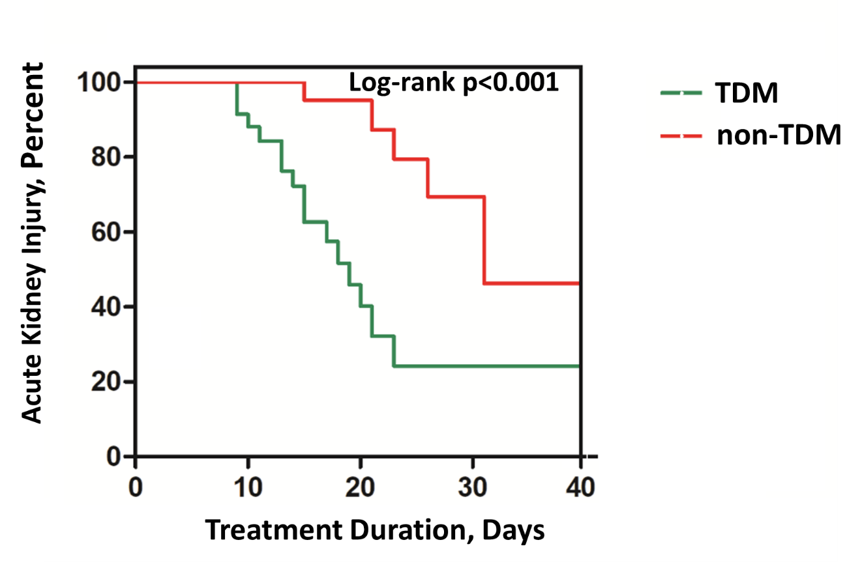
TDM, therapeutic drug monitoring.

