Supplemental data
Generation of SLCO2B1_{935G/A} and ABCC1_{2012G/T} plasmids
Plasmids sequences were verified using Sanger method (Eurofins, Germany) represented on Figure S1.
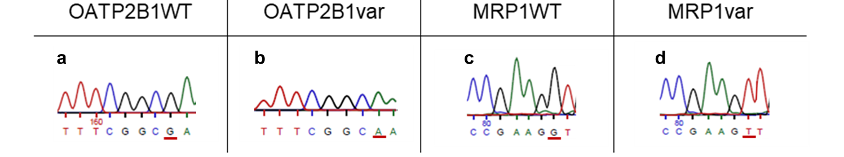FIGURE S1. Gene sequencing of HEK293 transfected cells with (a) OATP2B1WT, (b) OATP2B1var, (c) MRP1WT and (d) MRP1var.
Generation of stable ABCC1_{2012G} and ABCC1_{2012T} overexpressing cell lines and characterization of OATP2B1 expression level
Models were created using the same method as for the creation of SLCO2B1_{935G} or SLCO2B1_{935A} models. Cells were selected in culture with gentamicin (G418) in culture and overexpression of MRP1 protein was validated by FACS.
Effect of SLCO2B1_{935G} versus SLCO2B1_{935A} overexpression on ATV intracellular accumulation
Results presented in Figure S2 compare the intracellular ATV accumulation between HEK_{MRP1WT} and HEK_{CTRL}. ATV accumulated after 2h of incubation is lower in HEK_{MRP1WT} compared to HEK_{CTRL} at every concentration although significant at 150 and 500nM of the drug (***P < 0.0001 at both concentrations).
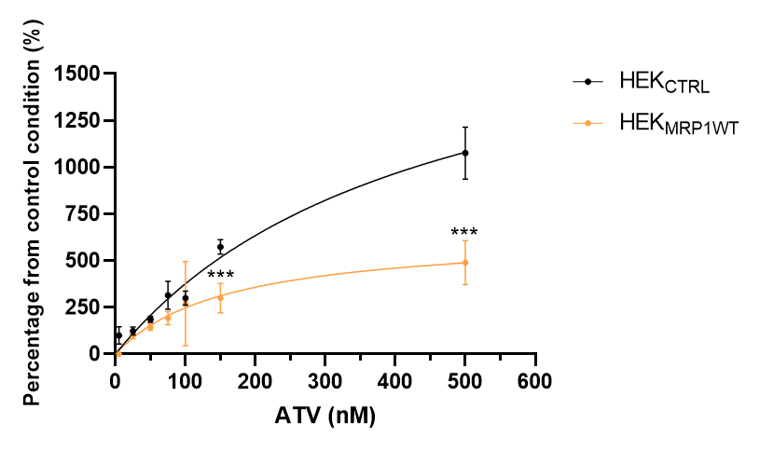
FIGURE S2. ATV accumulation experiment represented in percentage from the control condition (ATV accumulation in HEK_{CTRL} at the lowest concentration) in single transfectant model HEK_{MRP1WT} compared to the control cells HEK_{CTRL}. (***P < 0.0001 HEK_{MRP1WT} compared to HEK_{CTRL}).

