Measuring Serum Vedolizumab and Antibodies to Vedolizumab: Comparison of Commercial Assays With the Vedolizumab Clinical Development Assay

Supplemental Digital Content

Niels Vande Casteele, PharmD, PhD,* Lili Yang, MS,† Iwona Dobler, PhD,† Christian Agboton, MD, FFPM,‡ Teresa McRorie Osborn, PharmD,†,§ Ajit Suri, PhD,† Dirk Lindner, MSc,‡ and Glennda M. Smithson, PhD†

From the *Department of Medicine, University of California San Diego, School of Medicine, San Diego, California; †Takeda Pharmaceuticals, Cambridge, Massachusetts; and ‡Takeda International AG, Zurich, Switzerland. §Affiliation at the time the study was conducted.

Correspondence: Niels Vande Casteele, PharmD, PhD, University of California San Diego, School of Medicine, Division of Gastroenterology, IBD Center, 9500 Gilman Drive #0956, La Jolla, CA 92093 (e-mail: nvandecasteele@health.ucsd.edu; phone: +1 858 345 5932).

FIGURE 1. Reference assays

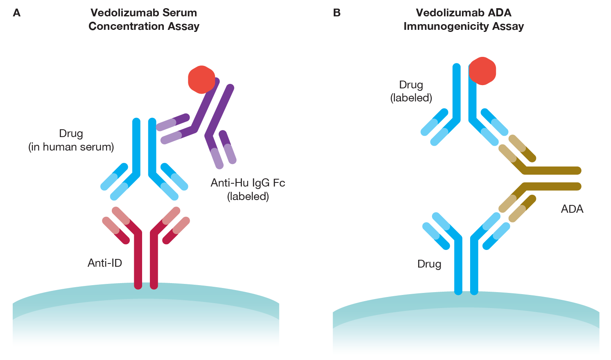
ADA, antidrug antibody; anti-Hu IgG Fc, anti-human immunoglobulin G antibody (Fc specific); anti-ID, anti-idiotype antibody.

FIGURE 2. Mean percentage differences in vedolizumab serum concentrations in 21 patient samples

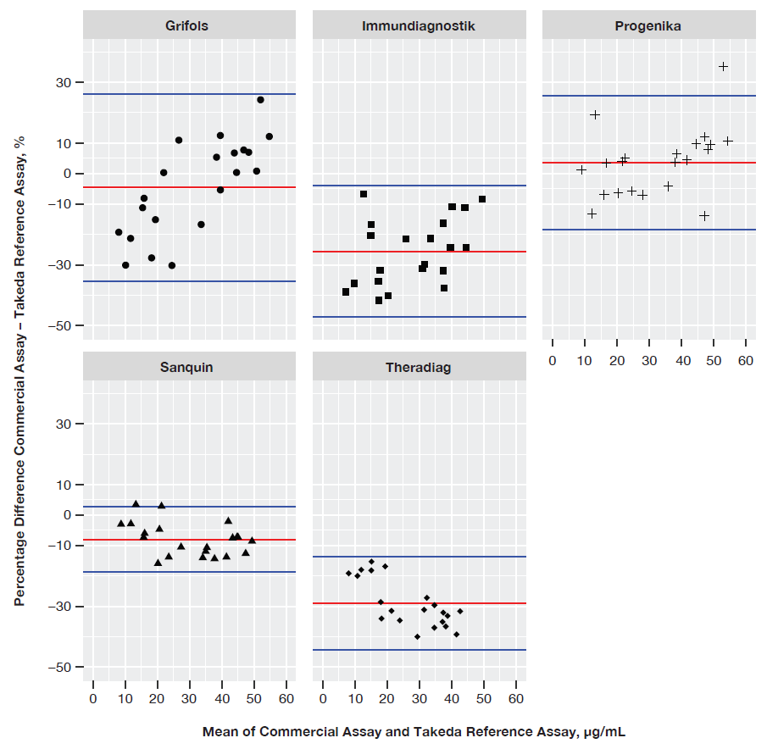
Measured by the commercial assays compared with the reference assay. Bland-Altman analysis results of samples from vedolizumab-treated patients with inflammatory bowel disease. The red lines represent the mean percentage difference across the range. The blue lines indicate the limit of agreements. For more information on sample sizes see Sample Sets section of Methods and Table 2, Supplemental Digital Content.
TABLE 1. Comparison of Assay Attributes.
Company  (Assay Source) | Vedolizumab Serum Concentration Assay Format | Lower Limit of Quantification, µg/mL* | Vedolizumab ADA Immunogenicity Assay Format
Takeda Pharmaceuticals | ELISA | 0.2 | ECL
Grifols Diagnostic Solutions (performed in TX) | ELISA,  PROMONITOR-VEDOLIZUMAB:ELISA | 1.4 | ELISA,  PROMONITOR-ANTI-VEDOLIZUMAB
Immundiagnostik AG | ELISA  (IDKmonitor® Vedolizumab drug concentration) | 1.7†,‡ | ELISA  (IDKmonitor® Vedolizumab free antidrug antibody)
Progenika Biopharma B  (performed in Spain) | ELISA,  PROMONITOR-VEDOLIZUMAB:ELISA | 1.4 | ELISA,  PROMONITOR-ANTI-VEDOLIZUMAB
Sanquin Diagnostic Services | ELISA  (Vedolizumab Spiegel ELISA) | 0.01 | RIA  (Vedolizumab-ABT)
Theradiag | ELISA  LISA Tracker® vedolizumab | 2 | ELISA  LISA Tracker® Anti-vedolizumab
*Samples with concentrations lower than the measurement range cannot be clearly quantified. The upper limit of the measurement range can be calculated as: highest concentration of the standard curve × sample dilution factor to be used.
†http://www.immundiagnostik.com/fileadmin/pdf/IDKmonitor_Vedolizumab_K9658.pdf.
‡Including a dilution factor of 200.
ADA, antidrug antibody; ECL, electrochemiluminescence; ELISA, enzyme-linked immunosorbent assay; RIA, radioimmunoassay.

TABLE 2. Samples used for measuring vedolizumab and determining the presence of anti-vedolizumab antibodies.
Samples used for measuring vedolizumab serum levels |  | Total samples prepared and tested | Final sample numbers used in the statistical analysis
Accuracy: | QPS vs commercial lab concentration values | 10 pooled samples x triplicates = 30 samples  2 selective samples x duplicates = 4 samples  23 patient samples x singlet = 23  Total 30+4+23 = 57 samples tested | Sample values between 1–60 µg/mL are included:  Final sample numbers used: (30+4-6) + (23-2) = 49
Precision: | % CV from replicates of vedolizumab concentration | 10 pooled samples x triplicates = 30 samples  2 selective samples x duplicates = 4 samples  Total 30+4 = 34 samples tested | Replicate sample values between 1–60 µg/mL are included:  Final sample numbers used: 30+4-6 = 28
Precision Not applicable | 23 patient samples (singlet),  2 specificity samples (BQL) | Not applicable | Not applicable
Specificity: | IFX or ADA without presence of VDZ (BQL in VDZ assay) | IFX (Duplicates)  ADA (Duplicates)  Total 4 samples | Not applicable
Selectivity | IFX+VDZ combo,  ADA+VDZ combo | IFX + VDZ (Duplicatas)  ADA + VDZ (Duplicatas)  Total 4 samples | Total 4 samples
Samples used for determining presence of anti-vedolizumab antibodies |  |  | Total samples
Absence of VDZ | 4 different levels of positive control spiked with VDZ samples (singlet) |  | Total 4 samples
Presence of VDZ | Samples above + 15µg/ml VDZ (singlet) |  | Total 4 samples

ADA, adalimumab; BQL, below limit of quantification; CV, coefficient of variation; IFX, infliximab; VDZ, vedolizumab.

TABLE 3. Mean for each QC and selectivity sample from each assay
Sample ID | Grifols | Immunodiagnostik | Progenika | Sanquin | Theradiag | Takeda Reference Assay
QC.1 | <1.00 µg/mL | <1.00 µg/mL | <1.00 µg/mL | <1.00 µg/mL | <1.00 µg/mL | <1.00 µg/mL
QC.2 | 2.83 | 2.36 | 2.82 | 2.28 | NA | 2.67
QC.3 | 9.85 | 10.65 | 10.39 | 9.43 | 8.32 | 10.74
QC.4 | 14.68 | 18.88 | 15.13 | 13.80 | 12.15 | 16.40
QC.5 | 21.17 | 18.99 | 22.64 | 17.98 | 14.63 | 21.23
QC.6 | 23.19 | 22.91 | 28.08 | 23.77 | 18.32 | 27.32
QC.7 | 31.02 | 27.70 | 33.91 | 27.12 | 23.05 | 30.72
QC.8 | 44.84 | 37.76 | 48.83 | 37.25 | 27.62 | 41.62
QC.9 | 58.34 | 41.97 | 61.37 | 44.75 | 32.98 | 52.25
QC.10 | >60.00 µg/mL | >60.00 µg/mL | >60.00 µg/mL | >60.00 µg/mL | >60.00 µg/mL | >60.00 µg/mL
SS.3 | 21.72 | 17.89 | 21.39 | 18.83 | 15.43 | 21.95
SS.4 | 23.91 | 19.11 | 19.27 | 17.90 | 15.01 | 21.80
All values in µg/mL.
ID, identifier; QC, quality control; SS, selectivity sample

TABLE 4. Coefficient of variation for each QC and selectivity sample from each assay
Sample ID | Grifols | Immunodiagnostik | Progenika | Sanquin | Theradiag | Takeda Reference Assay
QC.1 | Not calculated* | Not calculated* | Not calculated* | Not calculated* | Not calculated* | Not calculated*
QC.2 | 17.36 | 12.88 | 2.02 | 6.11 | NA | 3.59
QC.3 | 10.03 | 20.07 | 9.48 | 6.29 | 2.66 | 0.69
QC.4 | 10.95 | 41.59 | 10.15 | 6.03 | 2.97 | 3.18
QC.5 | 12.44 | 7.67 | 15.42 | 5.40 | 5.30 | 6.05
QC.6 | 10.54 | 13.73 | 11.63 | 1.27 | 9.08 | 4.57
QC.7 | 5.32 | 3.61 | 17.48 | 14.81 | 6.64 | 4.94
QC.8 | 13.32 | 8.77 | 7.33 | 3.17 | 7.35 | 7.75
QC.9 | 13.59 | 15.68 | 11.66 | 9.24 | 2.31 | 9.41
QC.10 | Not calculated* | Not calculated* | Not calculated* | Not calculated* | Not calculated* | Not calculated*
SS.3 | 0.68 | 6.78 | 2.20 | 6.57 | 12.53 | 6.57
SS.4 | 8.56 | 16.90 | 9.09 | 8.69 | 7.16 | 6.09
All values are %
*Not calculated since samples <1 µg/mL or >60 µg/mL were excluded from the analysis.
ID, identifier; QC, quality control; SS, selectivity sample

TABLE 5. Vedolizumab ADA Detection by Immunogenicity Assays
Company  (Assay Source) | Immunogenicity  (Vedolizumab ADA Detection)  [Yes/No] | Drug Tolerance  (Immunogenicity Detected in Presence of 15 µg/mL Vedolizumab) [Yes/No]
Takeda Pharmaceuticals  (reference assay) | Yes | Yes
Grifols Diagnostic Solutions | Yes | No
Immundiagnostik AG | Yes | No
Progenika Biopharma B | Yes | No
Sanquin Diagnostic Services | Yes | No
Theradiag | Yes | No
ADA, antidrug antibody.

