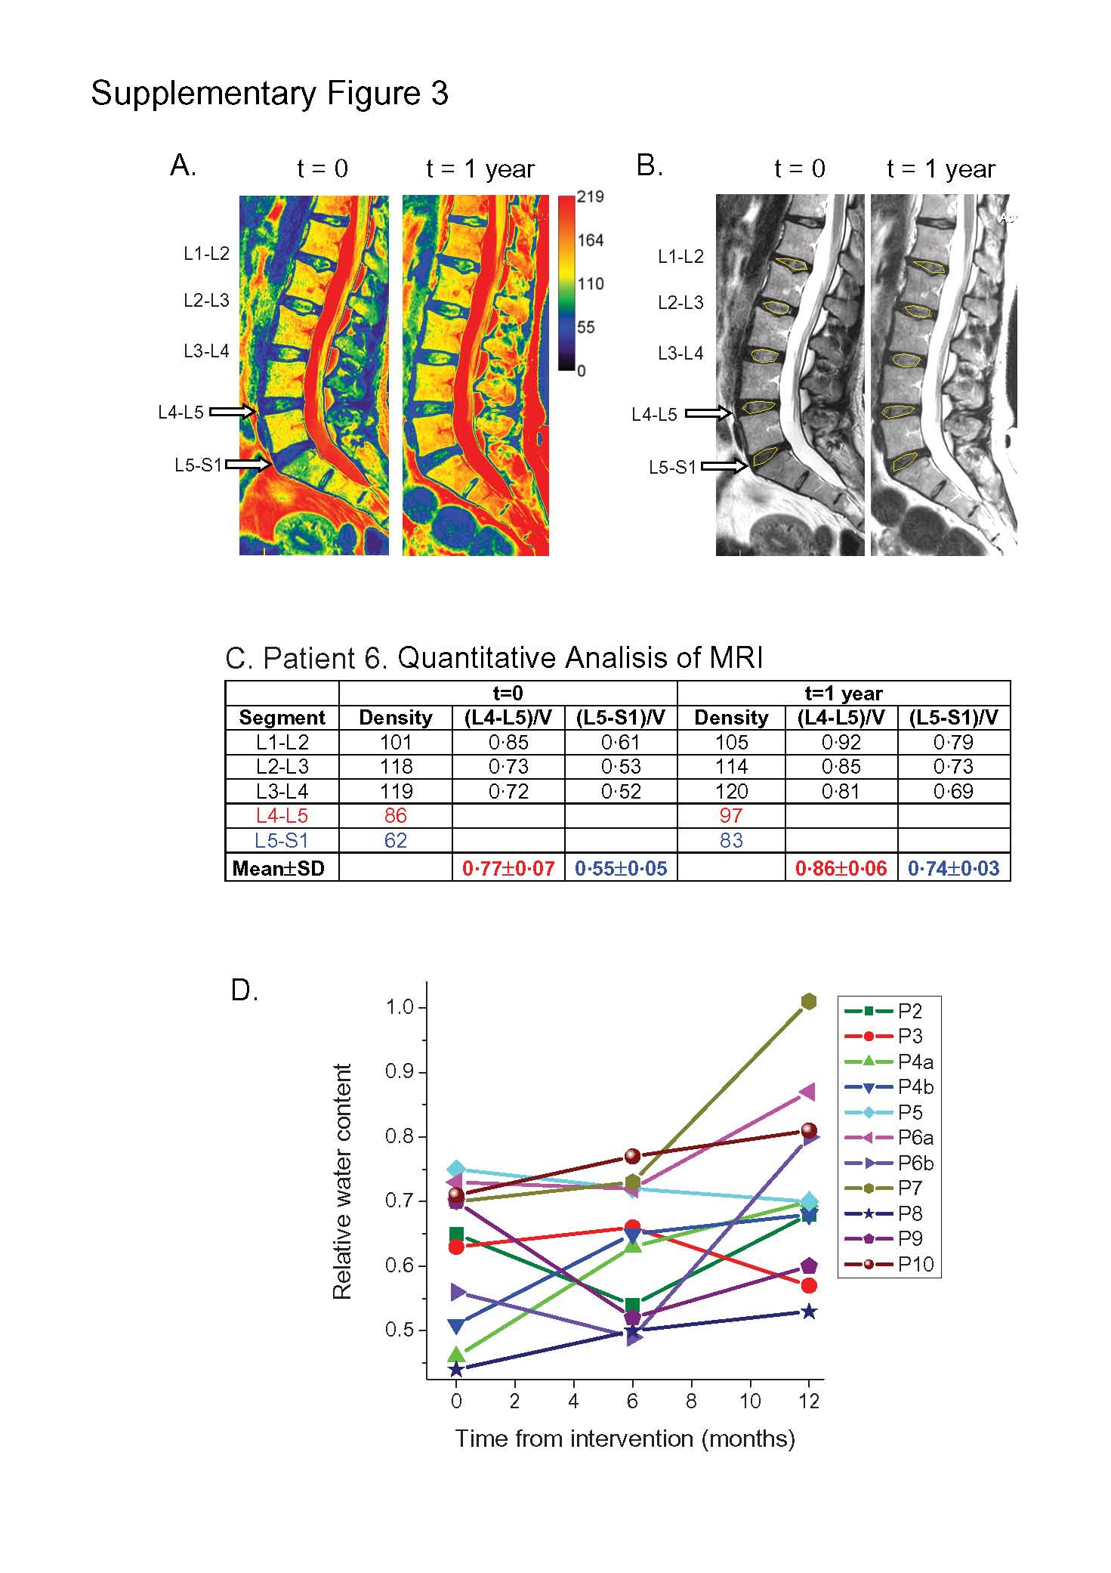

Supplemental Digital Content 5 - Figure 3: Illustration on how relative fluid content of the affected discs is determined and evolution of the patients during the first year. The densities of the affected disc and of 3-5 contiguous healthy lumbar discs were measured in T2-weighted sagittal images, and the density of affected discs was divided by that of the healthy discs; the average of these ratios was used as a relative measure of normal water content. A. Pseudocolor image and B. Grey image. The density before treatment (left) and 1 year after MSC treatment (right) is depicted in each set of images. In this two-segment example, L4-L5 and L5-S1 were affected (white arrows). The same ROIs were used for measurements at time 0 (prior to treatment) and at 1 year post-treatment ROIs are outlined in yellow in (B)]. Note that the relative fluid content is elevated at 1 year after the intervention for the two affected discs. C. Table with the numeric values. We first measured the density (mean grey value, from 0 to 255) of the affected segments and of the three contiguous segments above. The ratios (L4-L5)/V and (L5-S1)/V were calculated to normalise the data as relative affected disc/healthy disc water content. Mean±SD values are shown in the bottom row. D. Evolution of the relative water content 6 and 12 months after the intervention. Two different discs (a and b) were treated in and followed in patients 4 and 6. Data from patient 1 were lost. Average values are shown in Table 2.

