Psychological impact of predictive genetic testing for inherited Alzheimer’s disease and frontotemporal dementia: the IT-DIAfN protocol

SUPPLEMENTAL DIGITAL CONTENT 1

METHODS
The IT-DIAfN Protocol – further details
Prenatal counselling and diagnosis were not included in the protocol. Reasons for requesting the predictive genetic testing were qualitatively collected.
The expected time frame between blood sample and genetic disclosure was no longer than two months. Participants were allowed to withdraw from the protocol at any stage and could be readmitted by starting again with pre-test consultation.
For logistic reasons, the IRCCS Fondazione Besta carried out T1 follow-up assessment by phone. As a consequence, only qualitative information about possible life changes were collected and no psychological assessment was available for 7 participants.
Psychological assessment – further details
Personality traits were assessed by the Big Five Questionnaire,¹ and anxious symptoms by the State-Trait Anxiety Inventory.²
Depressive symptoms were evaluated by two scales. The HDRS was a clinician-administered scale, ranging between 0 and 52. A score of 0–7 is generally accepted to be within the normal range. The BDI was a self-administered scale, ranging between 0 and 63. Scores less than 9 indicated minimal symptoms associated to low mood, while higher scores were indicative of depressive symptoms of increasing intensity.
The SF-12 is a health-related quality of life questionnaire consisting of twelve questions and two summary scores to assess physical (Physical Component Summary) and mental (Mental Component Summary) health. For both dimensions, the score ranged from 0 to 100, with higher scores representing better health.
The WHOQOL-short version is a 26-items questionnaire consisting of four domains: physical health, psychological health, social relationships, and environmental health. The score ranges from 0 to 100; the higher the score, the greater the participant's perception of well-being in that domain.
Coping strategies were rated by the Brief COPE.³
The RSA measures the ability to adapt to psychosocial adversities. It evaluates six intra- and interpersonal protective dimensions of resilience: perception of self, planned future, social competence, family cohesion, social resources, structured style, personal competence. The RSA consists of 33 items, each ranging from 1 to 7. For each dimension, higher scores reflect higher levels of protective factor of resilience.
The MHLOC scale evaluated the degree to which people believed that health and disease were primarily consequence of individual behaviours, fate, or under the control of powerful others. Three domains were derived: internal, chance external, and powerful others external. For all domains, the range score is 6-36: the higher the score, the higher the participant's belief for that dimension.

REFERENCES
- Caprara GV, Barbaranelli C, Borgogni L. Big Five Questionnaire. Firenze: O.S. Organizzazioni Speciali; 1993.
- Spielberger CD. State-Trait Anxiety Inventory: Bibliography. 2nd ed. Palo Alto CA: Consulting Psychologists Press; 1989.
- Carver CS. You want to measure coping but your protocol’s too long: Consider the Brief COPE. Int J Behav Med. 1997;4:92-100.

Supplementary table 1. Sociodemographic and psychological features of 20 healthy at-risk relatives (see ‘Second consultation’ box in figure 1) included in IT-DIAfN protocol by genetic disclosure at baseline.

 | Genetic disclosure
 | disclosed  n=15 | not disclosed  n=5 | Pª | P^{b}
Sociodemographics
Age (years) | 40.3±9.6 | 39.2±19.9 | 0.672 | -
Gender (F) | 10 (66%) | 2 (40%) | 0.292 | -
Education
Middle | 1/14 (7%) | 1 (20%)
High | 4/14 (29%) | 4 (80%)
University | 9/14 (64%) | 0 (0%) | 0.047 | -
Years to expected disease onset | 15.5+14.3 | 13.5+19.4 | 0.866 | -
Family diagnosis
Alzheimer’s Disease | 5 (33%) | 4 (80%)
Frontotemporal Dementia | 10 (67%) | 1 (20%) | 0.069 | -
Psychological scales
Personality
BigFive Q. - Extraversion | 38.1±9.2 | 45.0±8.1 | 0.230 | 0.237
BigFive Q. - Agreebleness | 45.9±7.9 | 42.6±4.8 | 0.553 | 0.868
BigFive Q. - Conscientiousness | 40.1±10.8 | 47.2±6.4 | 0.168 | 0.216
BigFive Q. - Neuroticism | 38.9±9.8 | 34.2±6.1 | 0.349 | 0.691
BigFive Q. - Openness | 41.6±11.4 | 45.0±5.2 | 0.735 | 0.711
Anxiety
State -Trait Anxiety Inventory - State | 32.1±9.3 | 29.4±6.3 | 0.672 | 0.232
State -Trait Anxiety Inventory - Trait | 40.5±9.5 | 43.0±6.5 | 0.395 | 0.975
Depression
Beck Depression Inventory | 6.1±6.0 | 6.2±5.5 | 0.933 | 0.796
Hamilton Depression Rating Scale | 3.5±3.5 | 3.0±4.1 | 0.672 | 0.541
Quality of Life
SF-12 Physical Composite Score | 51.9±7.0 | 57.6±2.6 | 0.042 | 0.111
SF-12 Mental Composite Score | 44.5±10.5 | 37.8±12.8 | 0.266 | 0.564
WHOQOL – physical health | 74.7±13.8 | 84.8±8.0 | 0.142 | 0.364
WHOQOL – psychological health | 61.3±11.5 | 64.6±9.2 | 0.612 | 0.353
WHOQOL – social health | 66.1±16.7 | 66.6±19.6 | 0.612 | 0.890
WHOQOL – environmental health | 63.7±15.7 | 67.4±10.5 | 0.672 | 0.056
Coping Strategies
Brief COPE – problem focused | 18.9±3.3 | 17.2±3.1 | 0.343 | 0.849
Brief COPE – emotion focused | 25.4±4.6 | 22.4±3.1 | 0.156 | 0.341
Brief COPE - dysfunctional coping | 23.4±3.3 | 23.6±3.5 | 0.893 | 0.929
Resilience
RSA – self | 20.6±4.1 | 24.0±3.8 | 0.219 | 0.164
RSA – future | 10.7±2.7 | 12.8±4.0 | 0.343 | 0.840
RSA – structured style | 15.4±2.0 | 15.4±2.3 | 0.964 | 0.879
RSA – social competence | 23.1±4.2 | 24.4±5.2 | 0.444 | 0.559
RSA – family cohesion | 23.3±4.9 | 25.4±3.7 | 0.391 | 0.439
RSA – social resource | 30.5±4.0 | 29.2±7.4 | 0.687 | 0.791
RSA – personal competence | 31.6±6.2 | 36.8±7.0 | 0.219 | 0.514
Health-related beliefs
MHLOC - internal | 24.8±3.0 | 23.8±5.5 | 0.497 | 0.176
MHLOC – chance | 19.9±7.4 | 20.4±3.5 | 0.933 | 0.820
MHLOC – powerful others | 21.1±2.7 | 19.2±2.8 | 0.266 | 0.204

ªchi-square or Mann-Whitney test ^{b}age- and education-adjusted analysis of covariance
SF: Short Form, WHOQOL: World Health Organization Quality of Life, RSA: Resilience Scale for Adults, MHLOC: Multidimensional Health Locus of Control

Supplementary table 2. Psychological features of 20 healthy at-risk relatives (see ‘Second consultation’ box in figure 1) included in IT-DIAfN protocol by years to expected disease onset at baseline.

 | Years to expected disease onset
 | <4  n=7 | 5-23  n=13 | Pª | P^{b}
Personality
BigFive Q. - Extraversion | 40.0±10.3 | 39.8±9.1 | 1.000 | 0.135
BigFive Q. - Agreebleness | 44.4±10.2 | 45.5±5.5 | 0.877 | 0.533
BigFive Q. - Conscientiousness | 40.7±9.4 | 42.5±10.9 | 0.757 | 0.236
BigFive Q. - Neuroticism | 38.3±11.5 | 37.5±8.0 | 1.000 | 0.471
BigFive Q. - Openness | 40.0±14.1 | 41.6±11.6 | 0.588 | 0.896
Anxiety
State -Trait Anxiety Inventory - State | 29.0±5.9 | 32.7±9.7 | 0.485 | 0.986
State -Trait Anxiety Inventory - Trait | 37.1±7.1 | 43.2±9.1 | 0.115 | 0.231
Depression
Beck Depression Inventory | 4.1±4.7 | 7.2±6.1 | 0.241 | 0.591
Hamilton depression Rating Scale | 2.4±2.6 | 3.9±4.0 | 0.588 | 0.199
Quality of Life
SF-12 Physical Composite Score | 55.4±2.9 | 52.2±7.9 | 0.485 | 0.413
SF-12 Mental Composite Score | 46.9±3.7 | 40.7±13.3 | 0.485 | 0.197
WHOQOL – physical health | 84.0±8.8 | 73.5±14.0 | 0.081 | 0.421
WHOQOL – psychological health | 67.1±8.2 | 59.5±11.3 | 0.115 | 0.172
WHOQOL – social health | 71.1±20.5 | 63.6±15.0 | 0.275 | 0.332
WHOQOL – environmental health | 73.1±14.3 | 60.1±12.6 | 0.046 | 0.230
Coping Strategies
Brief COPE – problem focused | 19.0±3.7 | 18.1±3.1 | 0.432 | 0.880
Brief COPE – emotion focused | 26.3±3.3 | 23.7±4.8 | 0.261 | 0.504
Brief COPE - dysfunctional coping | 24.1±3.7 | 23.0±3.1 | 0.432 | 0.602
Resilience
RSA – self | 23.4±3.4 | 20.4±4.3 | 0.120 | 0.876
RSA – future | 11.0±4.0 | 11.4±2.7 | 0.592 | 0.313
RSA – structured style | 15.4±2.1 | 15.4±2.0 | 0.592 | 0.826
RSA – social competence | 23.7±4.0 | 23.3±4.7 | 0.967 | 0.167
RSA – family cohesion | 24.9±4.7 | 23.3±4.6 | 0.536 | 0.880
RSA – social resource | 29.7±6.6 | 30.4±3.9 | 0.773 | 0.837
RSA – personal competence | 35.3±7.2 | 31.7±6.2 | 0.536 | 0.744
Health-related beliefs
MHLOC - internal | 25.9±3.0 | 23.9±3.9 | 0.351 | 0.067
MHLOC - chance | 21.3±3.9 | 19.3±7.7 | 0.536 | 0.808
MHLOC – powerful others | 22.7±2.1 | 19.5±2.5 | 0.014 | 0.041

ªp on Mann-Whitney test ^{b}p on age- and diagnosis-adjusted analysis of covariance
SF: Short Form, WHOQOL: World Health Organization Quality of Life, RSA: Resilience Scale for Adults, MHLOC: Multidimensional Health Locus of Control

Supplementary table 3. Sociodemographic and psychological features of 16 healthy at-risk relatives (see ‘Third consultation/Blood draw’ box in figure 1) included in IT-DIAfN protocol by genetic status at baseline.

 | Genetic status
 | carriers  n=6 | non-carriers  n=10 | Pª | P^{b}
Sociodemographics
Age (years) | 41.8±9.9 | 40.1±9.6 | 0.635 | -
Gender (F) | 4 (67%) | 6 (60%) | 0.790 | -
Education
Middle | 1 (17%) | 0/9 (0%)
High | 1 (17%) | 4/9 (44%)
University | 4 (66%) | 5/9 (56%) | 0.300 | -
Years to expected disease onset | 16.4+14.7 | 13.4+14.8 | 0.713 | -
Psychological scales
Personality
BigFive Q. - Extraversion | 37.8±5.5 | 39.1±11.0 | 0.958 | 0.998
BigFive Q. - Agreebleness | 49.5±6.1 | 43.7±7.8 | 0.093 | 0.224
BigFive Q. - Conscientiousness | 37.0±11.0 | 42.4±10.1 | 0.263 | 0.520
BigFive Q. - Neuroticism | 42.7±7.0 | 36.9±10.4 | 0.181 | 0.470
BigFive Q. - Openness | 42.7±4.3 | 41.6±14.0 | 0.958 | 0.858
Anxiety
State -Trait Anxiety Inventory - State | 32.3±9.3 | 31.8±9.4 | 0.792 | 0.317
State -Trait Anxiety Inventory - Trait | 39.5±7.1 | 40.2±10.9 | 0.875 | 0.828
Depression
Beck Depression Inventory | 4.2±4.8 | 6.7±6.6 | 0.562 | 0.783
Hamilton depression Rating Scale | 2.0±1.8 | 4.1±4.0 | 0.428 | 0.540
Quality of Life
SF-12 Physical Composite Score | 55.0±5.5 | 50.5±7.3 | 0.220 | 0.416
SF-12 Mental Composite Score | 43.3±9.7 | 45.8±10.9 | 0.492 | 0.652
WHOQOL – physical health | 70.2±13.0 | 78.8±13.9 | 0.263 | 0.494
WHOQOL – psychological health | 68.7±8.8 | 58.7±12.4 | 0.147 | 0.219
WHOQOL – social health | 66.5±12.9 | 66.8±18.7 | 0.875 | 0.851
WHOQOL – environmental health | 64.0±19.7 | 65.6±14.4 | 0.792 | 0.972
Coping Strategies
Brief COPE – problem focused | 17.0±3.7 | 19.3±3.6 | 0.224 | 0.088
Brief COPE – emotion focused | 25.7±4.5 | 25.1±4.7 | 0.776 | 0.789
Brief COPE - dysfunctional coping | 21.3±3.6 | 24.1±3.1 | 0.145 | 0.375
Resilience
RSA – self | 21.8±5.3 | 20.7±3.8 | 0.776 | 0.981
RSA – future | 11.3±3.8 | 11.1±3.1 | 1.000 | 0.691
RSA – structured style | 16.2±2.1 | 15.1±1.8 | 0.529 | 0.256
RSA – social competence | 26.8±2.9 | 21.3±3.6 | 0.008 | 0.032
RSA – family cohesion | 25.2±4.2 | 22.8±5.5 | 0.529 | 0.708
RSA – social resource | 30.8±2.6 | 30.4±4.6 | 0.776 | 0.674
RSA – personal competence | 33.2±8.4 | 32.2±6.4 | 0.955 | 0.893
Health-related beliefs
MHLOC - internal | 22.7±2.7 | 26.1±2.3 | 0.056 | 0.033
MHLOC - chance | 20.3±5.7 | 19.6±8.2 | 1.000 | 0.830
MHLOC – powerful others | 19.5±2.6 | 21.9±2.4 | 0.073 | 0.093

ªchi-square or Mann-Whitney test ^{b}age- and education-adjusted analysis of covariance
SF: Short Form, WHOQOL: World Health Organization Quality of Life, RSA: Resilience Scale for Adults, MHLOC: Multidimensional Health Locus of Control

Supplementary table 4. Sociodemographic and psychological features of 15 healthy at-risk relatives (see ‘Genetic test disclosure’ box in figure 1) included in IT-DIAfN protocol by T12 follow-up at baseline.

 | T12 follow-up
 | completed  n=10 | not completed  n=5 | Pª | p^{b}
Sociodemographics
Age (years) | 41.0±10.0 | 39.0±9.8 | 0.679 | -
Gender (F) | 5 (50%) | 5 (100%) | 0.053 | -
Education
Middle | 1 (10%) | 0/4 (0%)
High | 3 (30%) | 1/4 (25%)
University | 6 (60%) | 3/4 (75%) | 0.769 | -
Years to expected disease onset | 13.5+14.3 | 19.4+15.0 | 0.371 | -
Family diagnosis
Alzheimer’s Disease | 4 (40%) | 1 (20%)
Frontotemporal Dementia | 6 (60%) | 4 (80%) | 0.439 | -
Psychological scales
Personality
BigFive Q. - Extraversion | 39.0±11.1 | 36.4±4.3 | 0.859 | 0.595
BigFive Q. - Agreebleness | 44.7±8.1 | 48.4±7.6 | 0.513 | 0.428
BigFive Q. - Conscientiousness | 40.1±11.3 | 40.0±10.7 | 0.953 | 0.878
BigFive Q. - Neuroticism | 37.2±10.7 | 42.4±7.2 | 0.310 | 0.358
BigFive Q. - Openness | 42.7±12.9 | 39.4±8.7 | 0.768 | 0.481
Anxiety
State -Trait Anxiety Inventory - State | 30.9±9.9 | 34.4±8.6 | 0.254 | 0.476
State -Trait Anxiety Inventory - Trait | 42.1±10.3 | 37.2±7.4 | 0.440 | 0.392
Depression
Beck Depression Inventory | 5.6±6.4 | 7.2±5.5 | 0.440 | 0.989
Hamilton depression Rating Scale | 4.1±4.0 | 2.2±1.9 | 0.513 | 0.261
Quality of Life
SF-12 Physical Composite Score | 51.5±6.3 | 52.6±9.1 | 0.768 | 0.272
SF-12 Mental Composite Score | 43.4±9.8 | 46.8±12.6 | 0.371 | 0.805
WHOQOL – physical health | 77.1±15.1 | 69.8±10.7 | 0.254 | 0.244
WHOQOL – psychological health | 59.6±12.9 | 64.8±7.8 | 0.440 | 0.482
WHOQOL – social health | 66.8±18.7 | 64.8±13.7 | 0.679 | 0.958
WHOQOL – environmental health | 61.0±17.0 | 69.2±12.3 | 0.310 | 0.598
Coping Strategies
Brief COPE – problem focused | 19.7±2.2 | 16.8±5.1 | 0.304 | 0.077
Brief COPE – emotion focused | 25.1±5.2 | 26.3±3.0 | 0.945 | 0.962
Brief COPE - dysfunctional coping | 23.5±3.7 | 23.0±2.4 | 0.733 | 0.673
Resilience
RSA – self | 21.2±4.1 | 19.3±4.1 | 0.539 | 0.611
RSA – future | 10.5±2.6 | 11.3±3.4 | 0.839 | 0.398
RSA – structured style | 15.0±1.6 | 16.5±2.5 | 0.304 | 0.101
RSA – social competence | 21.8±4.0 | 26.5±2.6 | 0.076 | 0.021
RSA – family cohesion | 23.1±5.4 | 23.8±3.7 | 0.945 | 0.520
RSA – social resource | 30.0±4.4 | 31.8±2.6 | 0.454 | 0.474
RSA – personal competence | 32.1±6.2 | 30.5±6.9 | 0.733 | 0.962
Health-related beliefs
MHLOC - Internal | 25.2±3.1 | 24.0±3.1 | 0.594 | 0.530
MHLOC - Chance | 20.5±7.3 | 18.6±8.3 | 0.679 | 0.948
MHLOC – powerful others | 21.9±2.4 | 19.6±2.9 | 0.129 | 0.117

ªchi-square or Mann-Whitney test ^{b}age- and education-adjusted analysis of covariance
SF: Short Form, WHOQOL: World Health Organization Quality of Life, RSA: Resilience Scale for Adults, MHLOC: Multidimensional Health Locus of Control

Supplementary figure 1. Spaghetti-plot of raw longitudinal data (T0: baseline; T12: 12-months follow-up) on the RSA planned future and Hamilton Depression Rating Scale in 10 healthy at-risk relatives (see ‘Follow-up’ box in figure 1) included in IT-DIAfN protocol. Dotted lines indicate carriers.

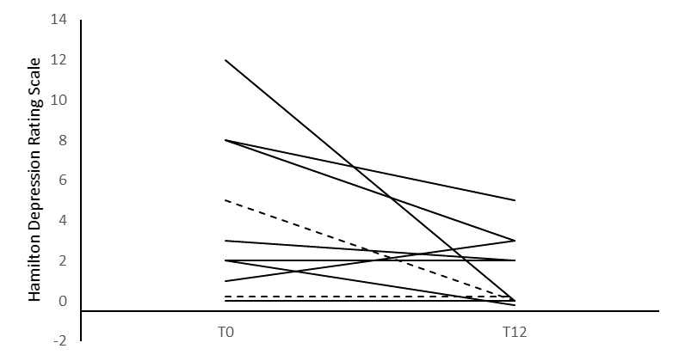 | 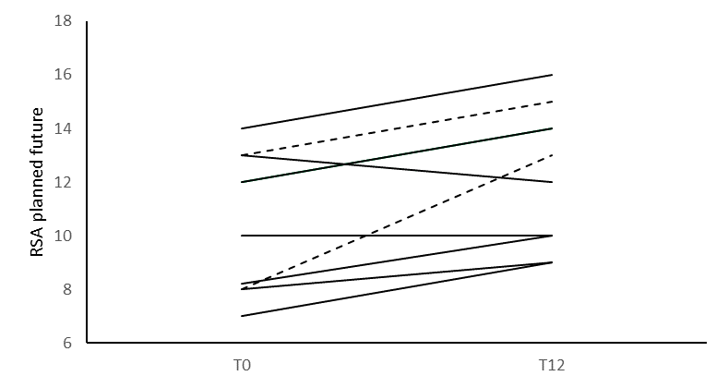

Supplementary figure 2. Differences between baseline (T0) and 12-months follow-up (T12) on psychological scales in 10 at-risk relatives (see ‘Follow-up’ box in figure 1) included in the IT-DIAfN protocol. Means and C.I., p on Wilcoxon test.

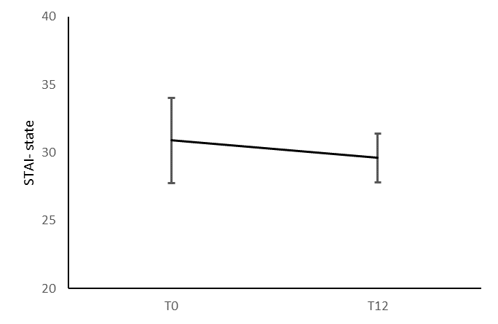  p=0.553 | 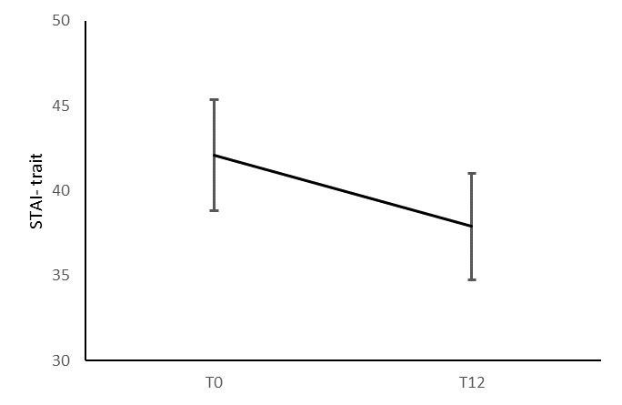  p=0.074 | 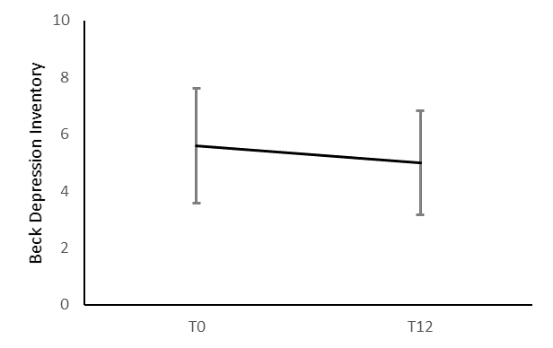  p=0.303 | 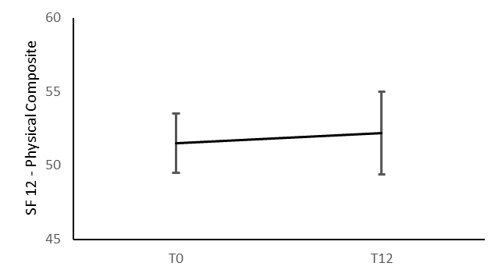  p=0.888
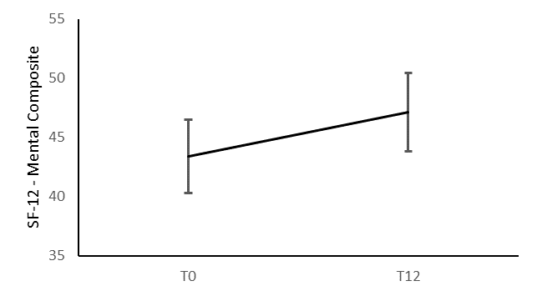  p=0.202 | 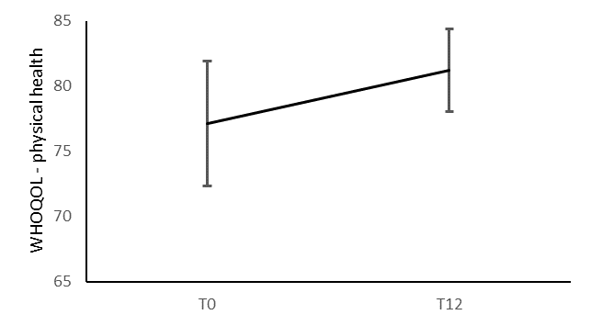  p=0.400 | 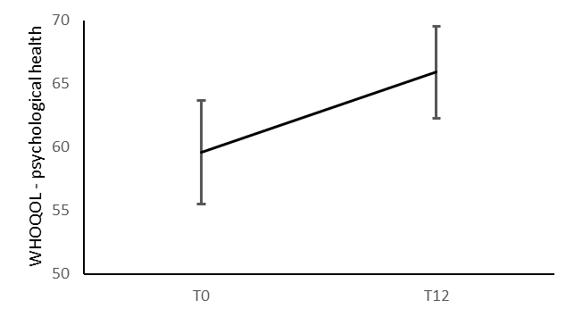  p=0.108 | 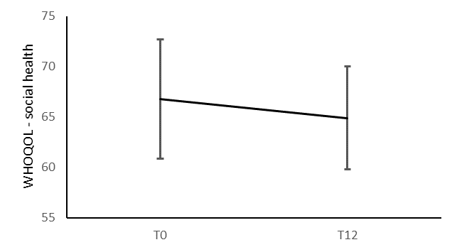  p=0.799
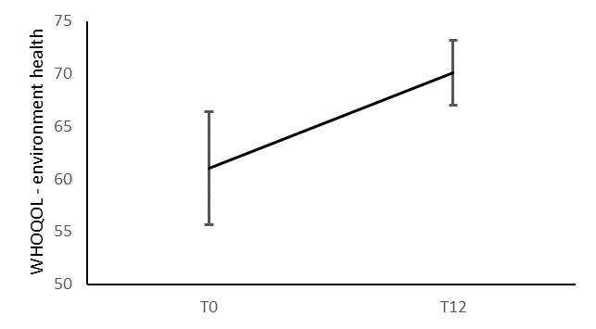  p=0.126 | 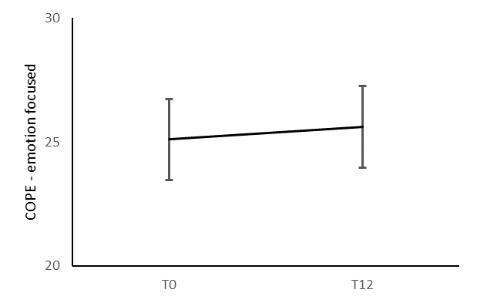  p=0.674 | 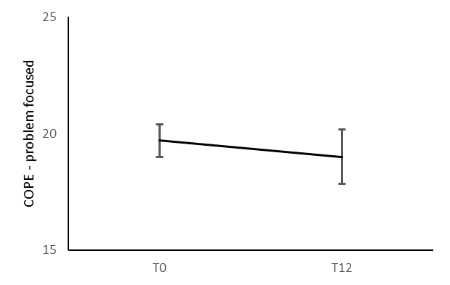  p=0.831 | 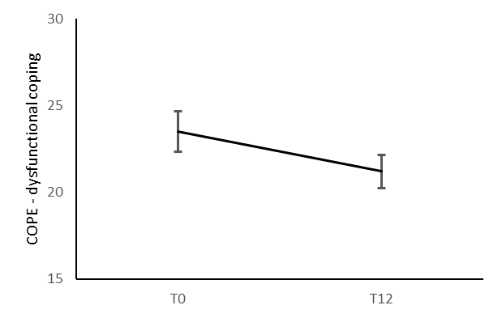  p=0.075
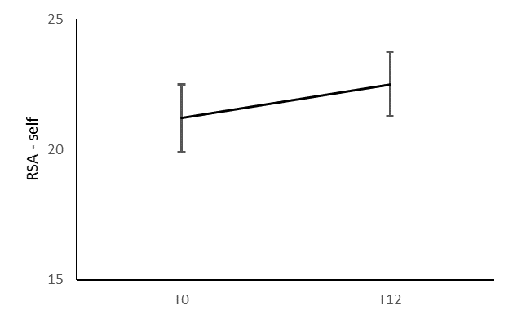  p=0.105 | 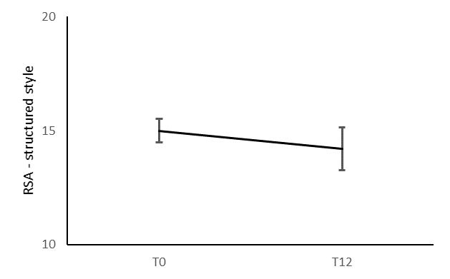  p=0.271 | 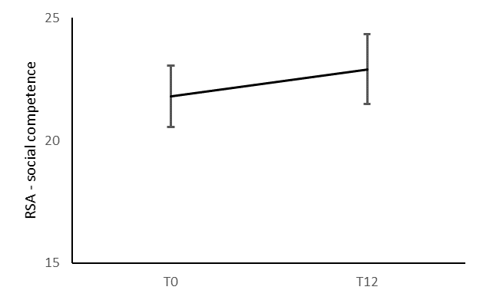  p=0.371 | 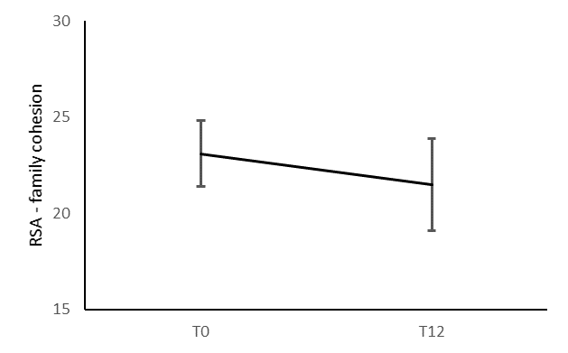  p=0.675
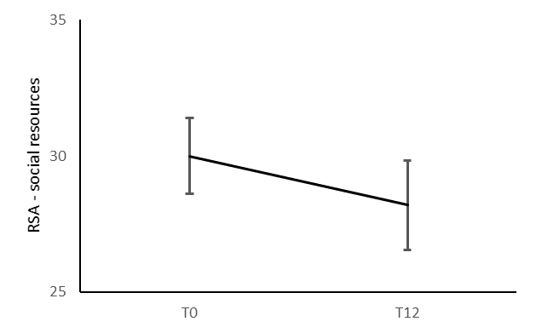  p=0.234 | 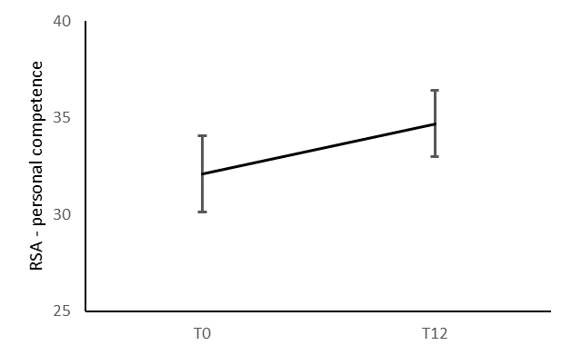  p=0.057 | 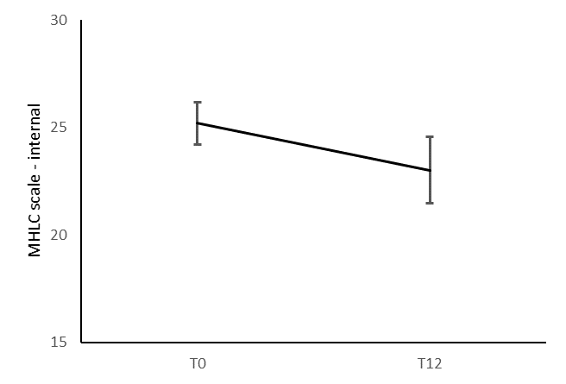  p=0.440 | 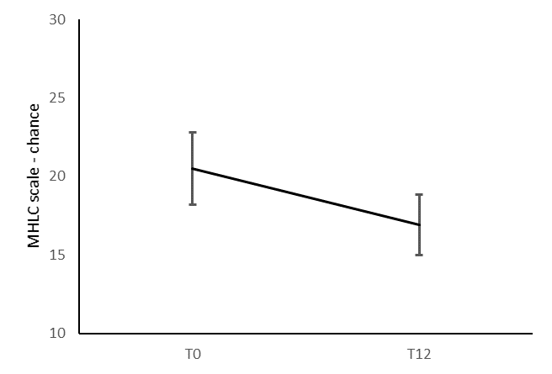  p=0.240
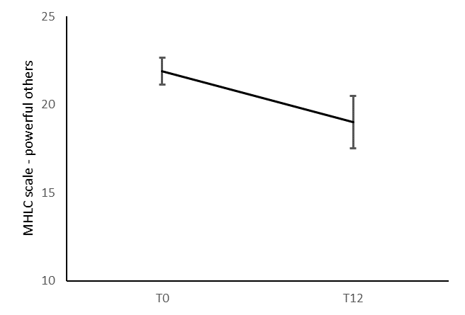
p=0.097

