Supplemental Digital Content 3. 90-Day Cost Plots and Length of Stay Distribution

Figure 1: 90-day reliability adjusted episode costs for entire cohort (74 facilities, 7,342 patients). Mean = $24,198, median = $23,744, range = ($17,303, $31,060).

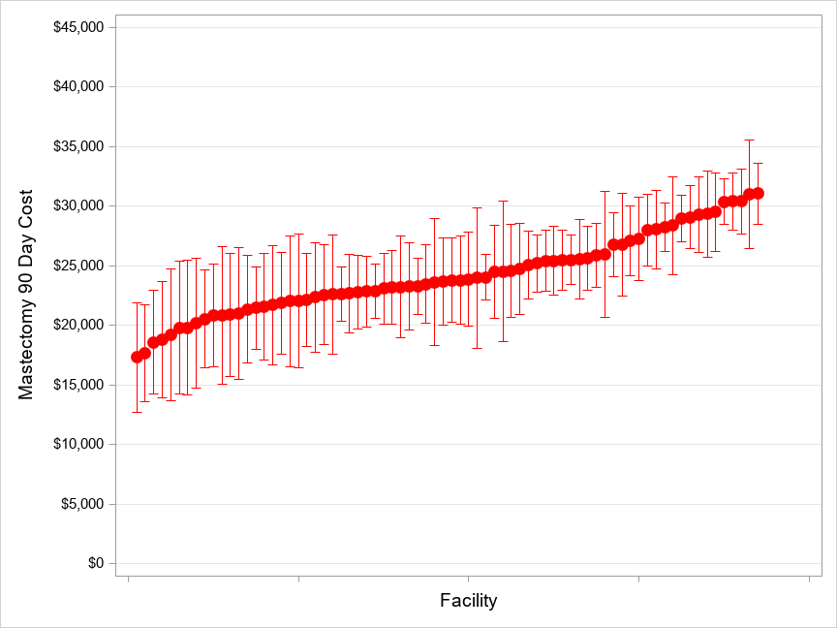

Figure 2 90-day reliability adjusted episode costs, by reconstruction status. (A) Without reconstruction. Mean = $21,859, median = $21,510, range = ($16,637, $27,493). (B) With reconstruction. Mean = $33,423, median = $33,602, range = ($24,555, $39,514).
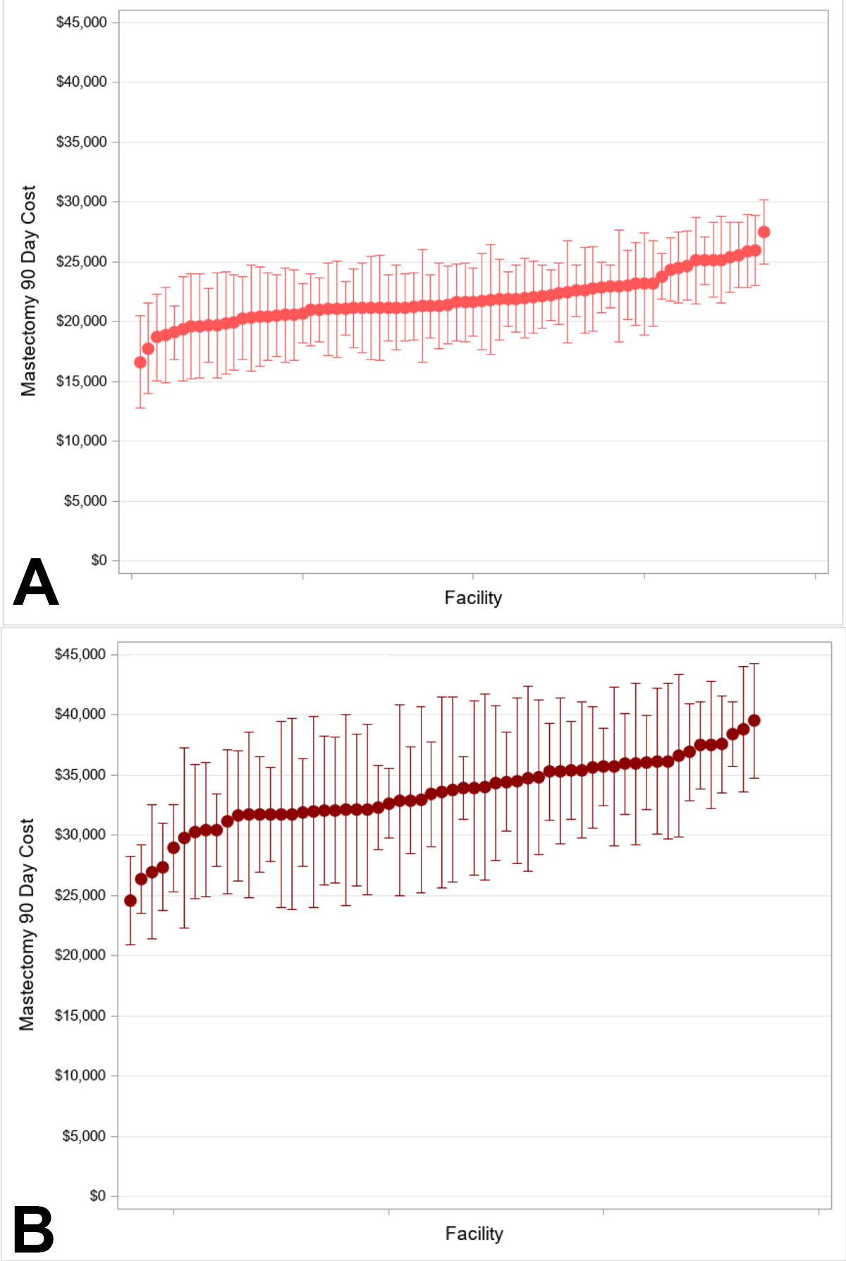

Figure 3: Mean length of stay × breast reconstruction status. (A) Without reconstruction. Facility mean = 1.5, median = 1.4; range = 0.4 to 5.3 days. (B) With reconstruction. Facility mean = 1.7; median = 1.6; range = 0.5 to 4.8 days.

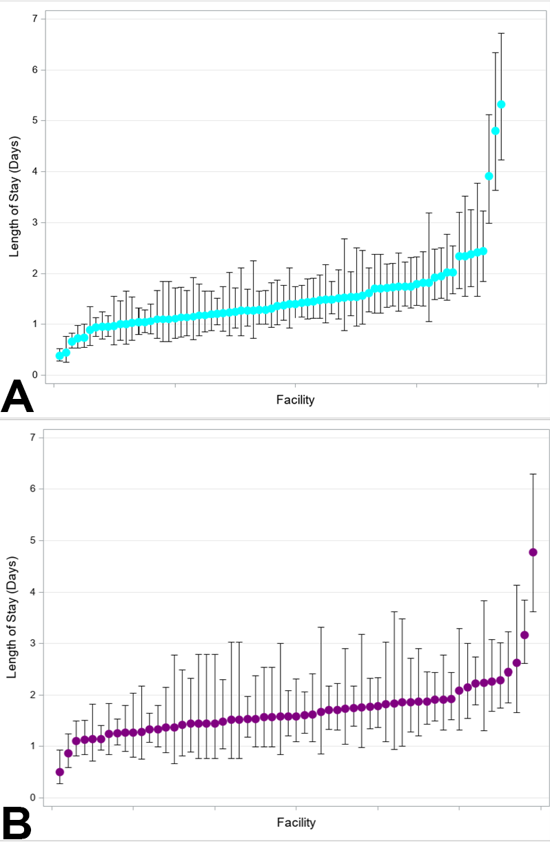
Figure 4: (A) Box plot of percentages of outpatient mastectomies, all n = 7342 women. Overall outpatient mastectomy rate = 16%. Median (interquartile range [IQR]) facility rate of outpatient mastectomy = 9% (6%, 18%); range 0% to 98%. (B) Box plot of percentages of outpatient mastectomy, omit reconstruction, n = 5,036 women. Outpatient mastectomy rate among patients without reconstruction=21%. Median (IQR) facility rate of outpatient mastectomy=10.5% (6.9%, 19.2%); range = 0% to 96%.
